Overview
This document serves as the Instruction manual for the Instron 4444 Mechanical Testing Machine. Its primary objectives are to ensure consistent and standardized operation of the machine, promote safety during its use, and facilitate efficient testing processes. By following the guidelines outlined in this manual, operators can achieve reliable results, maintain safety, and optimize the machine's capabilities for mechanical testing.
Machine Use
- Log onto the computer for the Instron machine
- Campus login with your RCS Username and password
- Local PC login
  - Username: EC-2025-LAB01\User
  - Password: designlab
- Verify display for test are set to desired UNIT system (switch located on back of control panel, see picture below)
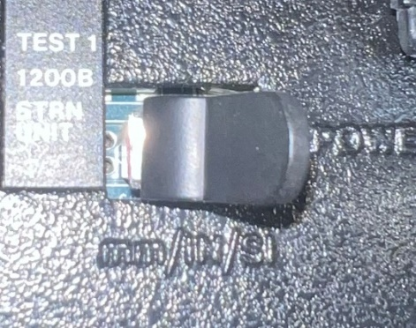
mm
IN
SI
Grip instructions
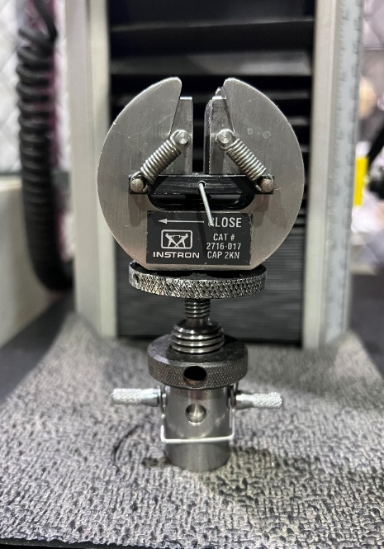
Metal clip

Pin hole

Grip wheel
Grip
Grip body
Mounting bracket
Mounting wheel
Pin

  - To attach grips:
    - Insert grip body into mounting bracket in the correct orientation (can be positioned at 90⁰ increments)
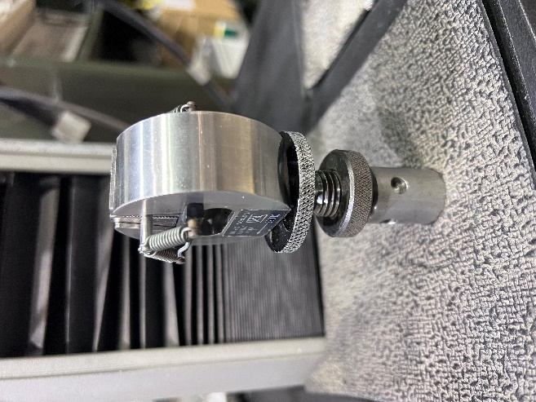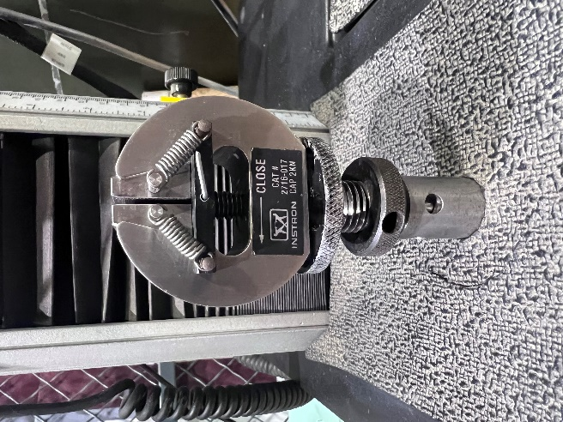
Mounting bracket
Grip body

    - Gently apply pressure to push the grip into the mounting bracket to align the pin holes, and insert pin at the correct orientation
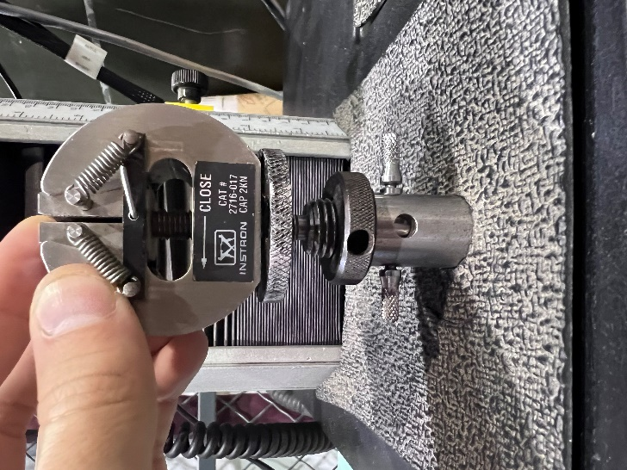
Mounting bracket
Pin hole

Pin

    - Attach metal clip to pin to prevent it from slipping out and hand-tighten circular mounting wheel
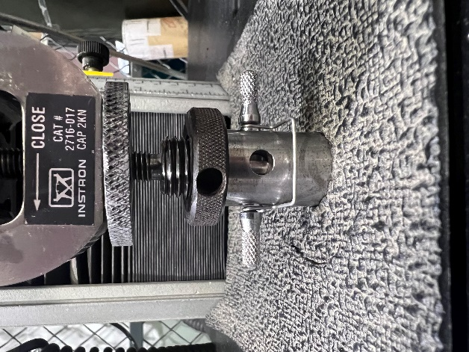
Metal clip

Mounting wheel

  - To close grips:
    - Hold grip body with an adjustable wrench
    - Place square nut wrench on square nut
      - If grips have circular grip wheel instead of square nut, use your HANDS to tighten. Grabbing with pliers will only damage the knurled surface of wheel
    - Turn square nut or circular grip wheel (NOT grip body) clockwise to close grip wedges
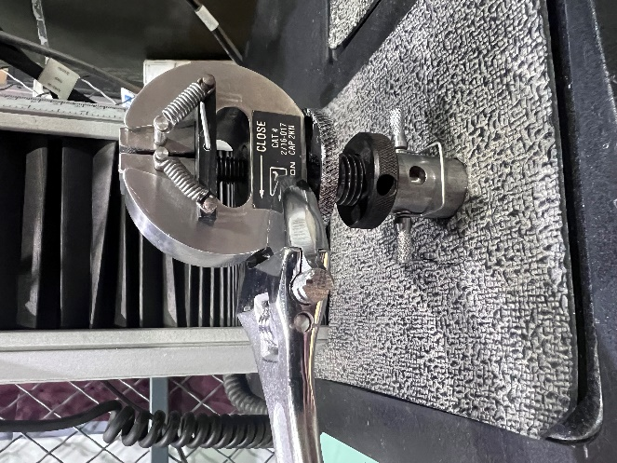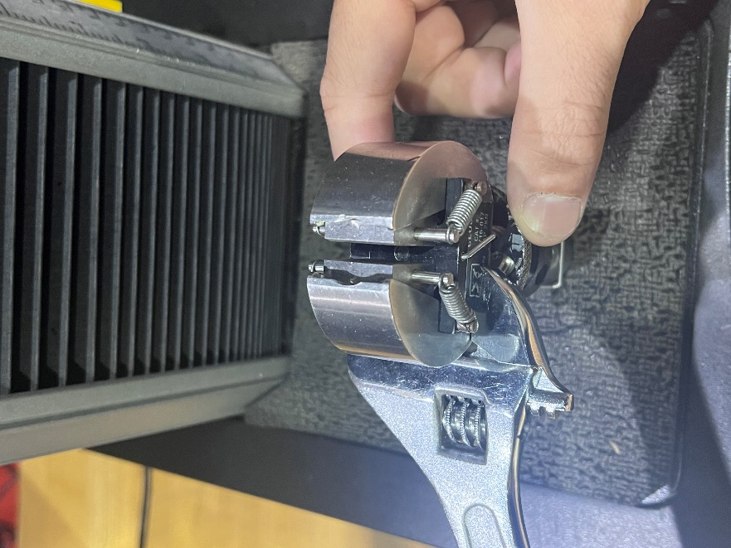
Wrench
Grip wheel
Grip body
HOLD WRENCH STEADY TURN KNURLED WHEEL

- Use the JOG button on the Instron machine (lower left) to move the top grip upwards (sample should be clear of bottom grip). Insert sample into top grip and tighten fully

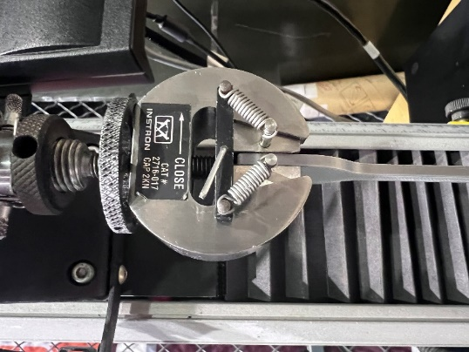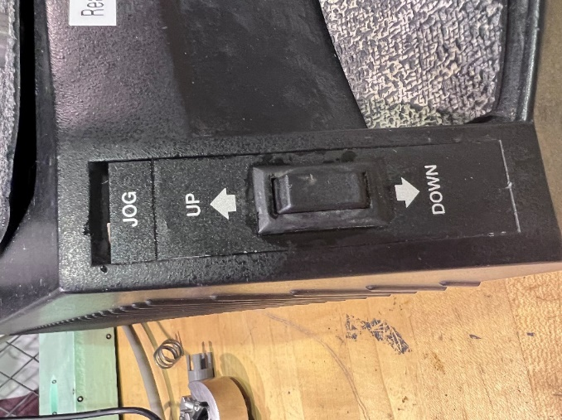

- Move the top grip downwards using the JOG button so that the other end of the sample is between the lower grip and tighten fully. The sample is now fully configured and ready to test
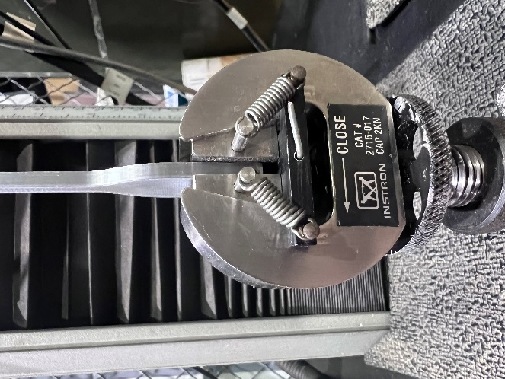

- Zero the load scale
- Press the “CAL” button within the yellow box labeled “LOAD”, and then “ENTER”
- Load readout should change to zero

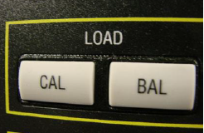

- Set desired testing speed
- Press the “SPEED” button, enter the desired speed (typically 50 mm/min) on the keypad, and press the “ENTER” key
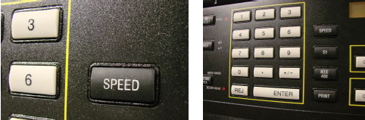

- Before running any tests, zero the extension measurement
- Press the “GL RESET” button, and then “ENTER”. This should be performed once


- To run the test, open the LabVIEW file labeled “Instron VI” on the attached computer
- This program saves the load, extension, and strain data for a single test as a .csv file
- Strain variable will be displayed and saved as ZERO, because no extensometer is currently installed on the machine
- Data will be saved to the Public Documents folder as intron-data.csv by default (this should be changed BEFORE EACH test)
  - If the file name is not changed, it will overwrite existing data
  - Be sure to save a copy of the data to a flash drive, as it may be overwritten by other users if left on computer
- Default data capture rate (sampling rate) is once every second (1000 milliseconds). This can be changed from the LabVIEW Interface
- After running each test, rename this file to prevent losing results. If not changed, each new test will overwrite the previously recorded data
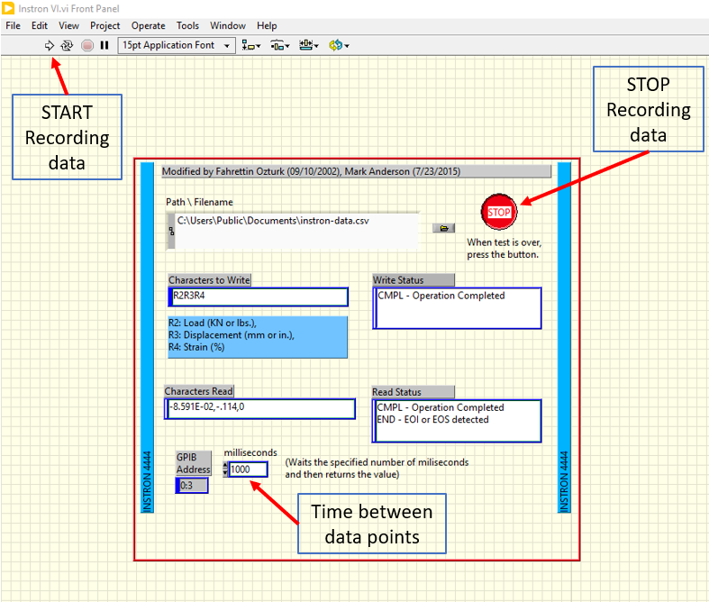

- Run the test by first pressing the “→” button on the LabVIEW interface, and then the button located at the bottom of the Instron interface
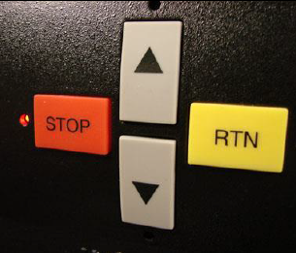
- Run the test until the sample snaps or slips, and promptly:
- press “STOP” on the Instron FIRST
- press “STOP” on the LabVIEW interface
*** Be sure to stop the Instron motion BEFORE stopping the LabVIEW program. ***

- Data from test will be saved to the filename specified in step 8.
Default filename and location is c:\Users\Public\Documents\instron-data.csv

[Nov 16, 2023 - AP]

