# svnx Guide

These screen shots were captured from version: svnX 1.3.4 - 2012-09-04. Other versions may look slightly different but the process will be the same.

It is recommended that you **FIRST** read the “[Subversion_Quick_Start_Guide_for_Dummies.docx](https://designlab.ecse.rpi.edu/redmine/attachments/download/53074/Subversion_Quick_Start_Guide_for_Dummies.docx)” document found in the Capstone Support wiki. This document has been written with that assumption.

Repositories are stored “in the cloud” on our Redmine server.

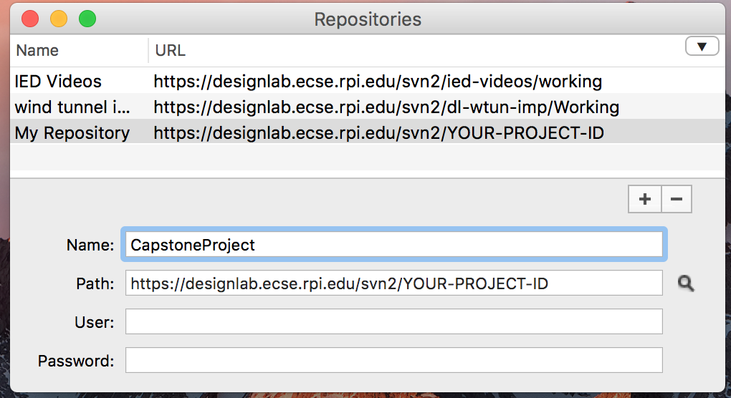

Figure - List of Repositories

As seen in Figure 1 - List of Repositories, the svnx tool allows you to access multiple repositories. Most Capstone teams, however, will only access a single repository.

Working copies are stored on your Mac’s hard drive. The svnx tool allows you to have multiple working copies in your Mac as shown in Figure 2 - Working Copies. Since most Capstone teams will only have access to a single repository they will have only a single working copy on their Mac.

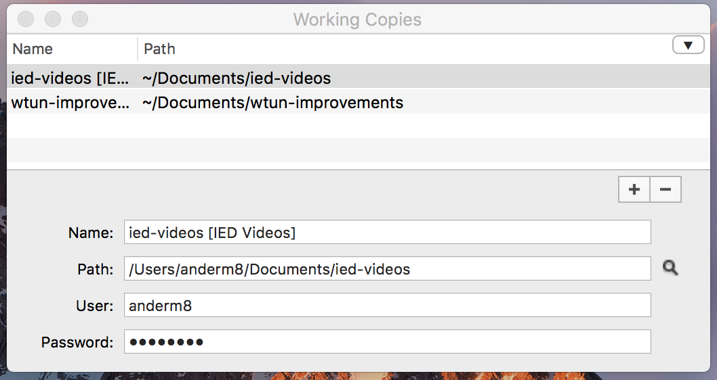

Figure - Working Copies

The first step is to add your repository to the list. Figure 4 - After Entering User Name and Password shows this process. Clicking on the “+” button brings up the lower part of the form where you enter the Name, Path, User and Password information. The name can be anything you like. The path should be as shown except you must replace “ags-dispenser” with whatever the id is for your project. For the user field you must use your Redmine username and your Redmine password.

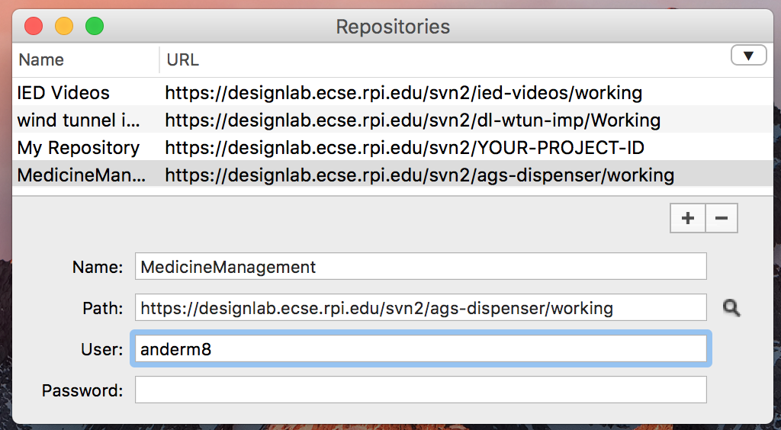

Figure - Adding a New Repository to Access

Once the information is complete, the Repositories window will look as in Figure 4 - After Entering User Name and Password.

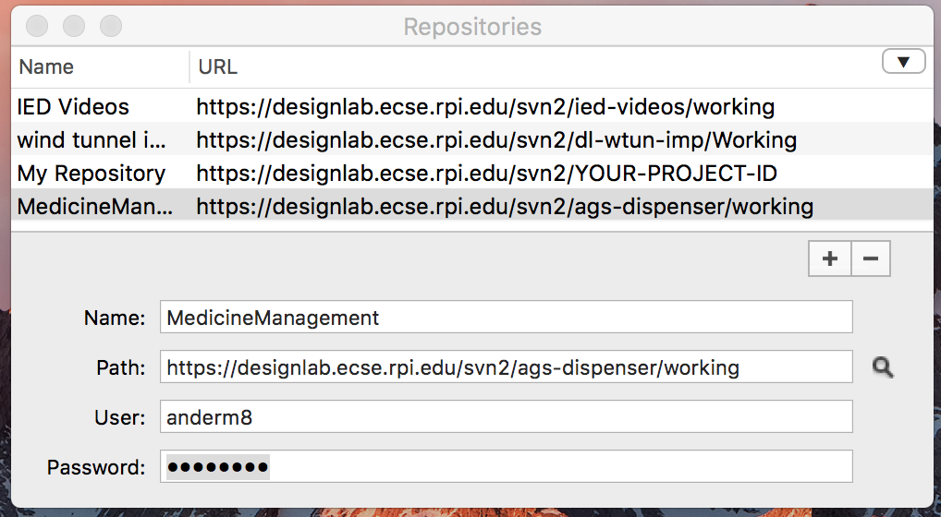

Figure - After Entering User Name and Password

The repository may now be accessed by double-clicking on it’s name in the list. This will open up the repository browser, seen in Figure 5 - Viewing the Repository's Contents. With this window you can navigate the repository’s contents, viewing both the files and folders as well as the recent history of commits. Normally we do NOT operate in the repository view window EXCEPT:

* To Import an initial folder structure needed when first creating a repository. This would be done ONLY ONCE for a given repository.
* To Checkout a working copy to get started using the contents of the repository.

Since we normally only use the working copy on our Mac, the next step is to create that.

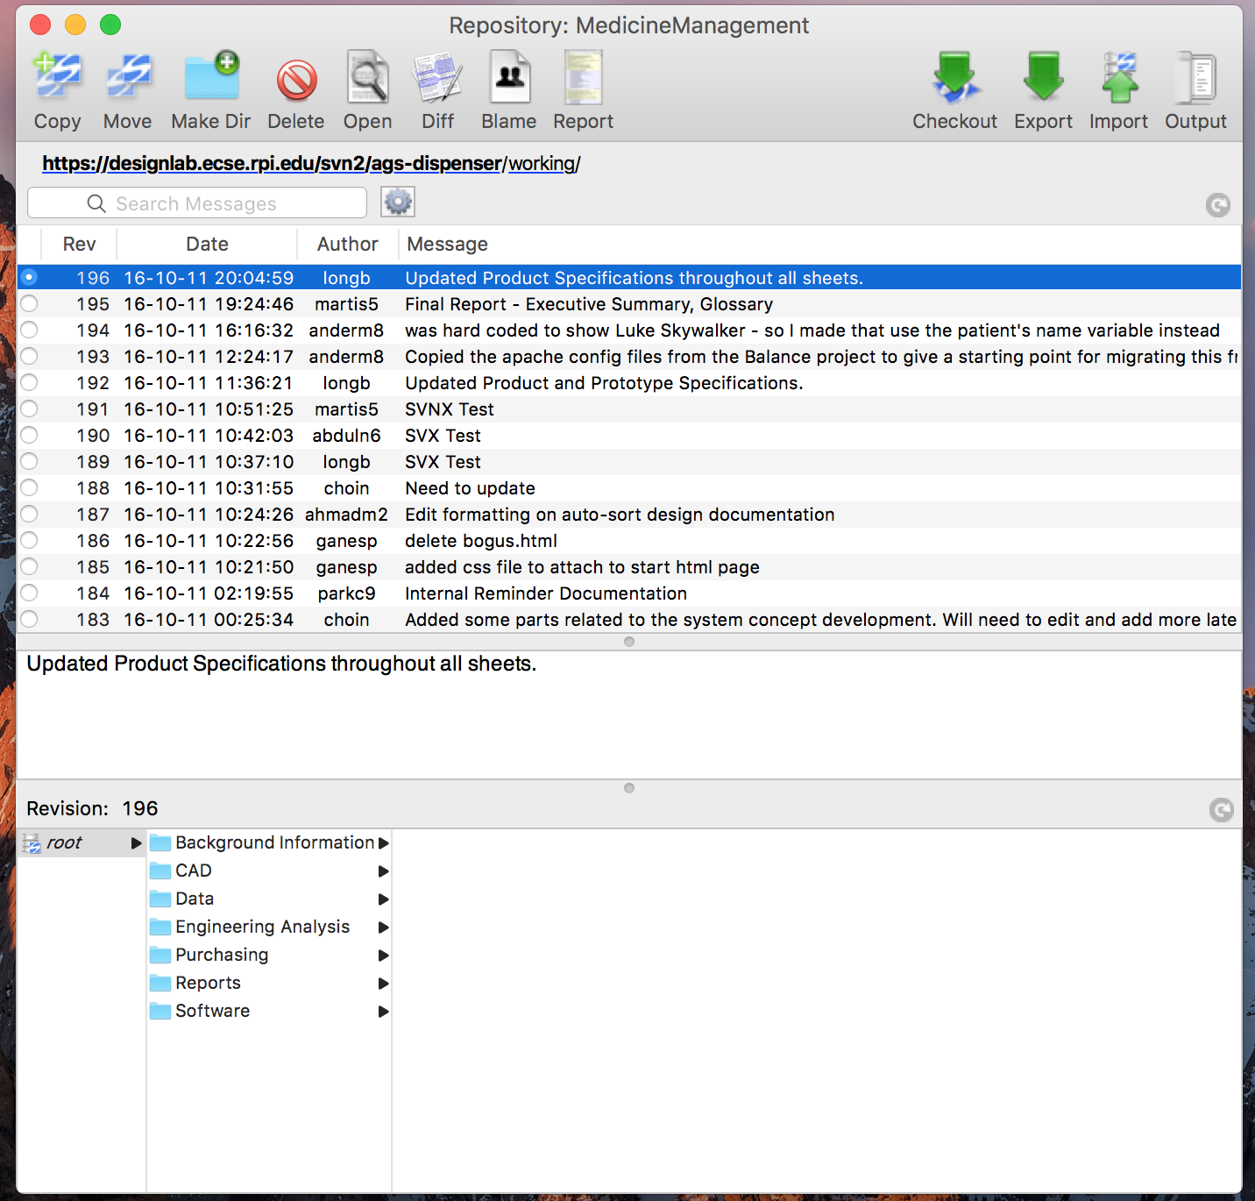

Figure - Viewing the Repository's Contents

Using the Checkout button on the Repository view window will bring up the ‘Checkout “working” into folder’ window as seen in Figure 6 - Checking Out from a Repository. Navigate to wherever you want to put the working copy. Place the working outside any portions of your hard drive that you currently backup. If you need a replacement copy of your working folder you can simply do another Checkout.

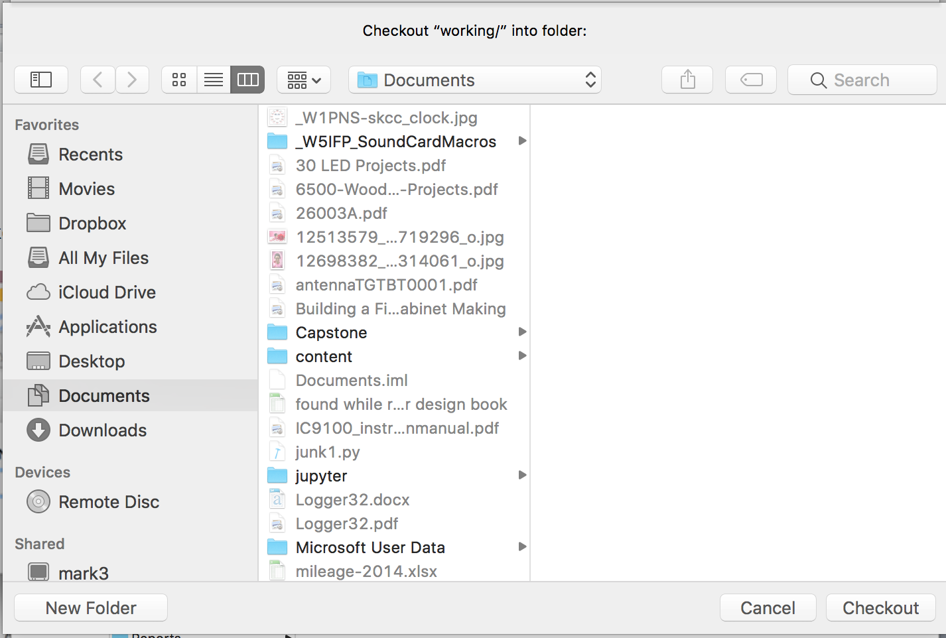

Figure - Checking Out from a Repository

Once you’ve made your selection as to where to put the working folder, click on the New Folder button. Then svnx will prompt you for the new folder name as seen in Figure 7 - Checking out a Working Copy.

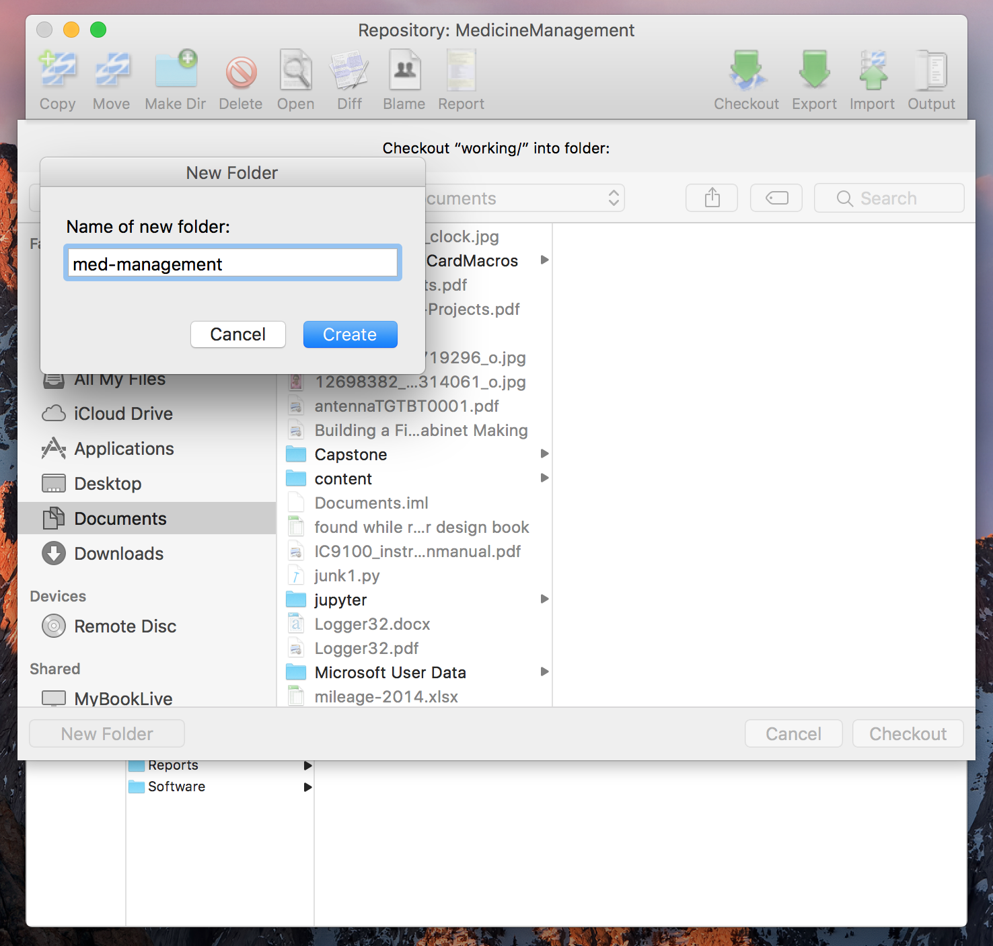

Figure - Checking out a Working Copy

That will create the new folder. Then click on the Checkout button. This will fetch all the files and folders from the repository and copy them to your Mac’s hard drive. The amount of time this takes will depend on the size of your team’s repository.

Once the checkout operation has completed it is possible to double click on the working copy’s name in the Working Copies window. This will bring up a display of the current status of changes made to your working copy on your Mac’s hard drive as in Figure 8 - Working Copy Status Window. When you make changes to your working copy, such as adding or deleting files, adding or deleting folders or modifying existing files, those changes will show up in this window.

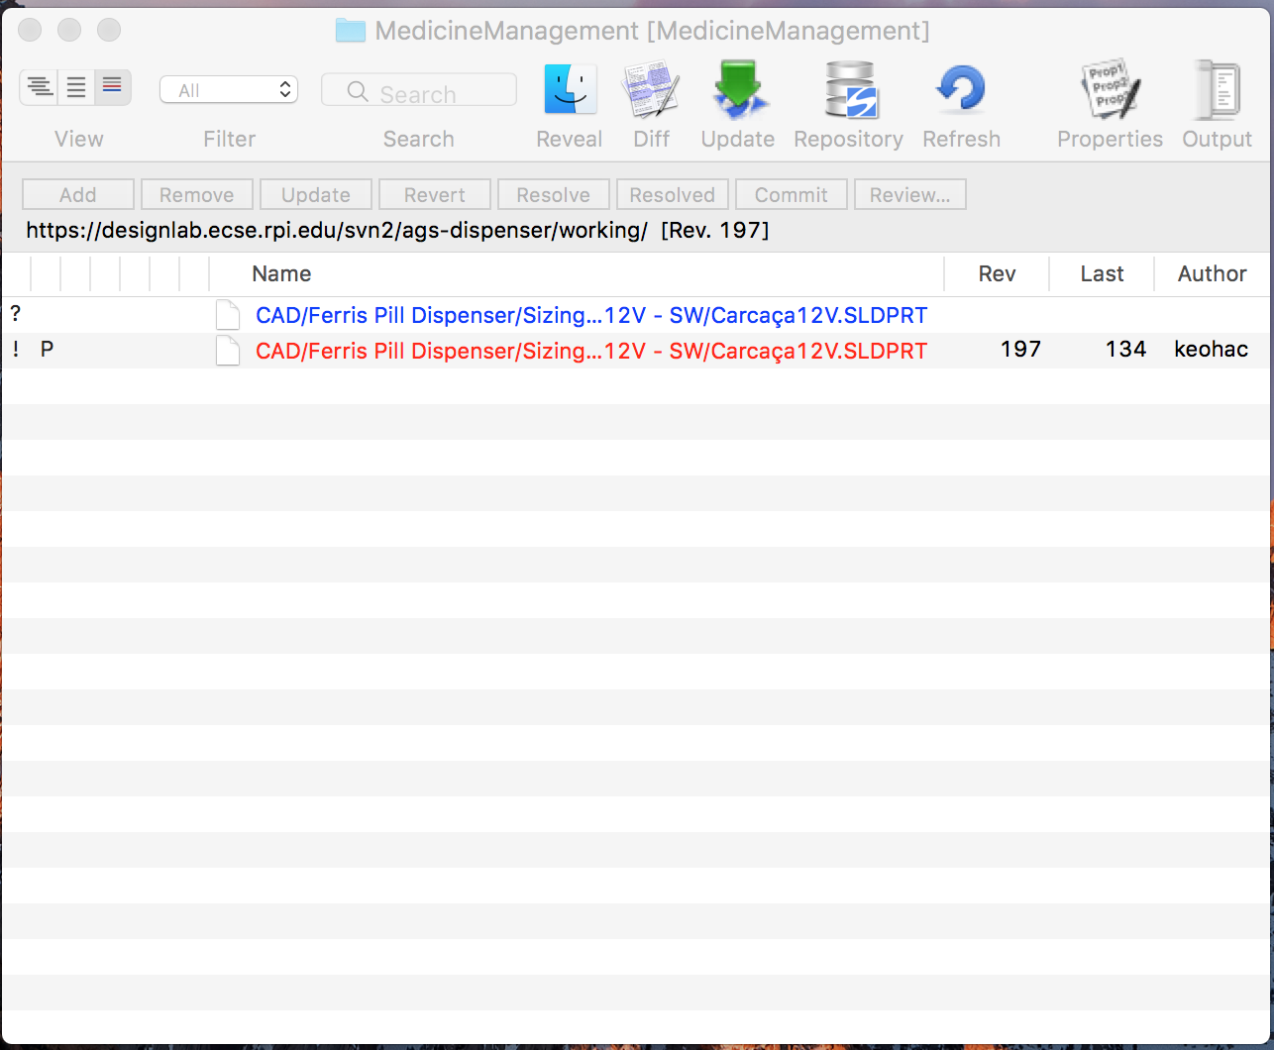

Figure - Working Copy Status Window

After you have done work on your Mac, the changes need to be committed back to the repository to be available to your team mates. This is done in the working copy status window using the Commit button. In Figure 8 - Working Copy Status Window there are no changes that need to be sent to the repository so the Commit button is grayed out. If there are changes, the Commit button will be available. After the commit, those entries will automatically be removed from the list.

Figure 1 - List of Repositories shows all of these svnx windows open at the same time.

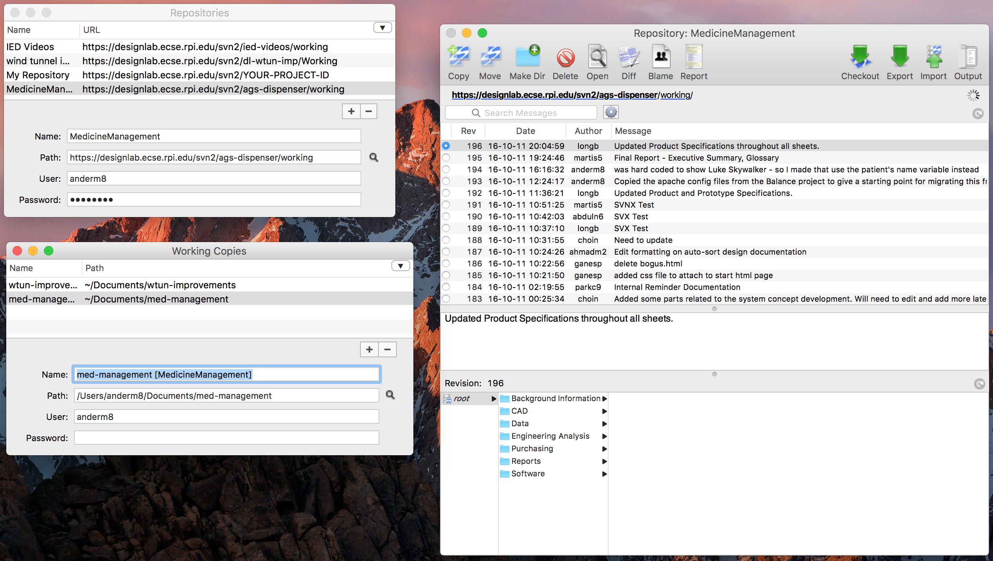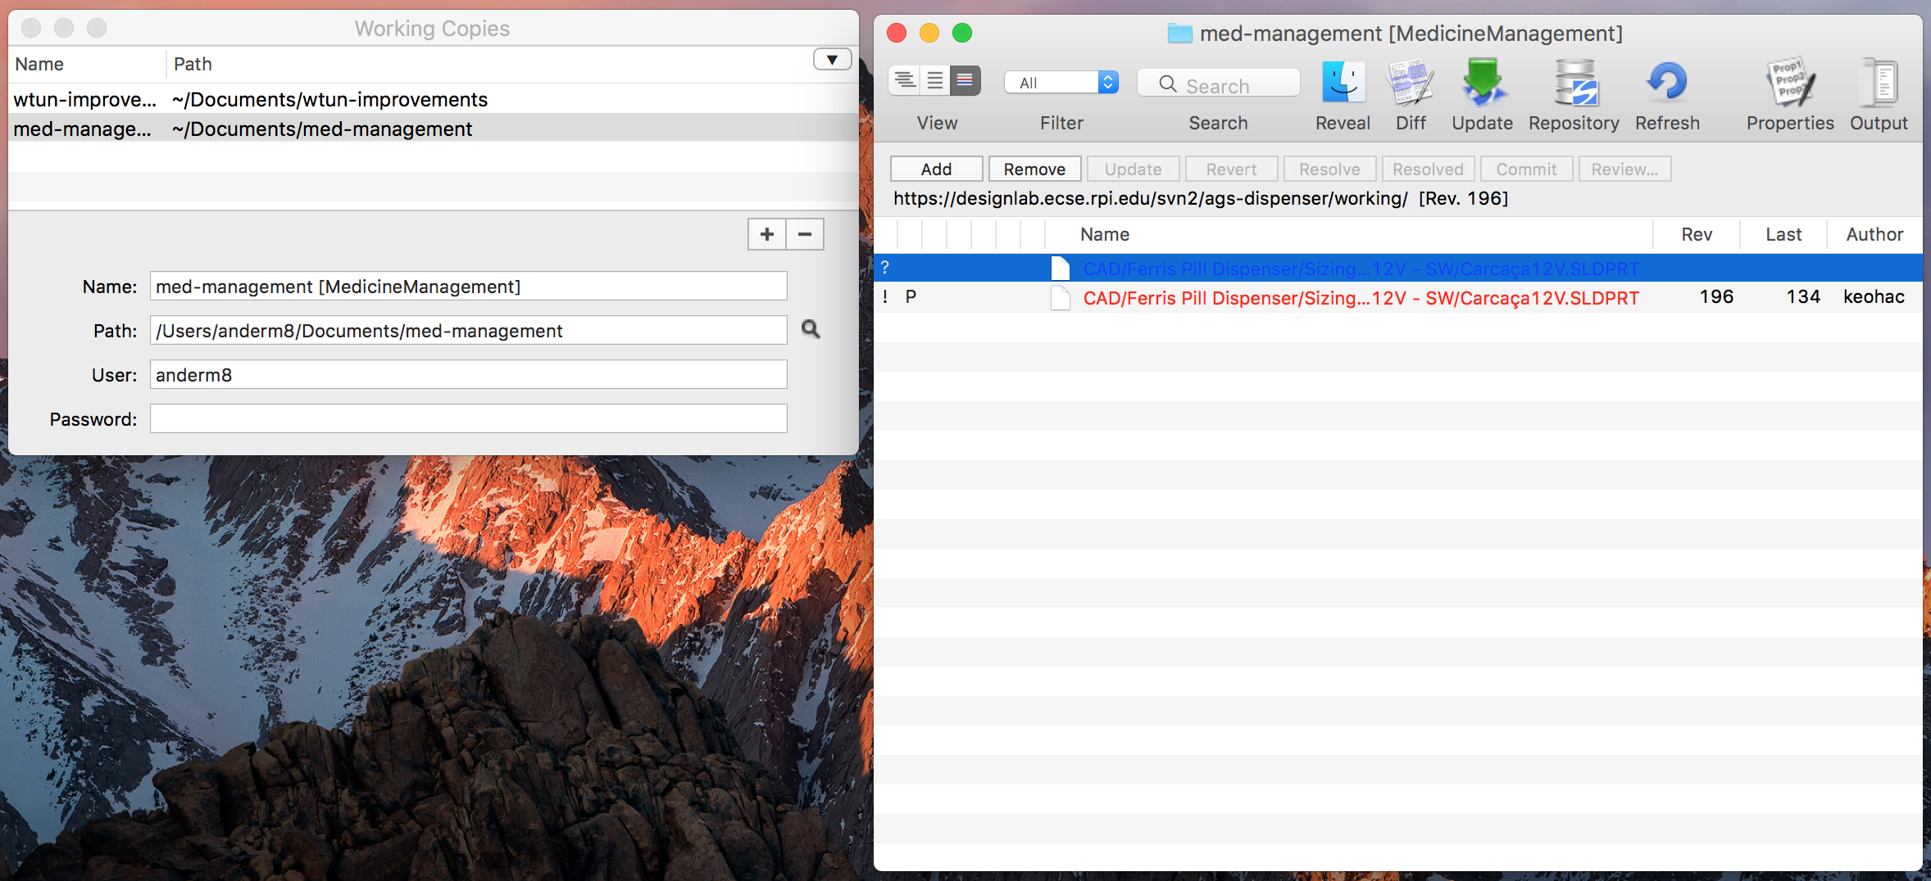

Figure - All the svnx Windows Open

Before doing work on your Mac, you need to be sure you have the latest versions of all files. This is done by using the Update button in your working folder view window. This is shown in Figure 10 - After doing an Update.

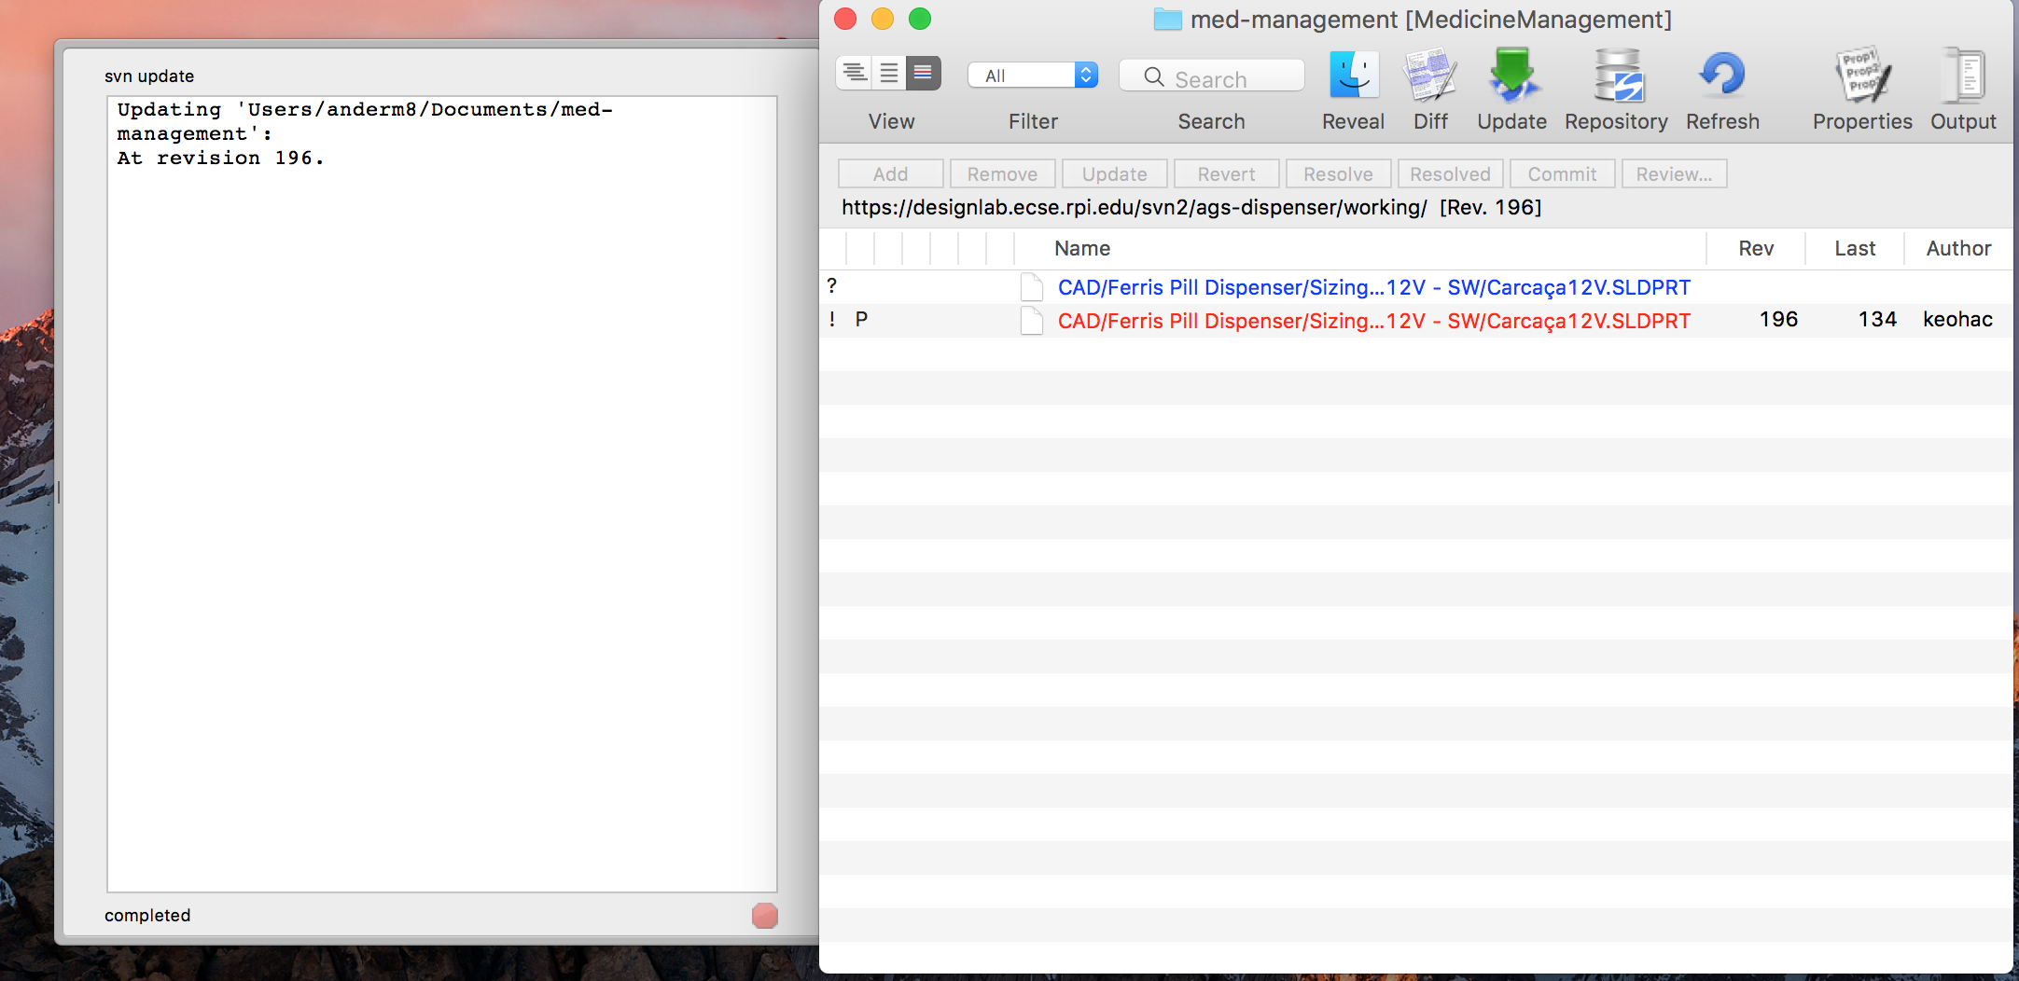

Figure - After doing an Update

Once you have updated your working copy you can view the actual folders and files in Finder. In Figure 11 - Opening the Working Folder in Finder we can now see the actual contents of the working copy. Here you can open files to work on them or create new files and folders as needed. After doing yourwork, be sure to go back to the working folder view window to do a Commit to send your work back to the repository!

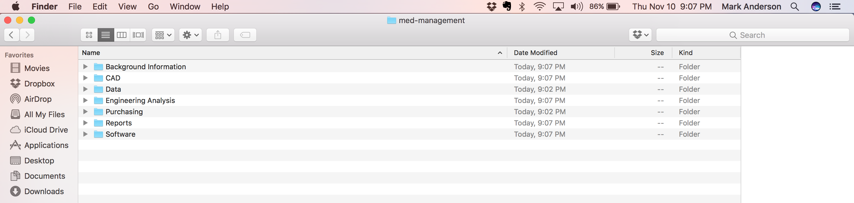

Figure - Opening the Working Folder in Finder

More information on svnx can be found on the internet.