ABB Robot Operation Instruction Manual
Information
- General Information
- Safety
  - Light Curtain
  - Occupancy Mat
  - Dead Man’s Switches
  - Computer Component Case Buttons
  - Yellow Button
- Quickset Menu
  - Mechanical Unit
  - Increments
  - Run Mode
  - Step Mode
  - Speed
  - Tasks to Stop and Start
- ABB Menu
  - RobotWare Arc
  - Production Manager
  - HotEdit
  - Inputs and Outputs
  - Jogging
  - Program Editor
  - Program Data
  - Production Window
  - Backup and Restore
  - Calibration
  - Control Panel
  - FlexPendant Explorer
  - Lock Screen
  - System Info
  - Event Log
  - Log Off Default User
  - Restart
  - Exit a Menu
- Pendant External Buttons

Operation
- Start Up and Shut Down
  - Start Up Instructions
  - Shut Down Instructions
  - Disconnecting the Battery
- Types of Motion and Coordinate Systems
  - Axis
  - Linear
  - Reorient
  - World Coordinate System
  - Base Coordinate System
  - Tool Coordinate System
  - Work Object Coordinate System
- Modes
  - Manual
  - Automatic
- Software and Programs
  - RobotStudio
  - Octopuz
  - Transfer Programs
  - Running Programs
  - Stopping Program
  - Restarting Program
- Inputs and Outputs
  - Example Schematic
    - 24V DC Input and Output
    - 120V AC Input and Output
  - Manual Control
  - Turn Output Program
  - Electrical Input Response
- Troubleshooting
  - Acknowledgment Events
  - Breaking Light Curtain
  - Stepping on Occupancy Mat
  - Robot Not Moving
  - ABB Menu Too Many Views
  - Emergency Stop State
  - Singularity Error
- Attaching Tool

Information
Section 1: General Information
The robot is called an IRB 1600 1.45 produced by the ABB company. It is an articulated robot meaning it has 6 degrees of freedom. It is much like a human arm with 3 degrees of freedom on the larger bicep-like part in the X, Y, and Z axis and 3 degrees of freedom on the smaller forearm/writs section of the robot in the X, Y, and Z axis. The arm device that controls the robot is called a teach FlexPendant. It is a touchscreen device meant to be worn on the inner forearm. The main computer component along with the FlexPendant are IRC5 models.
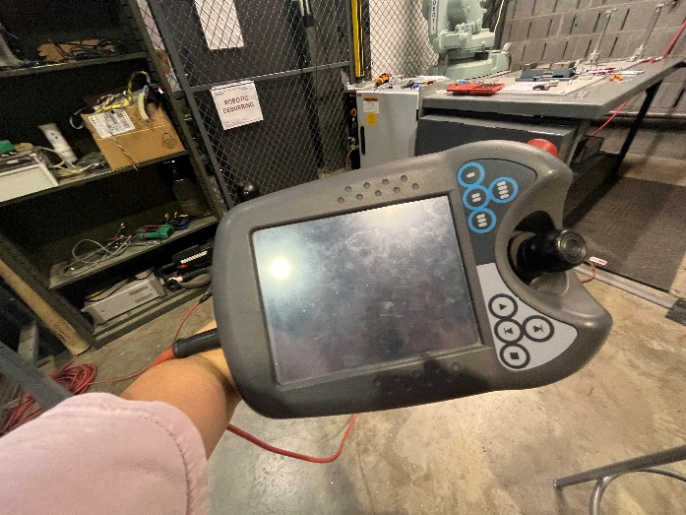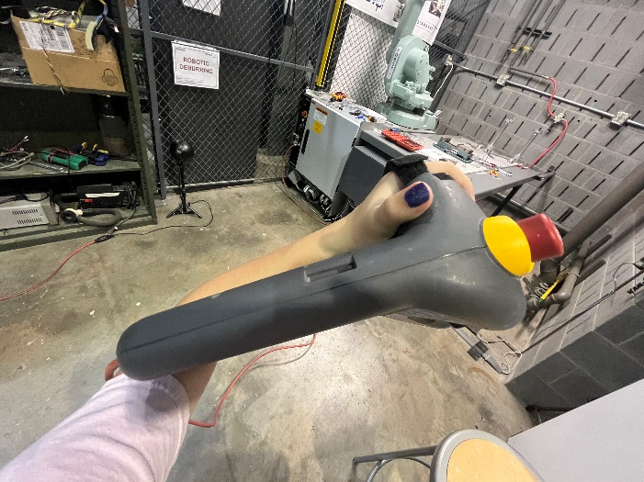
There is a light switch for the robot alcove near the stone wall to the right of the robot alcove. It should be labeled PANEL R-2K CKT36.
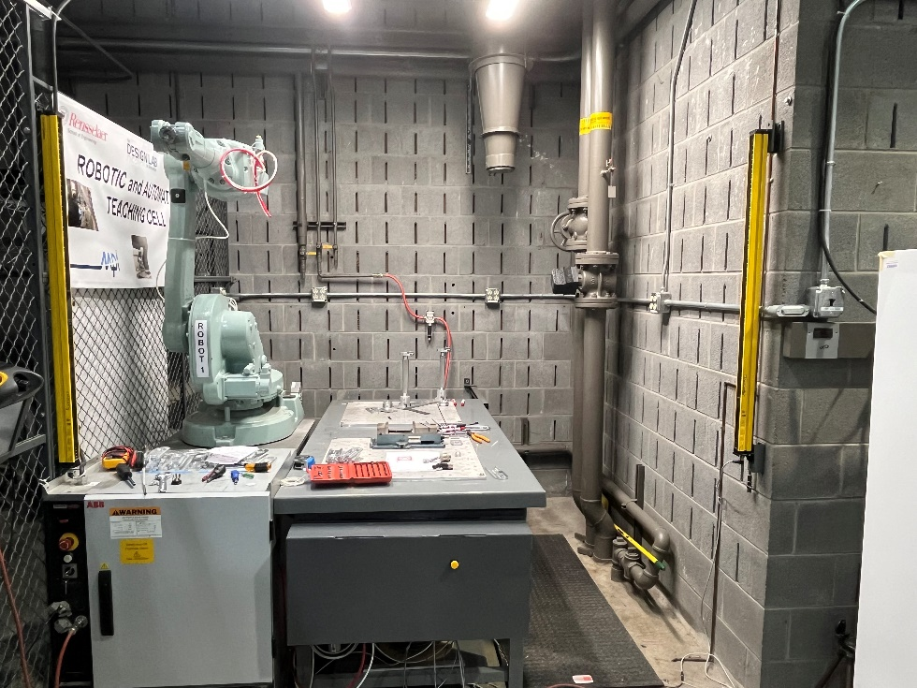

On the FlexPendant there are 4 different main sections.
- In the upper left is the red ABB menu. There are many operations that can be performed from the ABB menu. See Instructions 4 for more about the ABB menu.
- Next to the ABB menu the operating window, is shown with a man in green and a speech bubble. The operating window shows messages from the robot’s program.
- Next to the operating window is the status bar. This area shows the messages of the robot’s state. Any error message will appear here and if not acknowledged will prevent the robot from moving. See Operation 8a about clearing acknowledgments.
- Finally in the bottom right of the screen is the quickset menu. See Information 3 for more about the quickset menu.
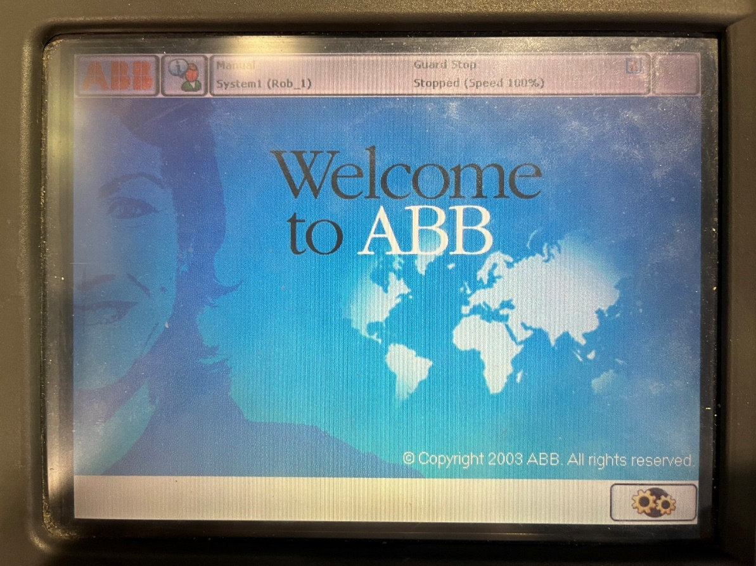
4
3
1
2

Section 2: Safety
- Light Curtain
There are two yellow bars on the walls near the alcove of the robot arm. When the robot is turned on the two yellow bars should turn on. When activated there will be beams of light passing between the bars preventing the robot from activating when something is blocking the path. Make sure nothing wider than a pen is blocking the path. When blocked the receiver should have a red light appear near the blocked screen sign and on the transmitter two orange lights should appear on the two bottom signs.
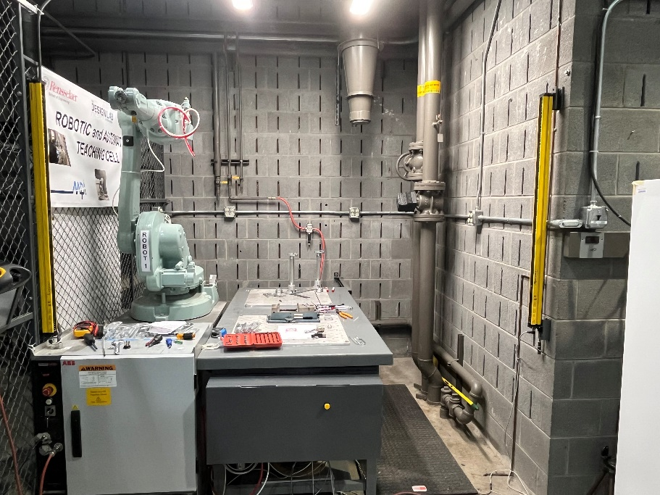
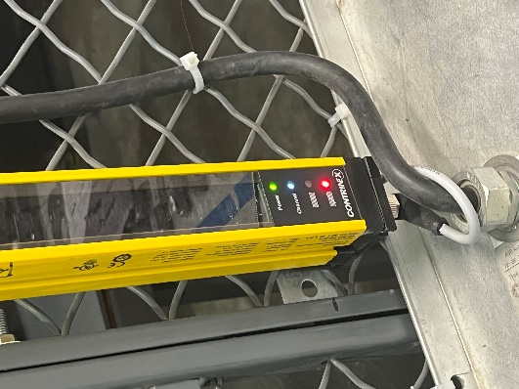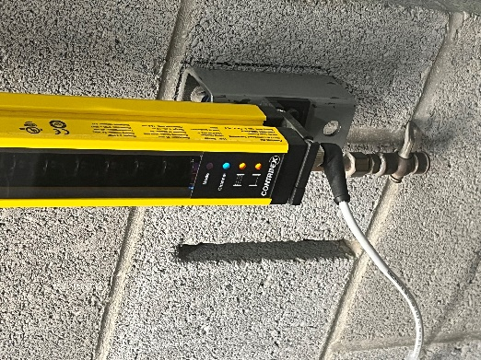
Transmitter
Receiver

- Occupancy mat
The occupancy mat is the black mat on the floor of the robot arm alcove. It is pressure activated and when someone stands on the mat it prevents the robot from moving.
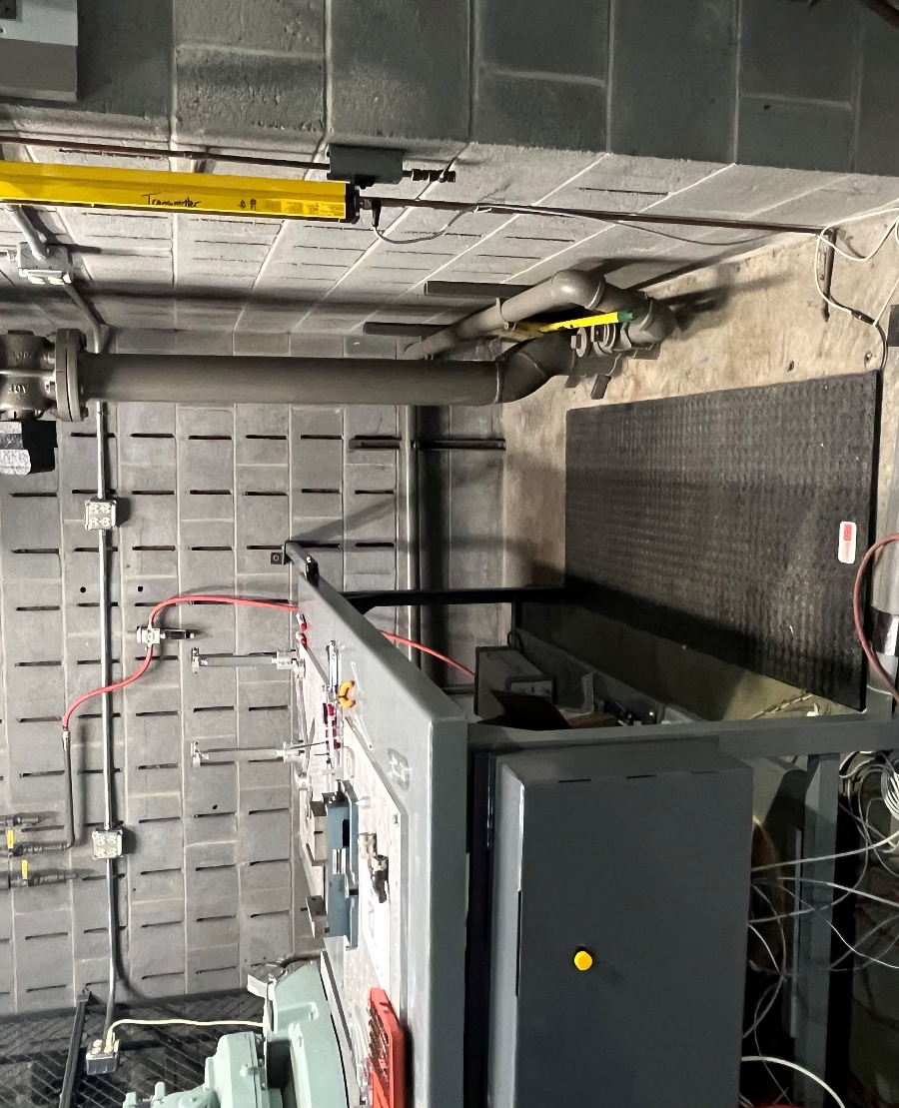
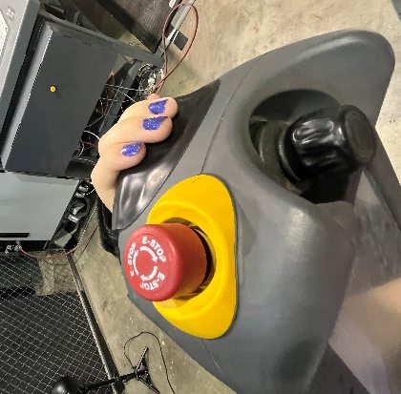
- Dead Man’s Switches
There are a few dead man switches for the robot arm.
- If the dark grey semicircle on the non-corded end side of the pendant is clicked into the second position, then the dead man switch is activated, and the robot will not move. Release the semicircle and restart the motion, only clicking into the first position.
- There is another dead man switch located on the FlexPendant. On the upper right-hand corner of the pendant, there is a bright red button with white arrows and the word E-stop printed on the top. If the red button has been fully clicked in, then the robot will not move. To release the button, twist the button clockwise.

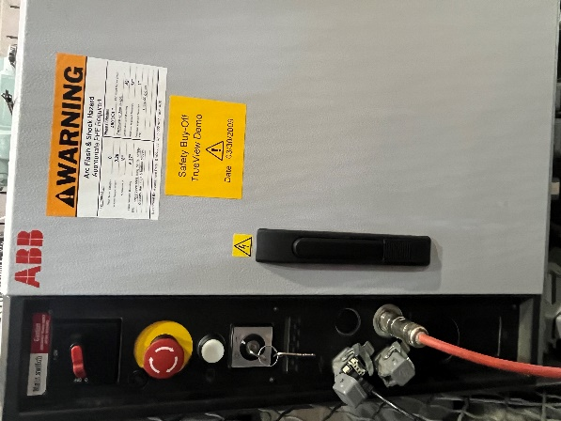
- Another switch is the red stop button located on the computer components panel. Push the button in to stop the motion of the robot. If the red button has been fully clicked in, then the robot will not move. To release the button, twist the button clockwise.

- After a dead man switch has been activated then the motors will need to be started up again. To do this click the white button on the light grey component panel. See Operation 6f for more information about emergency stop states.

- Computer Components Case Buttons
There are multiple buttons on the grey computer components case box located under the light screen.
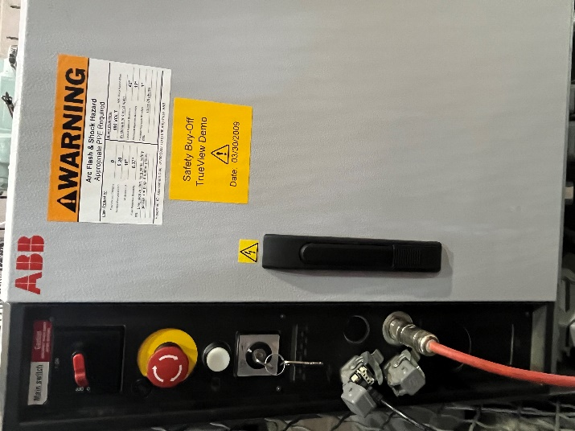
- The red switch is the main switch used to start the machine. The OFF position is horizontal, and the ON position is vertical. To start the robot arm, see Operation 1a.
1
2
3
4
- The red button with the white arrows is a dead man switch. See more information about dead man switches in section Information 2c.
- The white button is a motion reset button. The button will blink when the machine is turned on.
- The black output cord is connected to the light grey components box in a USB port covered by a grey lid. A flash drive can be connected to the black cord or to the USB port protected by the lid directly. This USB port is used to transfer programs from ABB Robot Studio or Octopuz to the robot arm. See more information about transferring programs in section Operation 6c.

- Yellow Button
There will be a yellow button on the dark grey component that holds the compressed air next to the computer components case. The yellow button is hooked up to the light curtain. The button is used to disable the curtain by blocking the signal between the curtains. HOLD DOWN the button to stop the transmission. When held down the light curtain will not appear to have changed but it is working.
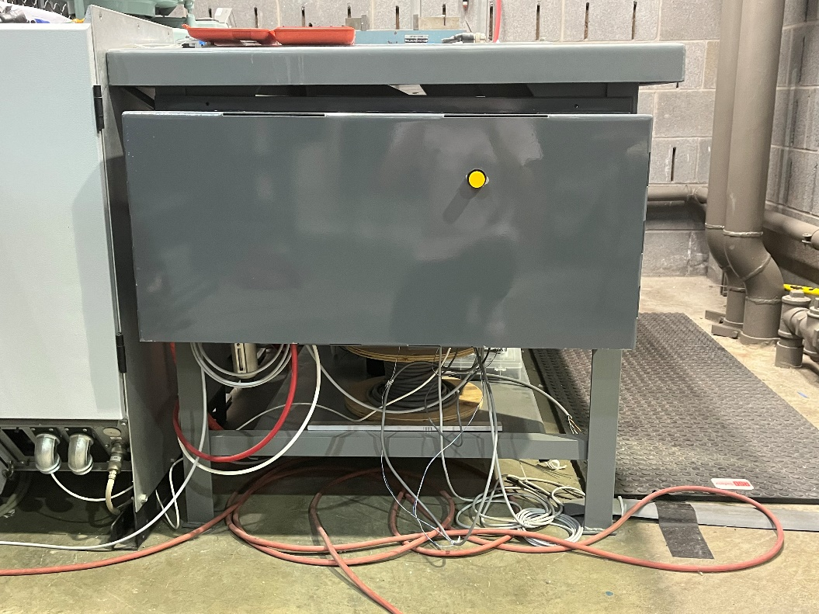

Section 3: Quickset Menu
In the bottom right of the screen is the quickset menu. The quickset menu serves as a shortcut for many basic functions. All the functions in the quickset menu can be edited in the ABB menu. See Instructions 4 for more about the ABB menu.

- Options
The options menu is the top section of the quickset menu, shown with an orange robot.
- Inside is the mechanical unit menu shown with an orange robot icon. It allows the correct robot to be selected and controlled.
- The second box under the menu is the motion mode box where 4 different modes left to right: axis 1-3, axis 4-6, linear, and reorient, can be selected. For more information about the motion mode Operation 2.
- Under the motion mode box is the tool section, shown with a little hammer icon, and the work object section shown with a little blue 3D box. Tool and work objects can be chosen in Octopuz for ease of use. See Operation 6b for more about Octopus.
In the show details section in the bottom right, a jogging system is added in the bottom left-hand corner indicated through a controller icon.

- The plus and minus will control the jogging speed.
- The dotted line icon underneath turns on or off user increment.
- The stop light icon to the right turns jogging supervision on or off.
- On the right in the same show details section are the 4 coordinate systems.
- Under the 4 coordinate systems are the 4 motion modes underneath. The coordinate systems can only be accessed in linear or in reorient mode not in either of the axis modes. For more information about the motion mode or coordinate systems see Operation 2.
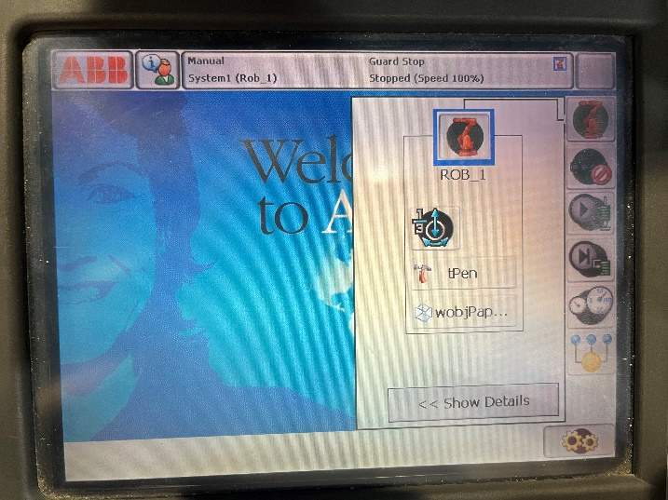
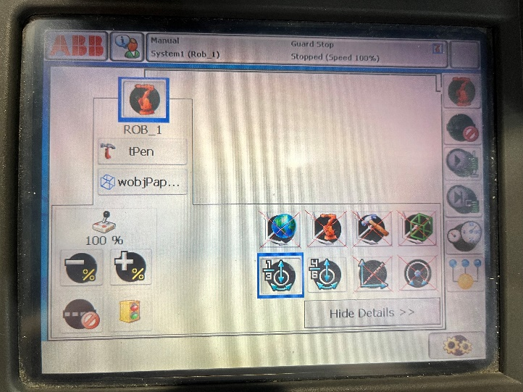
1
2
3
1
2
3
4
5
1
2
3
4
5

- Increments
The increment section is the second icon from the top of the quickset menu. It allows the user to change the increments the robot arm will jog in. Moving in increments is good for when slow and precise movements need to be performed.
- The top icon will turn increments off.
- The next three icons will jog in small increments, medium increments, and large increments.
- The user icon allows the user to input increments.
In the show values section the increment values, with units, will be shown for each increment option, and for each of the 4 motion modes, axis 1-6 is grouped under the one-axis icon. The user indictments can also be changed here by clicking on User and then clicking on the box on the left containing the values.
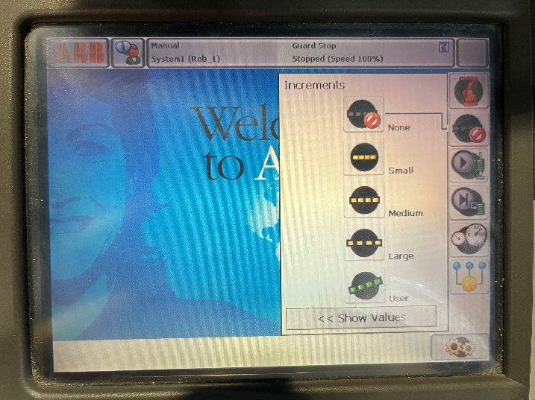
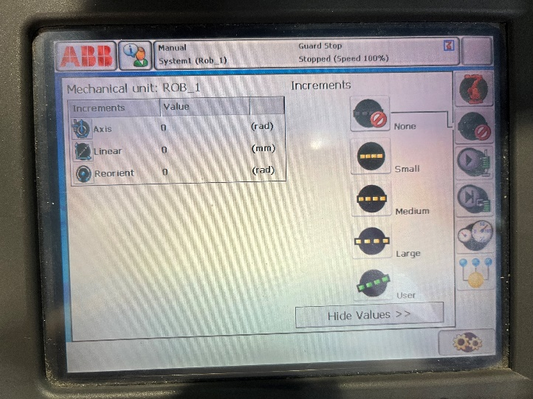
1
2
3

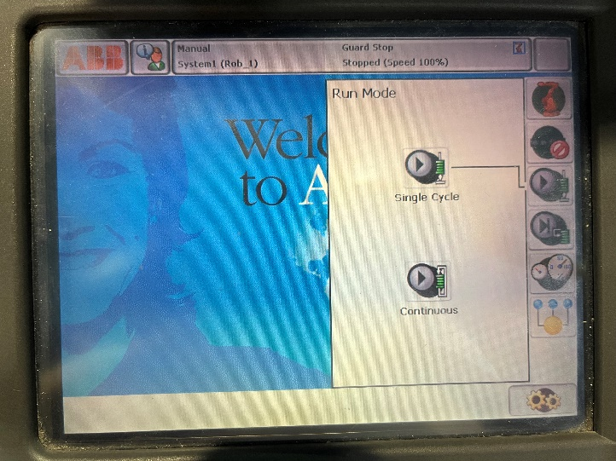
- Run Mode
Run mode is the third icon in the quest set menu.
- The Single Cycle run mode allows for single-cycle implementation. This is when all operations take the same amount of time.
1
2
- The Continuous run mode allows for multicycle implementation. This is when faster operations take less time than slower ones.

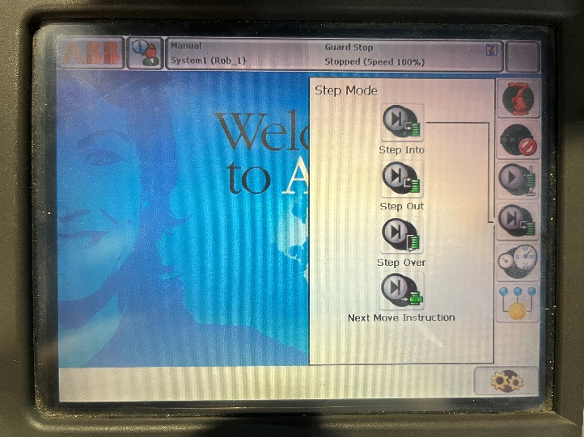
- Step Mode
Step mode is the fourth icon. Step Into will run a program one step at a time, waiting after each step for a user input signal to continue. Step Out will finish the steps in the current routine then stops at the next instruction in the routine. Step Over performs all one step selected in one routine. Next Move Instruction stops before and after the next movement instruction to allow for modification.

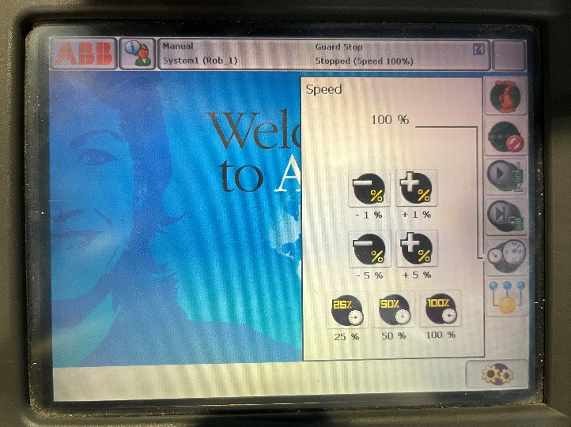
- Speed
The speed control is the fifth icon in the quickset menu. The speed panel controls the robot’s speed of jogging.
- The top two buttons will decrease, minus, the speed in increments of 1% and increase, plus, the speed in increments of 1%.
3
2
1
- The middle two buttons will decrease, minus, the speed in increments of 5% and increase, plus, the speed in increments of 5%.
- The bottom buttons will set the speed to 25%, 50%, and 100%.

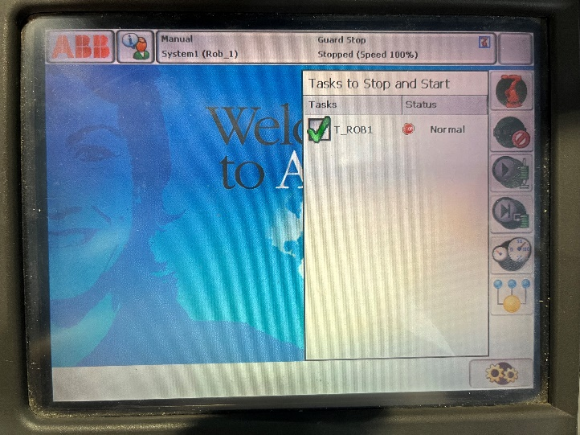
- Tasks to Stop and Start
The tasks panel will only show multiple tasks if the multitasking option is installed. Multitasking is not currently installed.

Section 4: ABB Menu
In the upper left is the red ABB menu. There are many operations that can be performed from the ABB menu.

- RobotWare Arc
RobotWare is the software used by the FlexPendant to communicate with the robot and outside computers. RobotWare Arc has a specific use for welding.
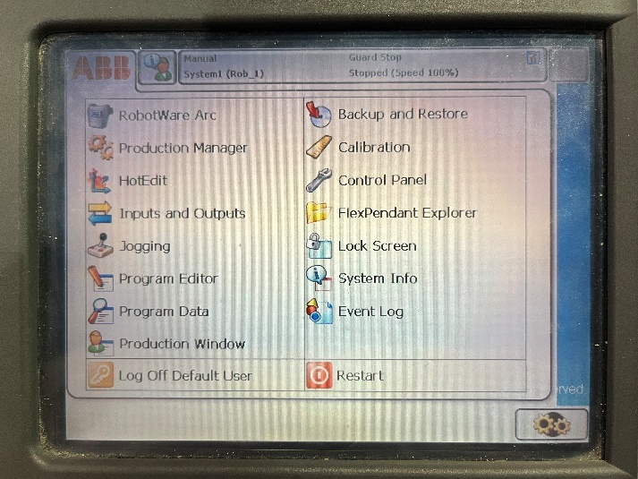
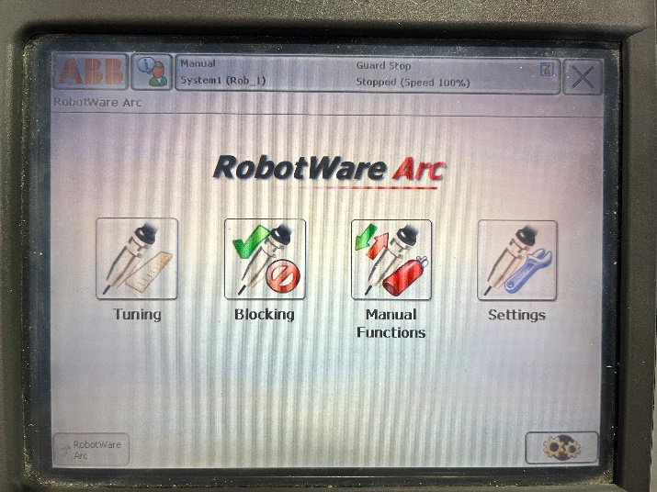
- Production Manager
Production Manager monitors and controls the production cycle.
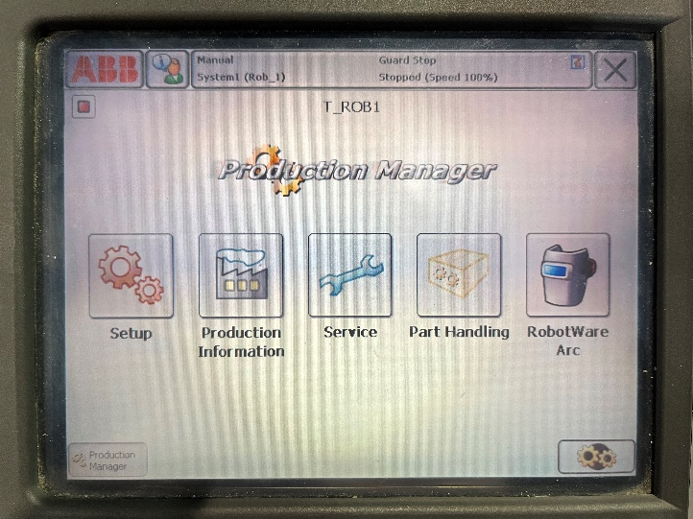

- HotEdit
HotEdit is used to tune program positions. Coordinates and orientations can be tuned. To tune a coordinate or orientation select the desired program and click tune targets. This will tune the position anywhere it is used in a program.
- In the bottom left File can be used to open a selection.
- In the bottom left, Baseline can be used to restore or commit a program.
- To add a tune to a position click Apply in the bottom right.
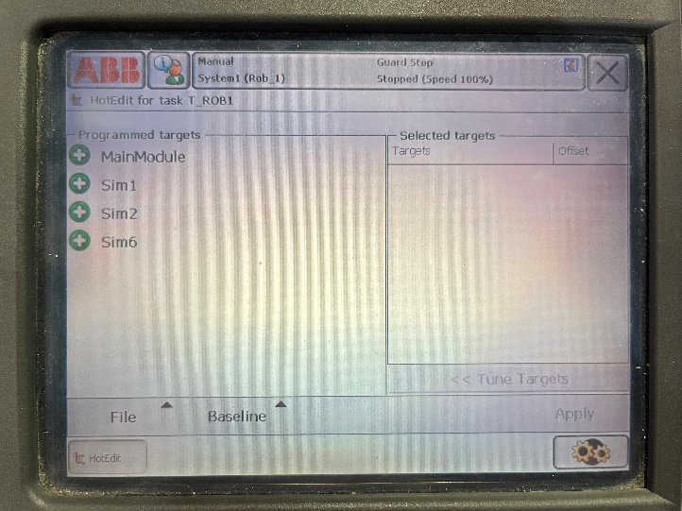
1
2
3

- Inputs and Outputs
Inputs and Outputs can be set up to connect to the compressed air flowing into the dark grey component box. This compressed air can be used to operate many tools that can be attached to the robot.
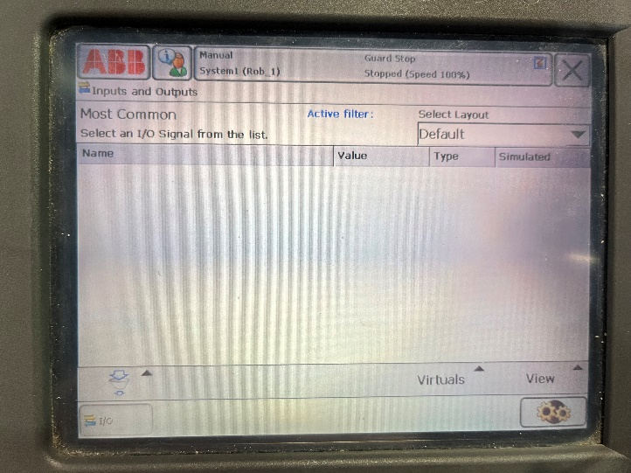
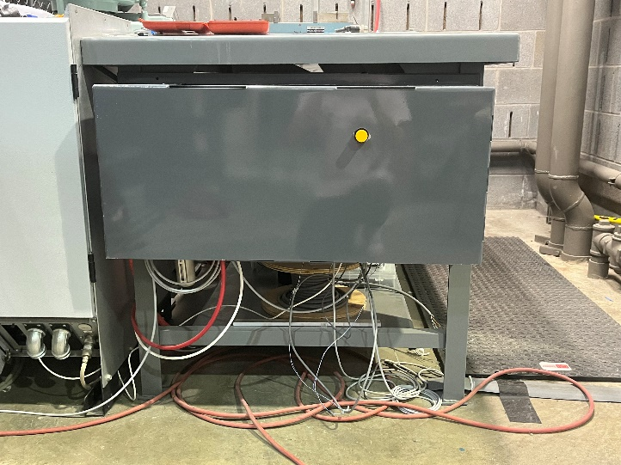

- Jogging
Jogging means moving/operating the robot arm. Elements that affect jogging can be changed here. Make sure to click OK to activate a change.
- Mechanical unit is the robot selected. Default: ROB_1
- Absolute accuracy. Default: OFF
- Motion mode is the way the robot will move, easier to change through the quickset menu. See Instructions 3a for information about motion mode in the quickset menu.
- Coordinate system is set to the X, Y, and Z system written on the table of the robot arm.
- Tool is a label to distinguish the tool attached to the robot and should alight with the tool chosen in the program. Can also be changed through the quickset menu. See Operation 6b for information about Octopuz. See Instructions 3a for information about tool in the quickset menu.
- Work object is a label to distinguish the object chosen to work on with the robot and should alight with the work object chosen in the program. Can also be changed through the quickset menu. See Operation 6b for information about Octopuz. See Instructions 3a for information about tool in the quickset menu.
- Payload is the weight a robot can carry. Here new payloads can be added and named to identify what is being carried.
- Joystick lock can lock one of the ranges of motion of the joystick.
- Increment is the increment amount the robot will jog at, easier to change through the quickset menu. See Instructions 3b for information about incrementing from the quickset menu.
Jogging shows the current position as well as the directions the joystick can move in the two boxes on the right side.
- Align, in the bottom left-hand corner, can be used to align to a certain coordinate system.
- Go To on the bottom of the screen can move the robot to a certain location.
- Activate on the bottom of the screen will activate a robot/mechanical unit.
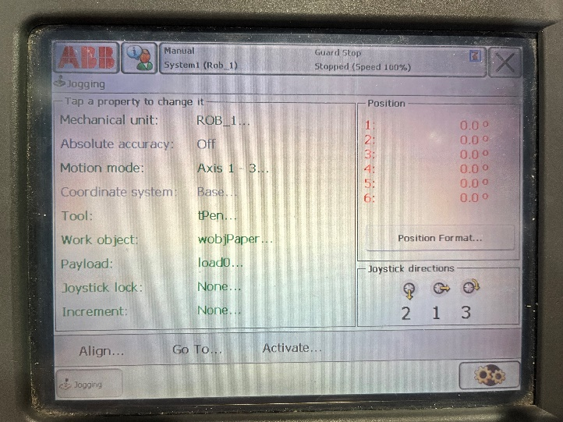
1
2
3
1-9

- Program Editor
Program Editor is where you upload, edit, or run programs. To add a program, see section Operation 6c. To run a program, see section Operation 6d.
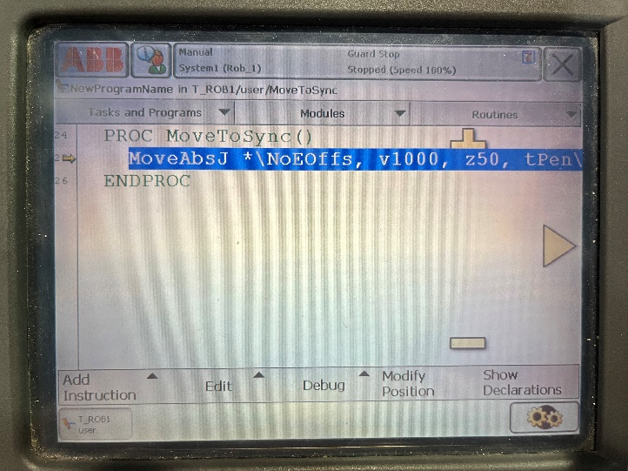

- Program Data
Program Data allows program data types to be seen and worked with. Click on the data type desired then click Show Data. The data type can then be viewed and edited. To go back to the data type selection click View Data Types in the bottom right-hand corner.
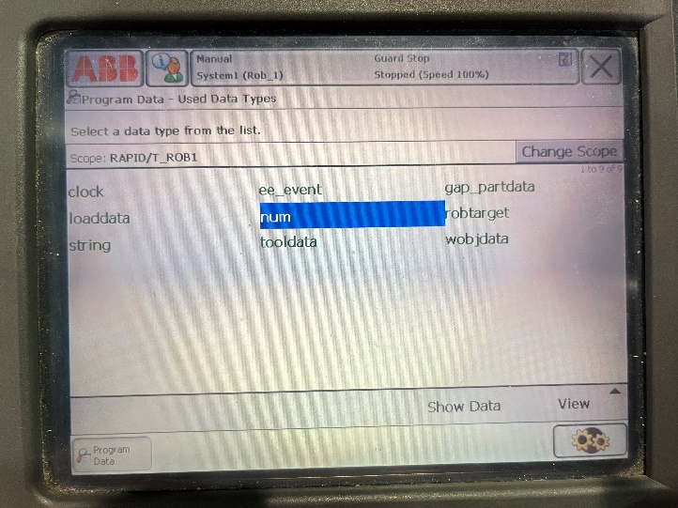

- Production Window
Production Window can be used to view the working program. Programs should be edited and run in the program editor instead of the production window due to having more control of the program and the debugging process.
- Load program will load a new program.
- PP to main moves the pointer to the main.
- Debug can be used to interact with the program.
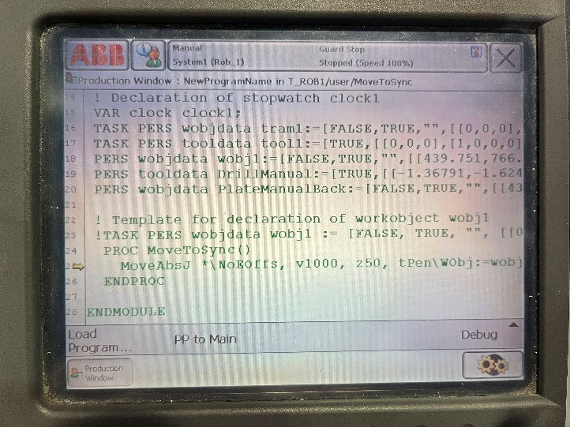
1
2
3

- Backup and Restore
Backup and Restore can be used to back up or restore a system.
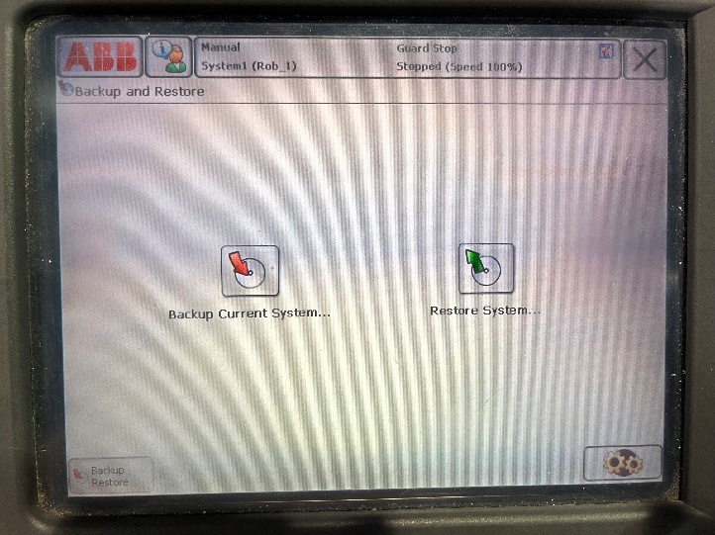

- Calibration
Calibration is used to calibrate a robot and to synchronize the robot coordinate system with the coordinate system of the world so the robot may start up. To see more about starting up or shutting down the robot see Operation 1a, 1b, and 1c.
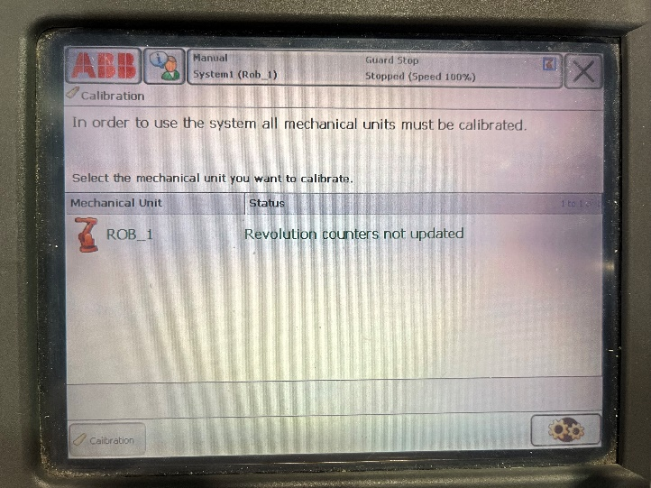

- Control Panel
Control Panel has many options.
- Appearances change brightness and contrast.
- Supervision allows for path and jog sensitivity to be supervised and changed. It also allows for non-motion execution to be turned on.
- I/O allows for the configuration of common inputs and outputs. See Instructions 4d for more information about input and outputs.
- Language changes the FlexPendant language.
- ProgKeys allows the upper blue buttons on the FlexPendant to be configured to certain actions. For more about programming the buttons see Instructions 5.
- Date and time allow the time and date to be changed.
- Touch screen allows the FlexPendant screen to be recalibrated.
- FlexPendant allows for the FlexPendant operating mode options to be changed.
- Configuration allows the system’s parameters to be viewed and changed. In the bottom left, file can be used to save or load parameters. In the bottom left, topic can be used to view other parameter types.
- Diagnosis creates a diagnosis file which can be useful in troubleshooting a program.
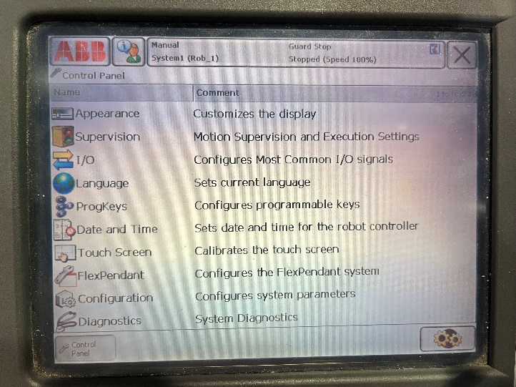
1-10

- FlexPendant Explorer
FlexPendant Explorer is a file manager.
- Files can be deleted, renamed, or moved using the menu option in the bottom left.
- The file with a red star creates a new folder.
- The folder with a green arrow moves a file to a different location.
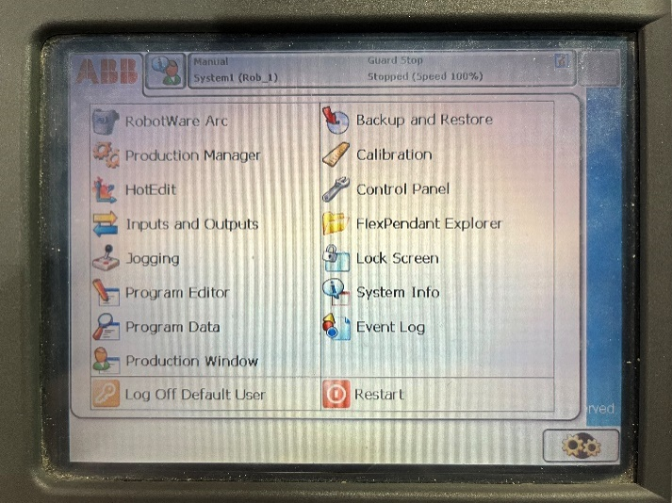
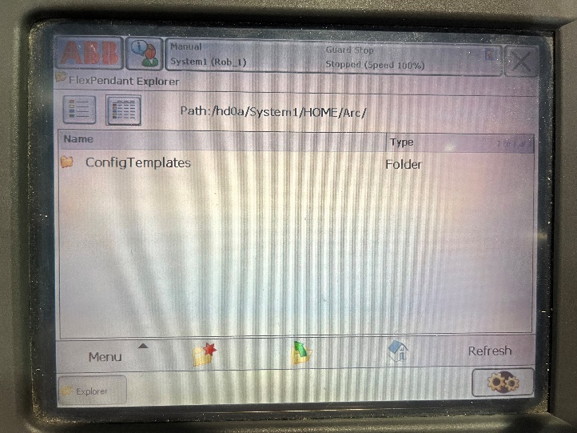
3
2
1

- Lock Screen
Lock Screen will lock the screen and prevent touch from activating it. This feature is mainly used for cleaning the screen.
- Click the Lock button to lock the screen.
- To unlock the screen, click the First to Tap button.
- Next click the Second to Tap button.
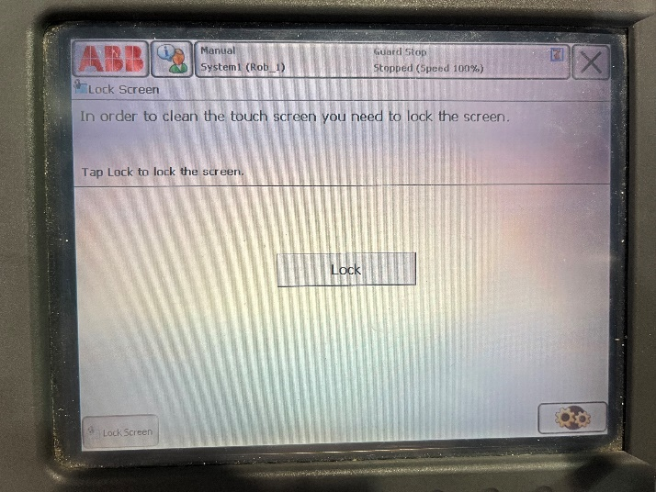
1
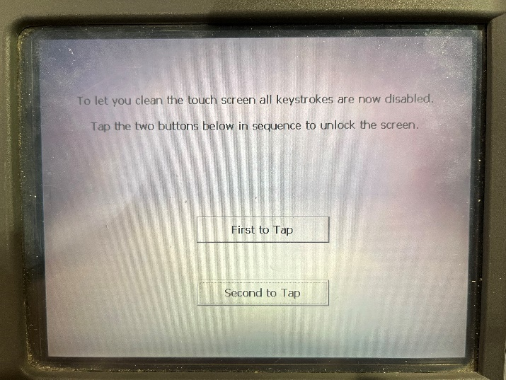
3
2

- System Info
System Info shows info about the controller and loaded system. Information about names of the controller, service port and local area network properties, installed system, currently used systems, name, and key of the control module, installed RobotWare options and languages, name and key of driver module, and additional installations by clicking on the green plus icons next to the words in the bot on the left.
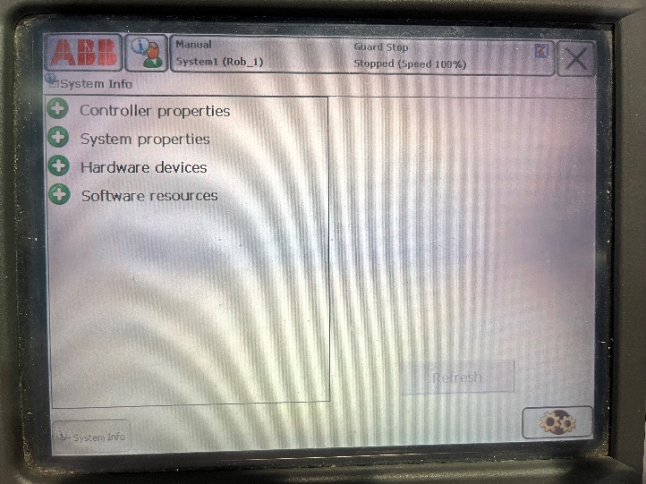

- Event Log
Event Log will redirect to the status menu. This area shows the messages of the robot’s state. Any error message will appear here and if not acknowledged will prevent the robot from moving. See Operation 8a about clearing acknowledgments. The status menu is easier to access from the main screen. To see more info about the status menu, see Instructions 1.
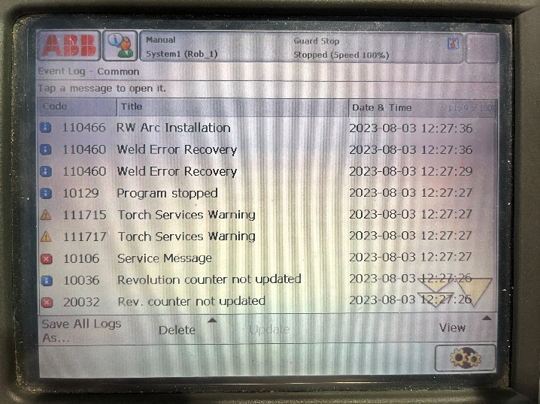

- Log Off Default User
Log off is used to switch to a different user.
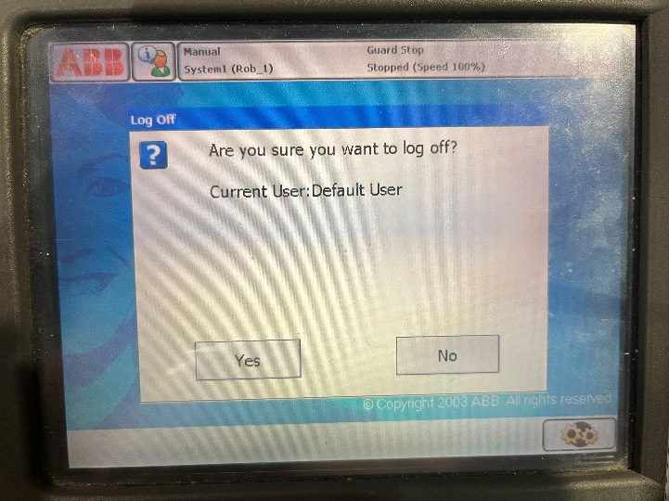

- Restart
Restart is used to reset the robot. The robot should not be restarted to shut down. To see information about the proper way to shut down the robot see Operation 1a, 1b, and 1c.
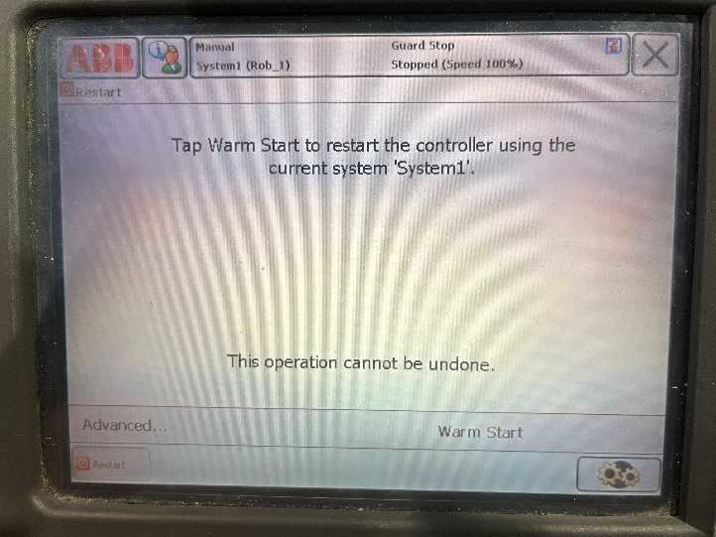

- Exit a Menu
The current ABB menu can be exited at any time using the X in the upper right hand corner.

Section 5: FlexPendant External buttons
The buttons on the external of the Flex pendant fall into 2 categories.

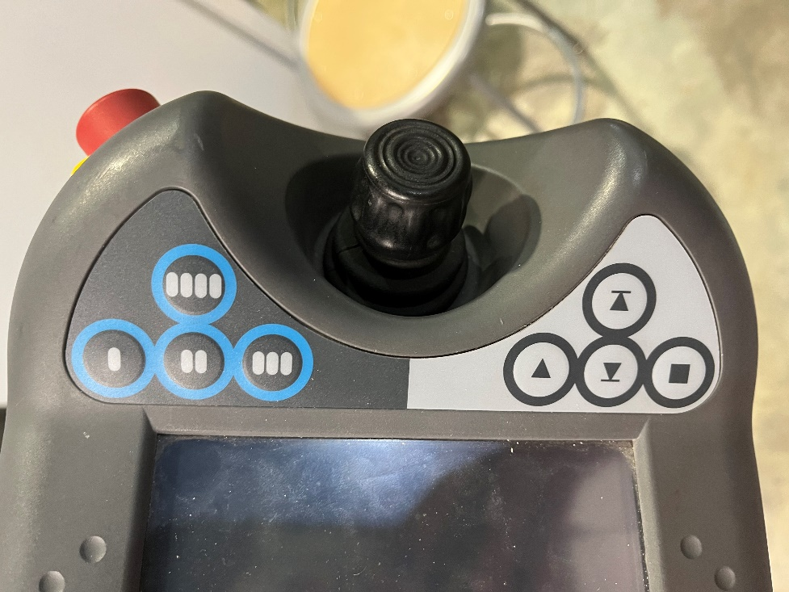
The blue buttons on the top are user programmable. To program the buttons, find the ProgKeys section in the FlexPendant under the control panel. See Instructions 4k for the location of ProgKeys. In ProgKeys choose to set the button as an input, output, or system. Then select the way the button will respond and decide if the auto should be on or off. For the output or system option, there are 5 additional options. Toggle switches the signal from 0 to 1 or vice versa. Set to 1 will set the button press to 1. Set to 0 will set the button press to 0. Press/release will set the value to 1 while pressed and 0 when released. Finally, pulse will set the value to pulse once.

The buttons silver/grey buttons on the bottom are used to execute programs. The top grey button is the play. The bottom is the stop. The middle left is a step backward, which goes one step back in the program. Finally, the middle right is step forward, which goes one step forward in the program.

Operation
Section 1: Start Up and Shut Down
- Start up Instructions:
- To turn the light curtain and the robot on turn the top red switch on the ABB computer components box to the vertical position labeled ON. The box is light grey, and the switch is red and labeled the main switch. The machine should let out a buzzing noise and the light curtain should activate. For more information about the light curtain see Instructions 2a.
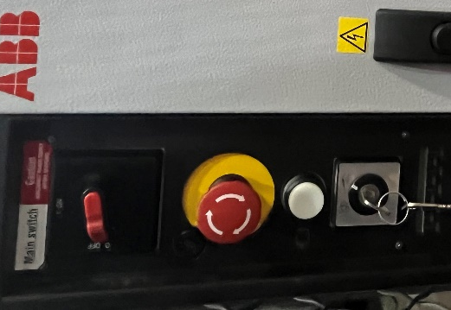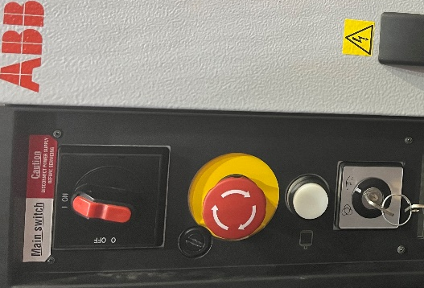
On Position
Off Position
- Next, take up the teach FlexPendant and secure it on your arm. The FlexPendant should rest on your inner forearm with your hand around the part of the controller that sticks out. Thumbs should stick up to secure the robot while the rest of your fingers rest on the dark grey semicircle.
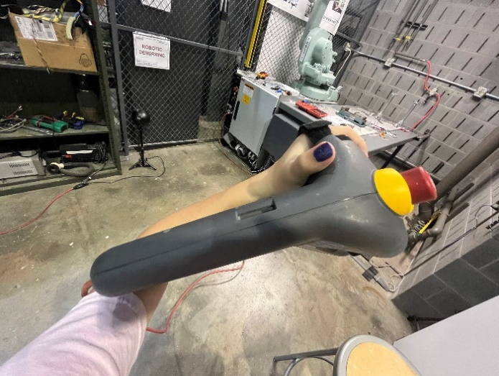
- Wait a moment for the FlexPendant to turn on.
- When the FlexPendant gets to the Event Message/Service message click on Acknowledge in the bottom right-hand corner. The event message wording doesn’t need to match the wording in the example picture below.
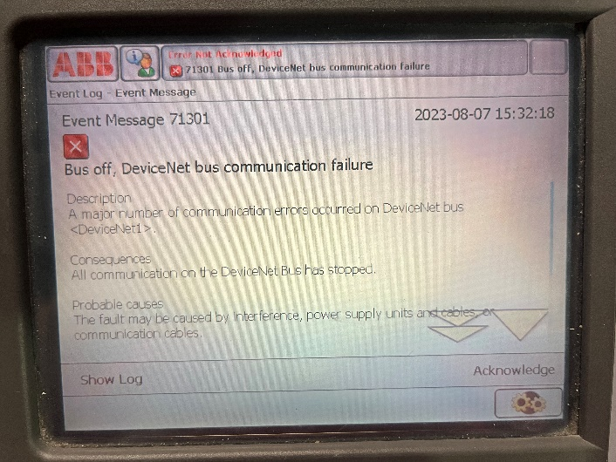
- Go to the ABB section, upper left, and in there go to calibrate. To find more information about the ABB selection see section Instructions 4.
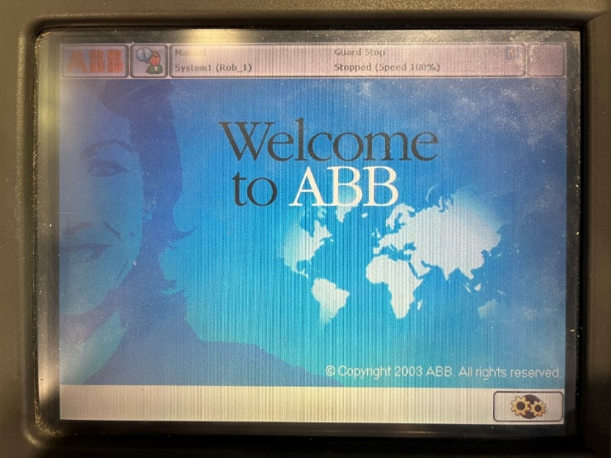
- Go to revolutions not updated and click on the words.

- Select the circle next to the update revolution counter then click Yes proceed.
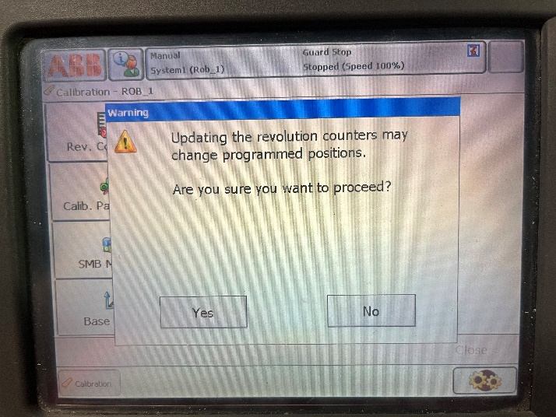
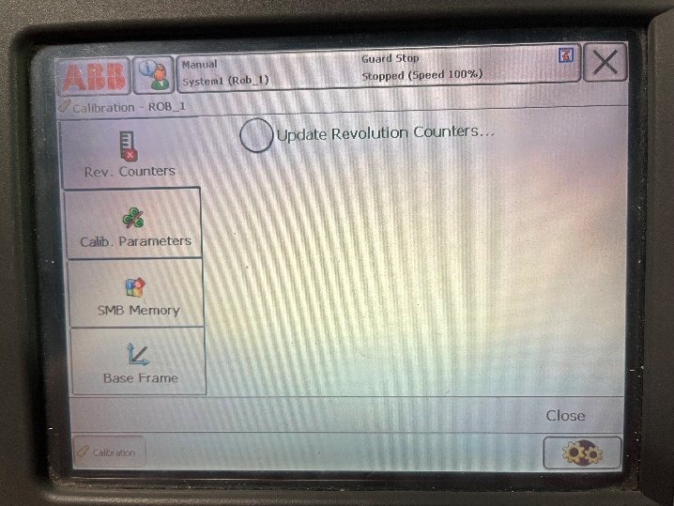
- Select robot 1 by clicking so there is a green checkmark next to rob1 then click OK in the bottom right corner.
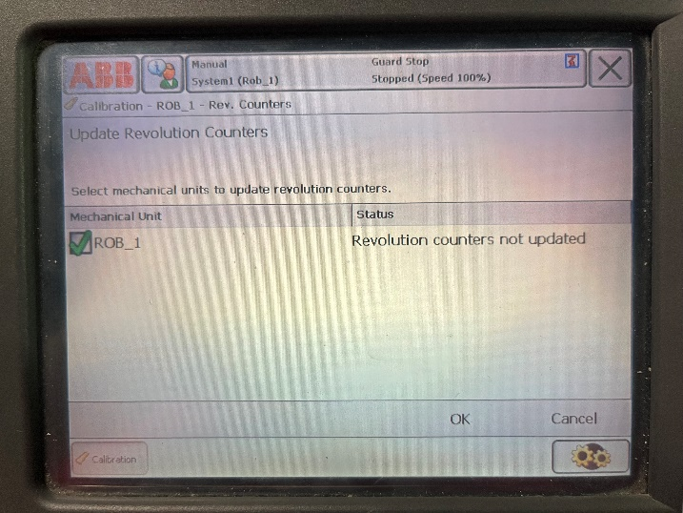
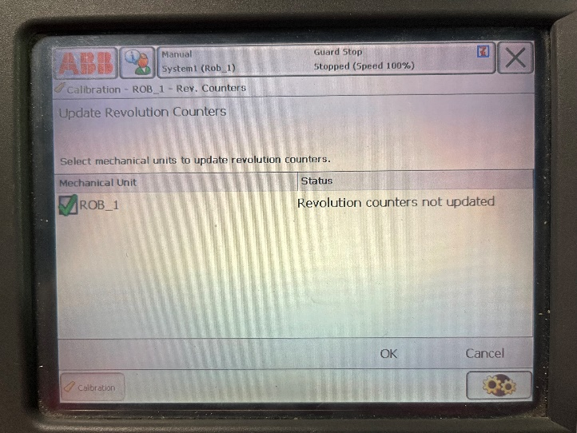
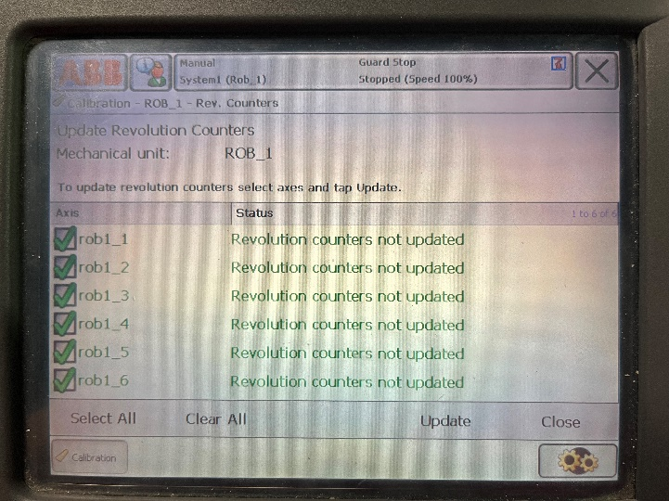
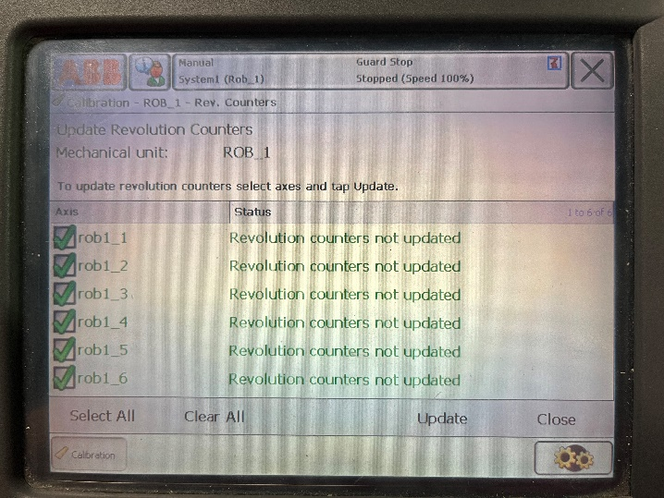
- Select all axis by clicking so there is a green checkmark next to rob1_1 to rob1_6. Click update in the lower right-hand corner.
- Click Update then wait for the Revolution counter update finished successfully message to pop up to click OK.
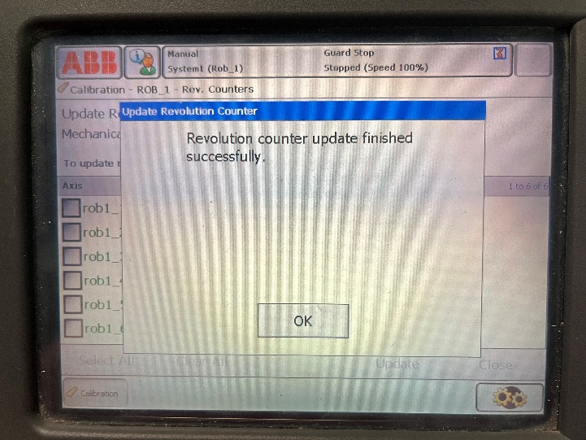
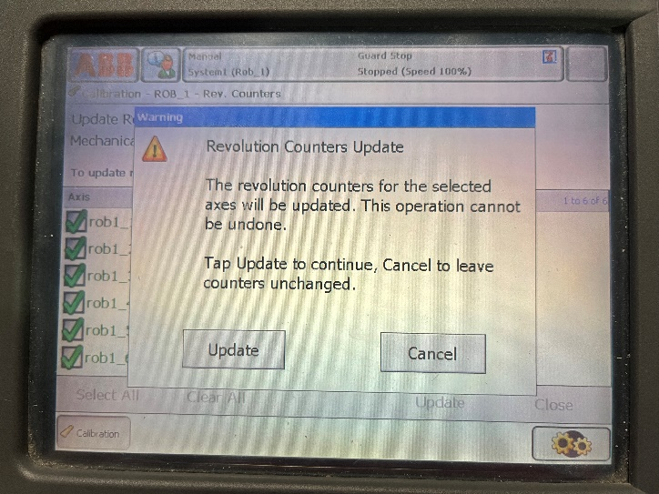
- Close out of that window with the big X in the top right.
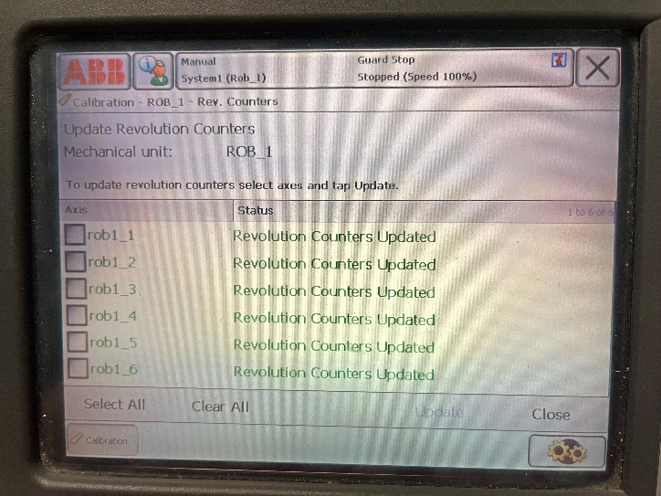
- To move the robot arm out of the light curtain initially holds down the yellow button on the dark grey component box for steps 13-14. This allows the robot to move out of the light curtain and will need to be held down until the robot is out of the light curtain. For more information about the light curtain see section Instructions 2a.
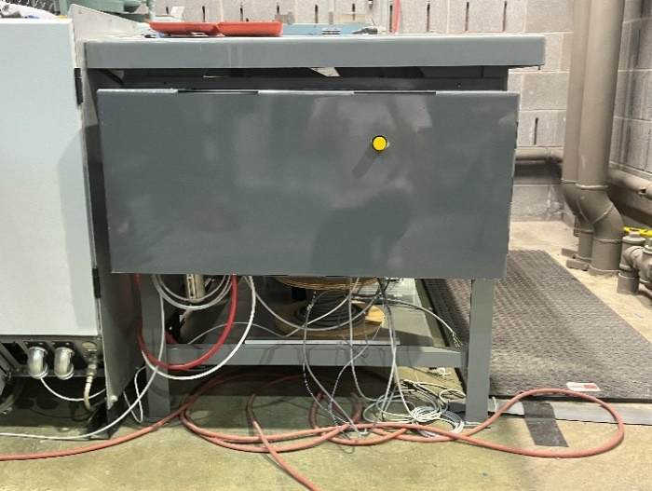

- To move the robot arm, hold down the dark grey semicircle on the FlexPendant to the first stop position and you hear the first click. If you hold down too hard the FlexPendant will move to the second position, make a second click. In the second position, the robot will not operate so release and retry for the first position. The second position is a dead man switch. See Instructions 3b for more information about the dead man switch.
- The robot can then be moved using the joystick in 3 ways. The robot can move in the incorrect direction so BE CAREFUL and do small movements initially. The joystick can move right/left, up/down, or the top black part of the joystick can be twisted clockwise or counterclockwise. Depending on which mode you are in depends on which way the robot will move. To change modes, see instructions 3a. One the robot is out of the way of the light screen the yellow button can be released.

- Shut down Instructions:
- To shut down, a preset program will be run which will move the robot to its shutdown position. The shutdown position is zero on all axes and will be blocking the light screen. This is to prevent incorrect startup and operation of the robot.
- In the ABB menu go to the program editor. To learn more about the program editor see Instructions 4f for more info about the program editor.
- Click on modules on the top in the middle.
- Select MainModule then Show Module in the bottom right.
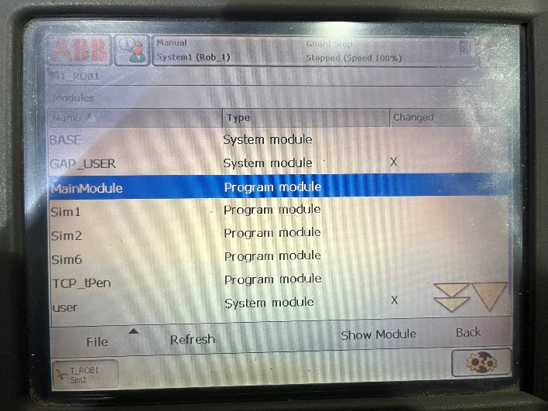
- Click on Debug in the bottom right-hand corner then in the box on the right select PP to routine.
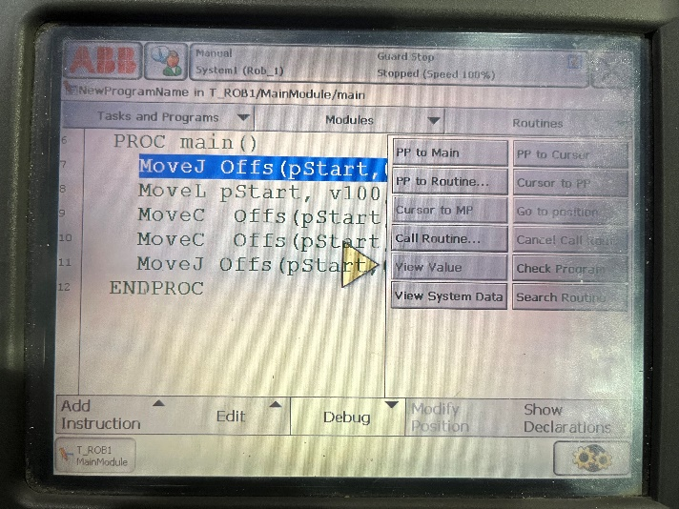
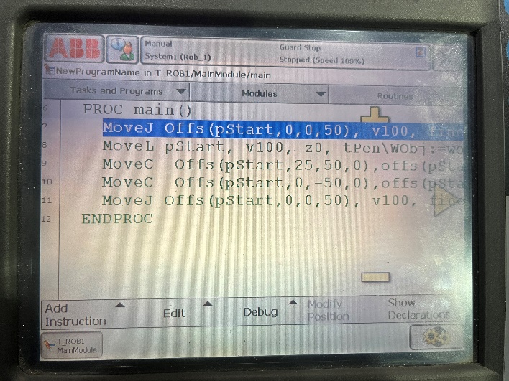
- Select MoveToSync and click OK.
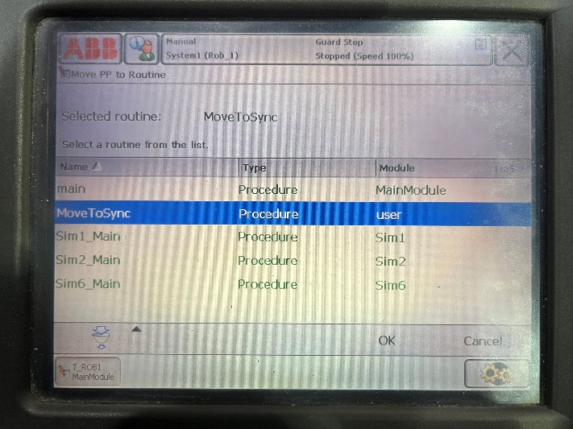
- Hold down the yellow button on the dark grey component box for the entirety of step 8.
- On the FlexPendant click the dark grey semicircle down to the first stop then click the silver external play button. To learn more about the FlexPendant external buttons see Instructions 5.
- Now release the yellow button and click Acknowledge on the event message in the bottom right hand corner.
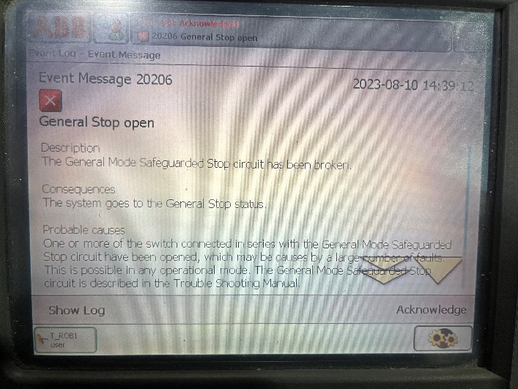
- Finally don’t exit out of the screen just disconnect the battery, instructions below.

- Disconnecting the Battery:
- After running the shutdown program the FlexPendant should be in the same MoveToSync program file, if not return to the MoveToSync file using the same instructions for shutting down, instructions above.
- Once again click on Debug in the bottom and click Call Routine, in the same box as PP to Routine.
- Click on Bat Shutdown and then click Go To on the bottom right.
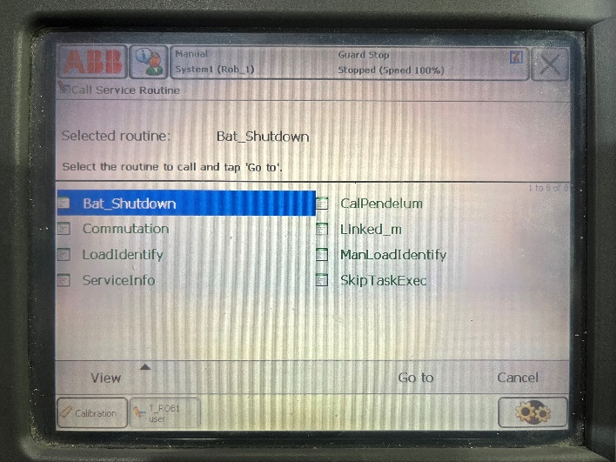
- In the bottom of the box to the right will say to execute the service routine, press the Start button.
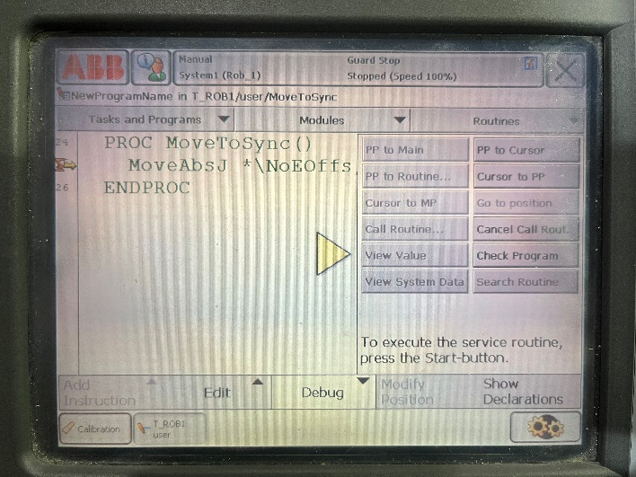
- Hold down the yellow button down for steps 6-8.
- On the FlexPendant click the dark grey semicircle down to the first stop then click the silver external play button. To learn more about the FlexPendant external buttons see Instructions 5.
- A screen will appear that says ABB Robotics, Battery transport shutdown, Service program. In the bottom left click shutdown.
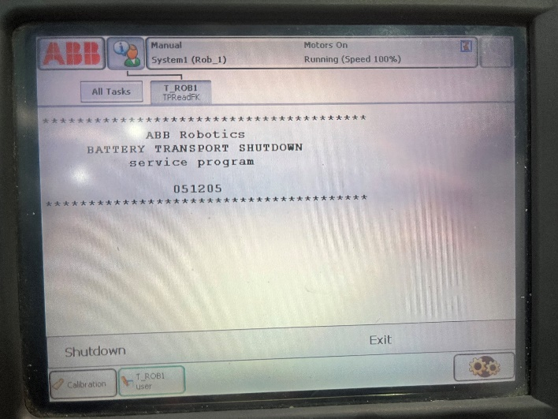
- Now release the yellow button and click Acknowledge on the event message in the bottom right hand corner.
- Turn the red main lever on the light grey computer components box to the horizontal position labeled OFF.

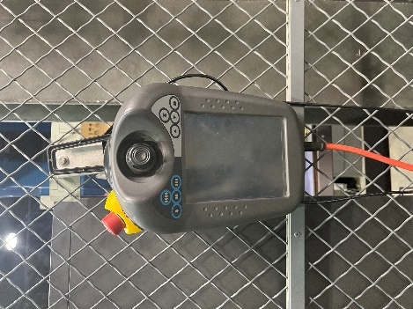
- Then hand the FlexPendant on the hook on the chain fence near the root alcove.

- Finally, shut off the light on the wall near the robot alcove.
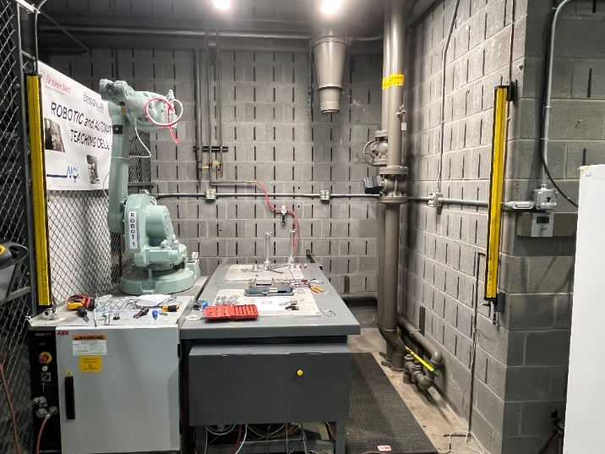

Section 2: Types of Motion and Coordinate Systems
- Axis
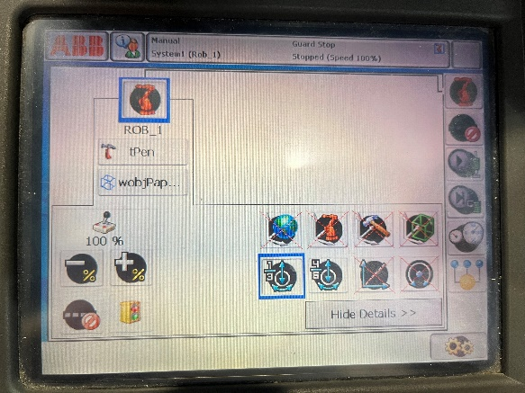
There are 6 axes of rotation on the robot arm. It is much like a human arm with 3 degrees of freedom on the larger bicep-like part in the X, Y, and Z axis and 3 degrees of freedom on the smaller forearm/writs section of the robot in the X, Y, and Z axis. Axes 1-3 refer to the axes on the large biceps and axes 4-6 refer to the axes on the smaller forearms.

- Linear
Linear motion will move the tip of the robot arm from one point to another. It will use any combination of X, Y, and Z axis motion that gets from one point to another.

- Reorient
Reorient motion will lock one point into place and move the rest of the robot. Default the fixed point is the tip of the robot arm.

- World Coordinate System
World coordinate system will set the coordinate system origin that all movements are based on to the world origin. The coordinate systems can only be accessed in linear or in reorient mode not in either of the axis modes.

- Base Coordinate System
Base coordinate system will set the coordinate system origin that all movements are based on to the base origin. The coordinate systems can only be accessed in linear or in reorient mode not in either of the axis modes.

- Tool Coordinate System
Tool coordinate system will set the coordinate system origin that all movements are based on to the tool origin. The coordinate systems can only be accessed in linear or in reorient mode not in either of the axis modes.

- Work Object Coordinate System
Work object coordinate system will set the coordinate system origin that all movements are based on to the work object origin. The coordinate systems can only be accessed in linear or in reorient mode not in either of the axis modes.
Section 3: Modes
- Manual
Manual mode is when the user uses the FlexPendant to control the movement of the robot. Manual mode uses the joystick.

- Automatic
Automatic mode is activated when the robot jogs based on a previously created program. Automatic mode uses the external buttons and program tabs of the ABB menu. To see more information about the external buttons, see Instructions 5. To see more information about the program tabs of the ABB menu see Instructions 4f and 4g.
When a program is created sometimes a path is impossible for the robot to follow. The robot arm can be taken out of automatic mode and put into manual mode to try and maneuver the robot into a better position to complete the rest of the program in automatic mode at any time using the external buttons. To see more information about stopping and starting a program see Operation 4e and 4f.

Section 4: Software and Programs
- RobotStudio
RobotStudio is the ABB company specific program used to work with ABB products. Octopuz is another program, however, Octopuz works more generally with robots across the market. To see more about Octopuz see Operation 4b. To gain access to ABB RobotStudio a student must obtain permission from Sam Chiappone (chiaps@rpi.edu) and agrees to the ABB RobotStudio License Agreement. Then use RPI’s IT service download instructions to gain access to RobotStudio. RobotStudio is for long programs, while the FlexPendant is for changing the path of the program. RAPID is the coding language both ABB RobotStudio and Octopuz are in.
Once RobotStudio is downloaded add IRC 5 as the RobotWare type. To do this go to Add On in the upper tabs then select RobotWare for IRC 5 from the available list. RobotWare for IRC 5 may be further down in the list. Then in the upper right-hand corner make sure it is the most recent version and click the add button. Accept the license agreement. RobotWare is the software that runs the robot, it can also be used in RobotStudio for simulations.
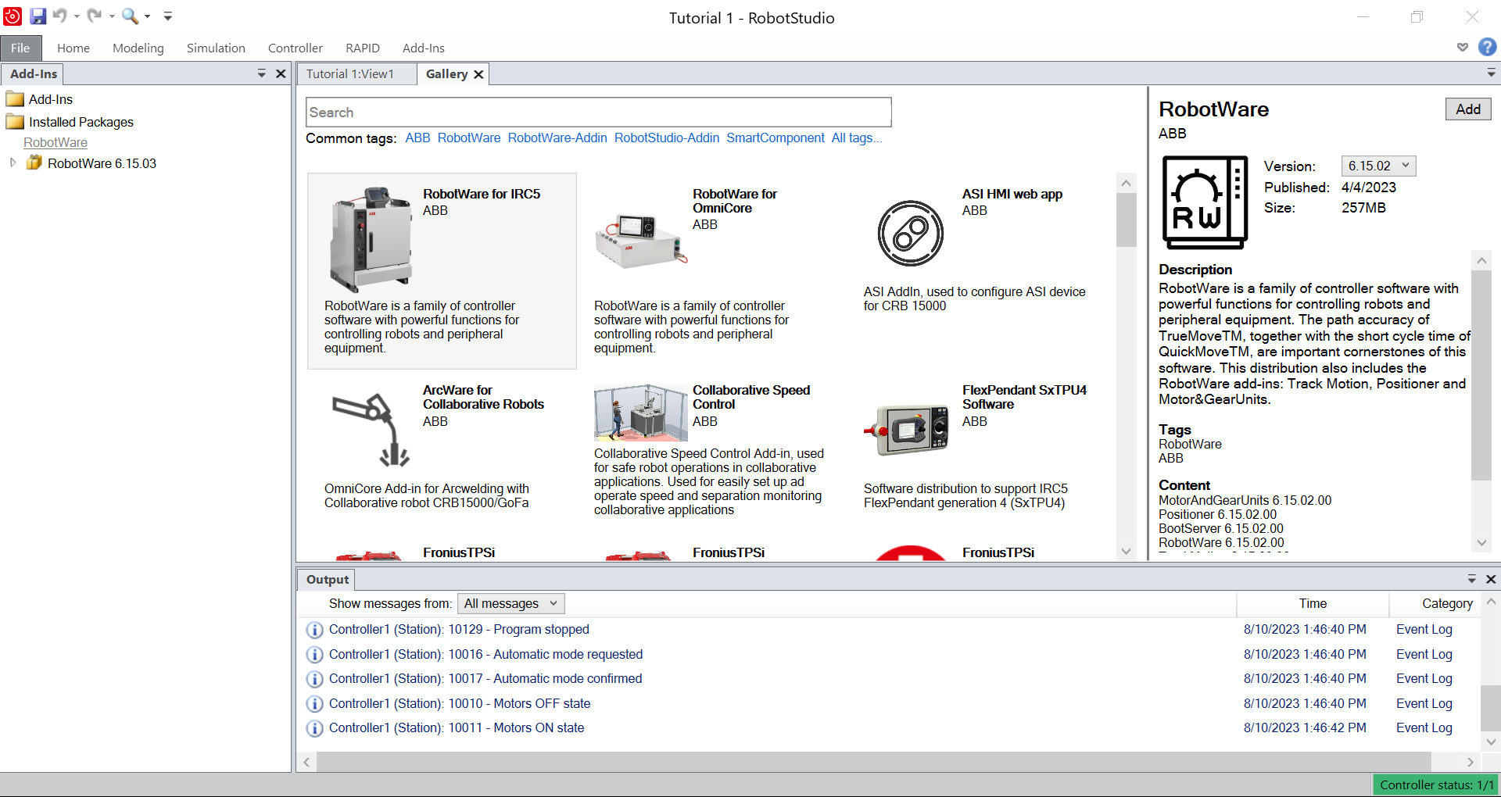

It is recommended to watch the first 5 beginner tutorials from the ABB playlist.
Tutorials from ABB: https://new.abb.com/products/robotics/robotstudio/tutorials
Tutorial 1: How to make a new file and save, select a robot, pan, rotate, and zoom.
Tutorial 2: How to open a file, create a system, and run a jogging simulation in different types of motion with quick select icons and modify.
- To see more about the types of motion see Operation 2.
Tutorial 3: How to import equipment, attach equipment to the robot, create a path, and execute path instructions.
Tutorial 4: How to delete a path and a path’s targets, import and modify geometry, and save a station.
- Find the tutorial 4 files here https://forums.robotstudio.com/discussion/13184/getting-started-tutorial-4-objects
Tutorial 5: Create a work object, add targets, create a path along the targets, synchronize to rapid code, check the rapid code, and run the simulation.
- When auto-configuring autoconfigure to all move instructions

- Octopuz
Octopuz is a program that works with many robots across the market. To gain access to Octopuz a student must first get instructor approval. After getting approval, the student should gain access to the section of the Explorer File where the program and download instructions are stored. RAPID is the coding language both ABB RobotStudio and Octopuz are in. If any issues should be brought up to Jeff Morris, morrij5@rpi.edu, NOT OCTOPUZ SUPPORT.

It is recommended to watch the beginner tutorials from the Octopuz Academy website. A login and password are needed for Octopuz Academy which can be gotten from the instructor.
Tutorials from Octopuz https://octopuzvc.support.octopuz.com/hc/en-us/categories/4853525128205-Tutorials
Getting started tutorials:
- Notice that the tutorials start from bottom to top
Tutorial 1 Getting started: How to change views, move, scroll, find the E-catalog, interact using jogging, import geometry, delete and connect objects, hide components, import stuff from the robot, copy and modify paths, solve for troubleshooting path issues, collision detector, change the play of the simulation, and where to find the process, drawing, and modeling tabs.
Tutorial 2 Moving, snapping, and aligning components: How to add components, move objects, move the objects using the coordinates, move in reference to parent, world, and object, snap using one or multiple points, change the origin of an object, aligning an object with faces or edges
Tutorial 3 Exchanging Robots: How to transfer programs between robots.
- This is not applicable since the Deign lab only processes the ABB 1600, but the exchange will swap the position and the programming of the robot
Tutorial 4 Manual Programming: How to use PNP to connect objects, attach objects together, save a home state, use point-to-point to make a path, use binary outputs to change the state of an object, use path points to move between locations, and how to use a signal to connect robots and sensor
Tutorial 5 Components and Statement Variables: How to create an interface between objects, save a position, find robot parameters, see the variables of a weld, and how to output the code from a program.
The welding tab is not on the default settings. Instead of setting the position to an appropriate X, if the ABB 1600 is being used then recommended use 700 in the X. Then instead of the weld tab use the programming tab. When it wants to use the generate well use the create button then create a path and use the floor-wall setting. Finally press the play button to watch the simulation move along the path.
- Extra notes:
- All tutorials can be completed using the ABB 1600 1.45 robot instead of the tutorial robot, but dimension adjustments will need to be made.
- If ABB 1600 1.45 is used, then wobj1 is a good base to use.
- Reminder undo won’t delete a path, paths need to do that manually.
- One unit is equal to one real-life millimeter.
- Point-to-point, orange arrows, moves in 3D while using linear motion, blue arrows, moves in 1D.
- When creating a path need to account for any tool attached.
- Cloning will clone anything that is attached to an object.
- PnP stands for Plug and play.

- Transfer Programs
Transfer a Program to the robot arm:
- To expert code off Octopuz click on the Program panel in the upper section.
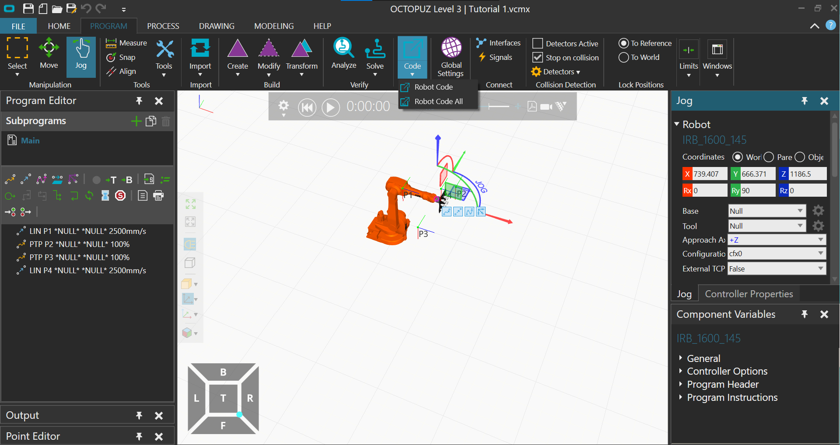
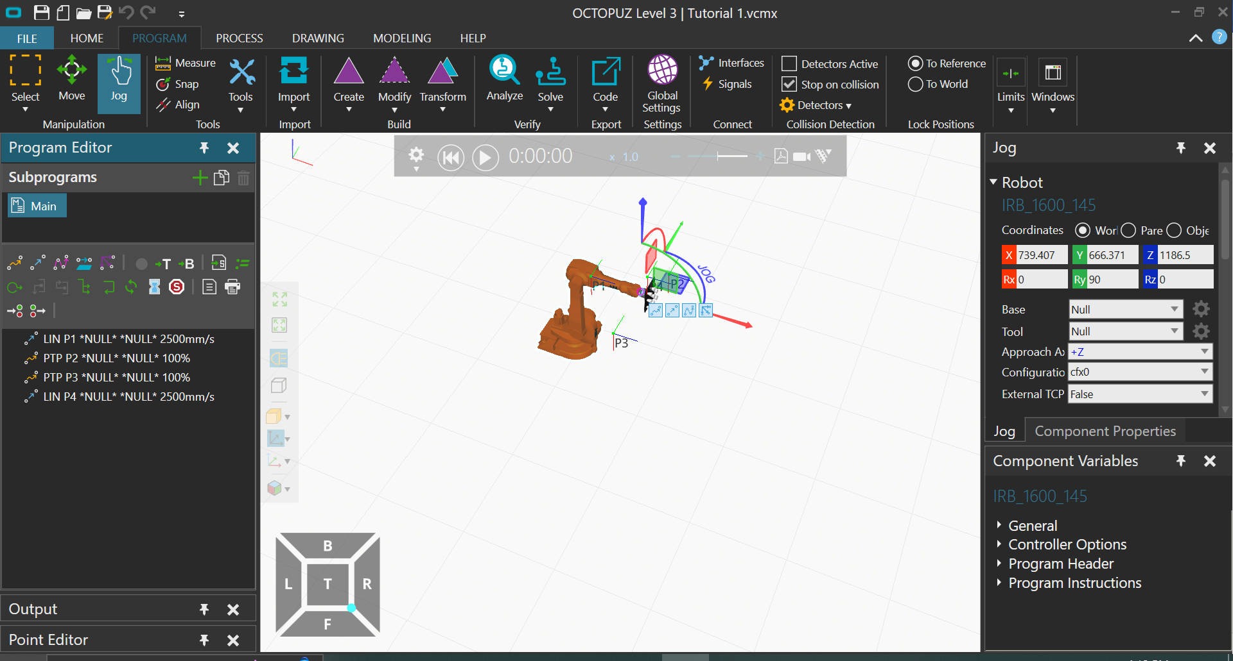
- In the export tab click code. Then click robot code.

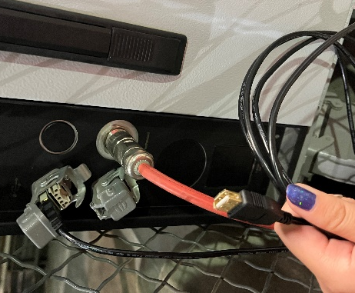
- Save the code to a flash drive.
- Unplug the flash drive and connect it to the black output cord connected to the light grey components box or directly into the light grey components box in the USB port covered by the black output cord. To learn more about the components on the light grey box see Instructions 2d.

- Then go to the FlexPendant.
- In the ABB menu go to the program editor. To learn more about the program editor see Instructions 4f.
- Click on Modules in the top middle. Click File on the bottom left. Click Load the Module.
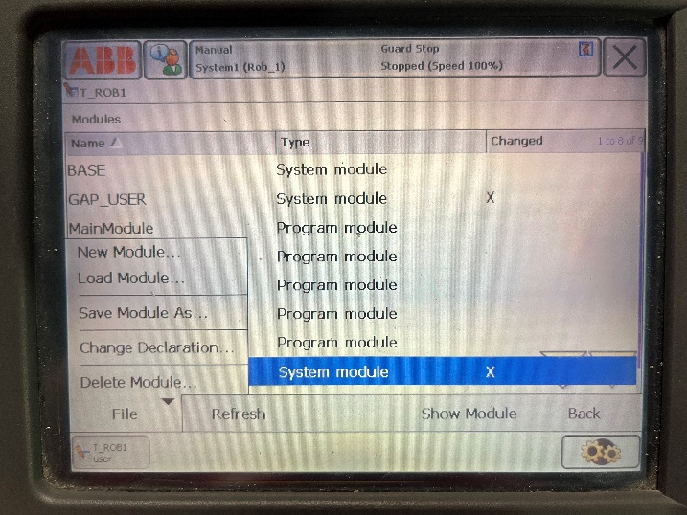
- Click yes to lose the program pointer.
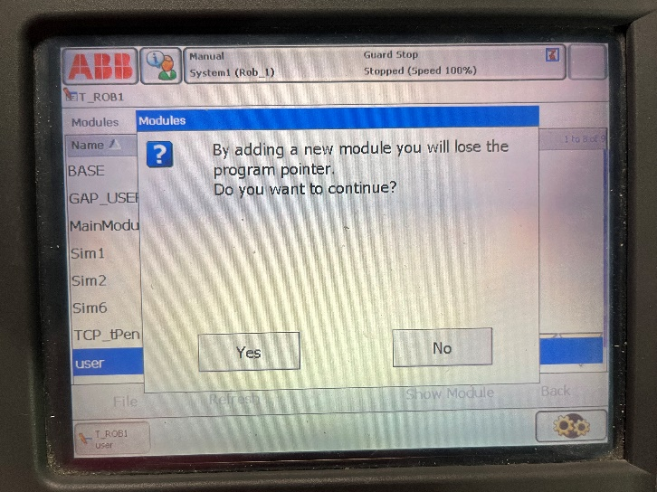
- Click on the file with the green arrow in the bottom left until the name of your flash drive becomes available. The type should be Removable. The name of the flash drive in the example is /bd0/.
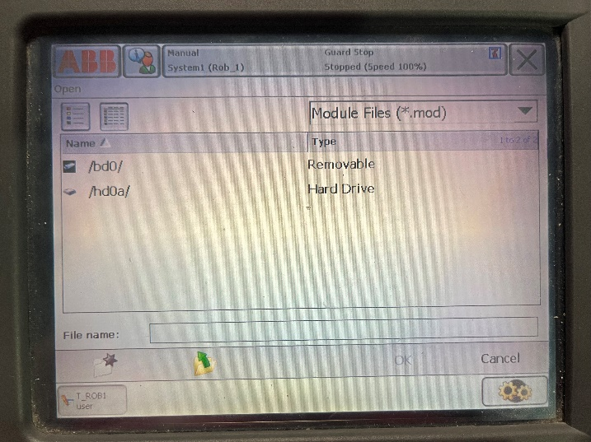
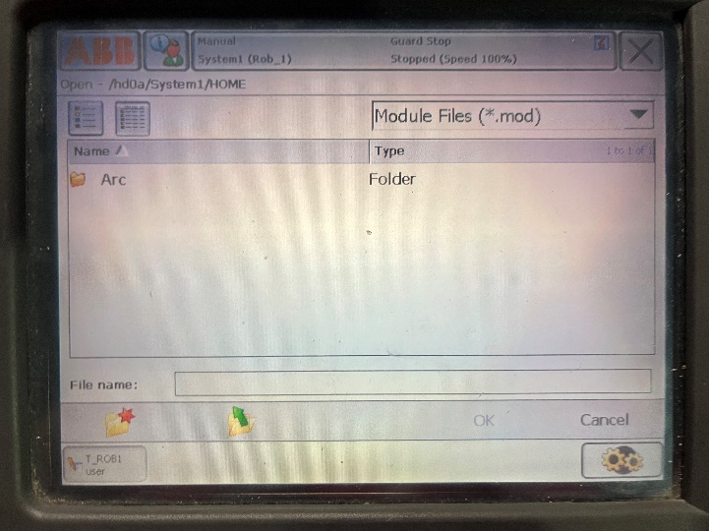
- Then click on the name of your flash drive and then click on the name of your file.
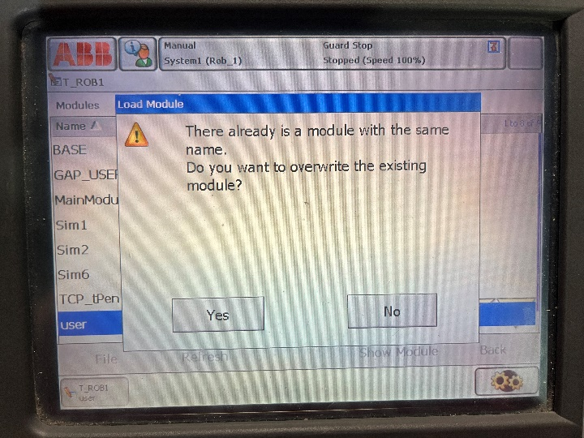
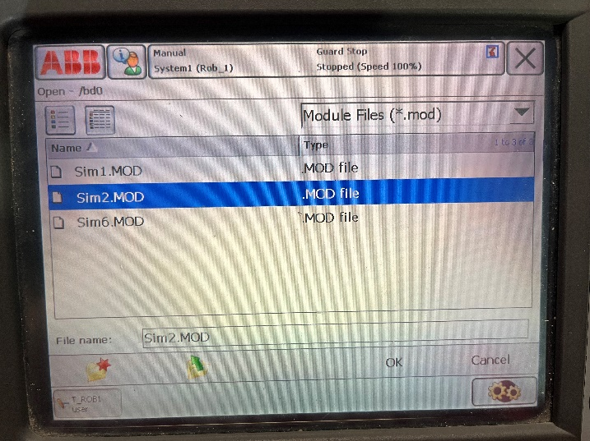
- Click OK in the bottom right hand corner. If you have previously added your file to the FlexPendant it will ask you if you want to override the file. If it won’t open there could be an issue with the code.
- Running programs
Running the program on the robot arm:
- If you have just uploaded the program skip to step 4.
- In the ABB menu go to the program editor. To learn more about the program editor see Instructions 4f.
- Click on Modules in the top middle.
- Click on the file name you want to run and click Show Module.
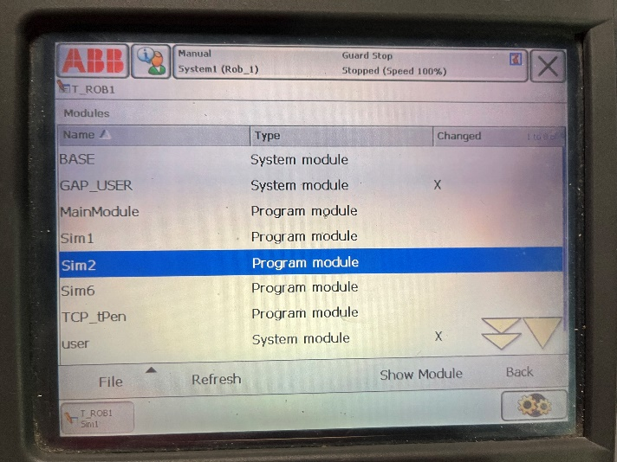
- Click debug in the bottom right. Then click PP to routine in the box to the right.
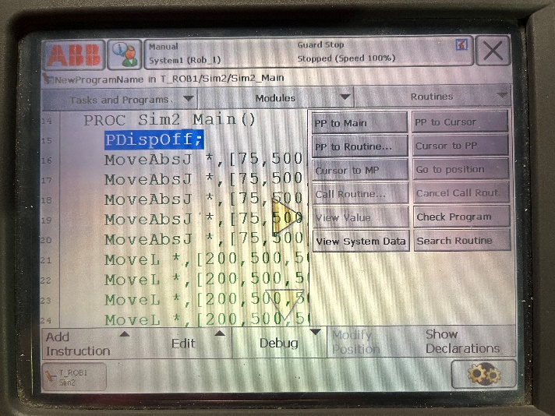
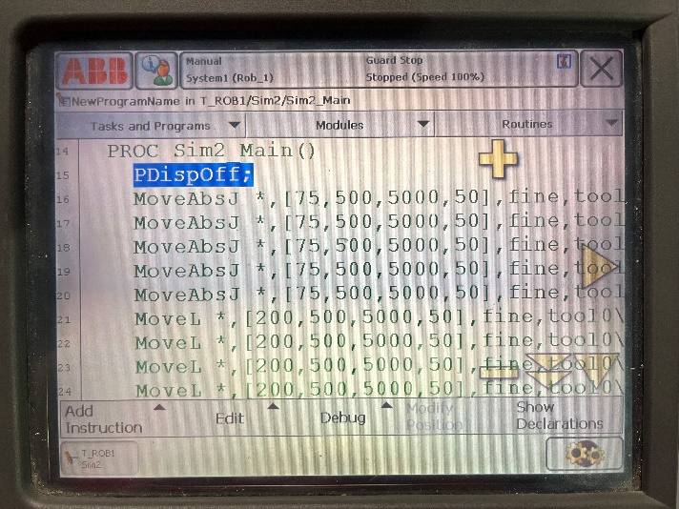
- Then select your program name and click OK. A little yellow arrow should appear to the left of the code showing where the code will start.
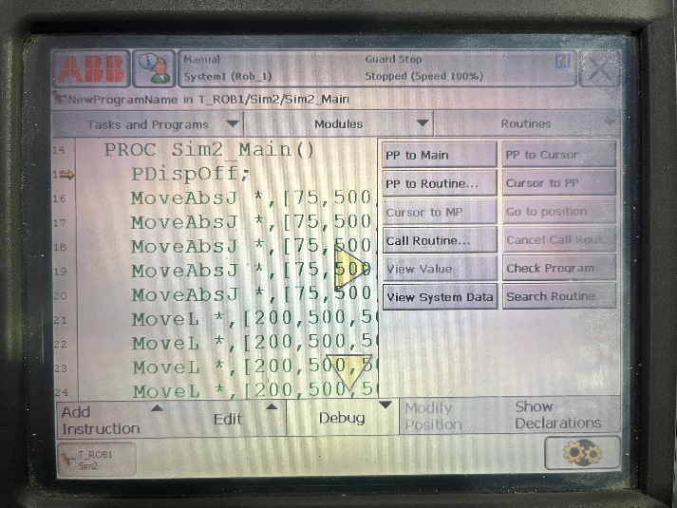
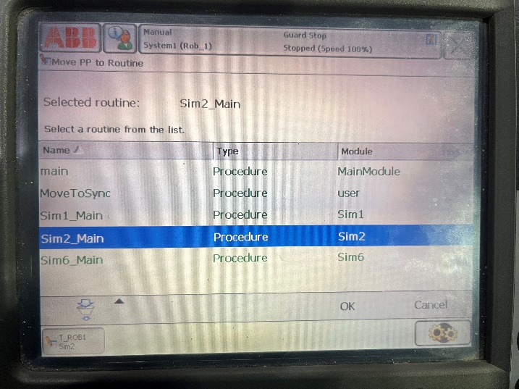
- Then on the FlexPendant hold down the dark semicircle and click the top play button of the silver/grey external buttons. See Instructions 5 to find out more about the external buttons.

- Stopping Program
To stop a program while it is running either activate a dead man switch or click the stop sliver external button on the FlexPendant. To learn more about the dead man switches see Instructions 2c. To learn more about the external buttons editor see Instructions 5.
- Restarting Program
To restart a program after a stop depends on what was used to stop the program.
If the stop sliver external button on the FlexPendant has been clicked, then click the play silver on the FlexPendant to continue the program. To learn more about the external buttons editor see Instructions 5.

If a dead man switch has been used to stop the program.
- First unclick the dead man switch by twisting the knob clockwise. To learn more about the dead man switches see Instructions 2c.
Clockwise
Clockwise
- Next, accept the acknowledgment in the status menu at the top of the screen. Click on the event that needs acknowledgment, most likely the top message with a red X mark box next to it. Open the vent and click Acknowledge int eh bottom right hand corner. To learn more about accepting the acknowledgment see Operations 6a.
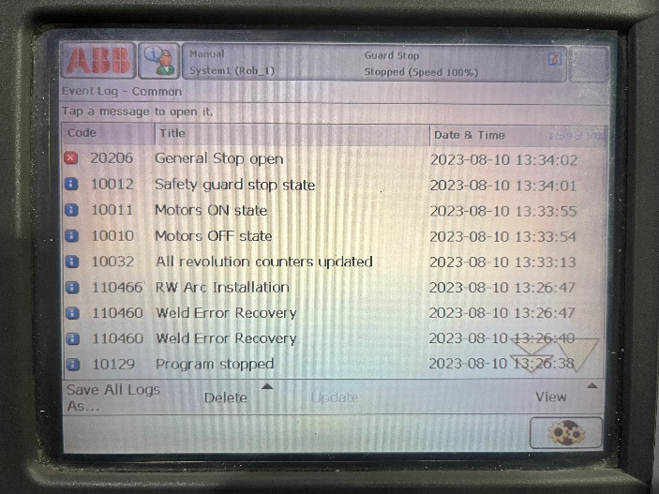
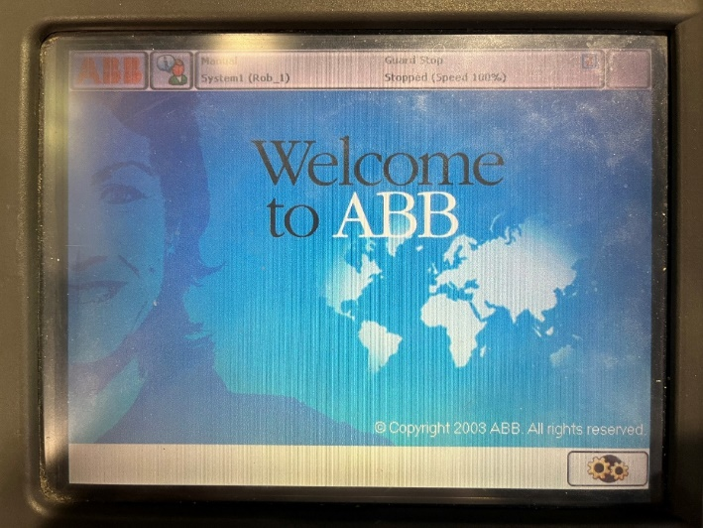
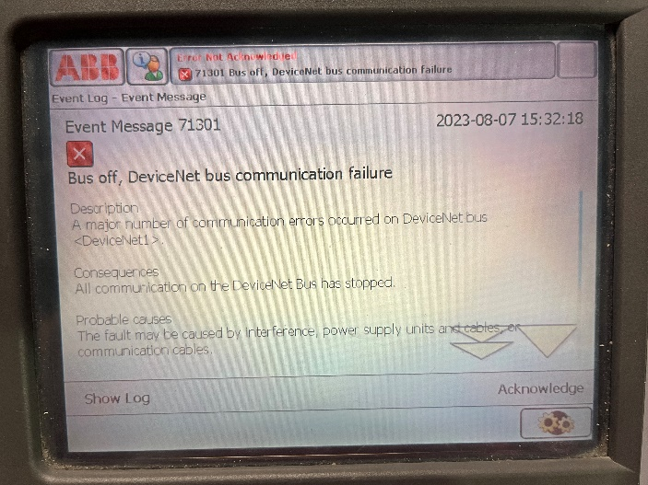
- Next, click the white button on the light grey components box to restart the motors. To learn more about the computer components buttons see Instructions 2d.

- Now, the dark grey semicircle can be pressed down to the first stop again and the silver play button on the FlexPendant can be clicked to start the program from where it left off. To learn more about the external buttons editor see Instructions 5.

Section 5: Inputs and Outputs

Section 6: Troubleshooting
- Acknowledgment Events
Acknowledgment events occur when the robot encounters an error and must be acknowledged for the robot to move. An event message will appear on the screen of the FlexPendant. Click acknowledge in the bottom right hand corner to Acknowledge the error. To acknowledge a closed error, go to the status bar and click on the unacknowledged error. Open the error and click Acknowledge in the bottom right hand corner. For more about the status bar see Instructions 1.

- Breaking Light Curtain
If the light curtain is blocked, then the robot will not move. If the curtain is blocked while the robot is in motion, then the robot will stop. To see more information about the light curtain, see Instructions 2a. To restart the motion, release the dark grey semicircle and acknowledge the error. See Operation 6a above for more information about acknowledging errors. Finally, click the dark grey semicircle back into the first position and resume jogging with the joystick.

- Stepping on Occupancy Mat
If the occupancy mat is being stepped on, then the robot will not move. If the occupancy mat is stepped on while the robot is in motion, then the robot will stop. To see more information about the occupancy mat, see Instructions 2b. To restart motion, step off the mat and acknowledge the error. See Operation 6a above for more information about acknowledging errors. Click the dark grey semicircle back into the first position and resume jogging with the joystick.

- Robot Not Moving
If the robot is not moving here are some places to check:
- Make sure all event messages are acknowledged. An event message will appear on the screen of the FlexPendant. Click acknowledge in the bottom right hand corner to Acknowledge the error. To acknowledge a closed error, go to the status bar and click on the unacknowledged error. Open the error and click Acknowledge in the bottom right hand corner. For more about the status bar see Instructions 1. See Operations 6a for more information about acknowledging event messages.
- Make sure the light curtain is not blocked. See Operations 6b for more information about fixing a broken light curtain.
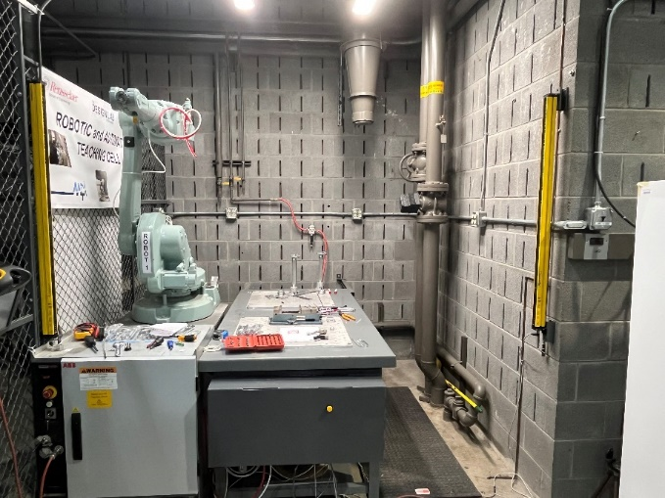
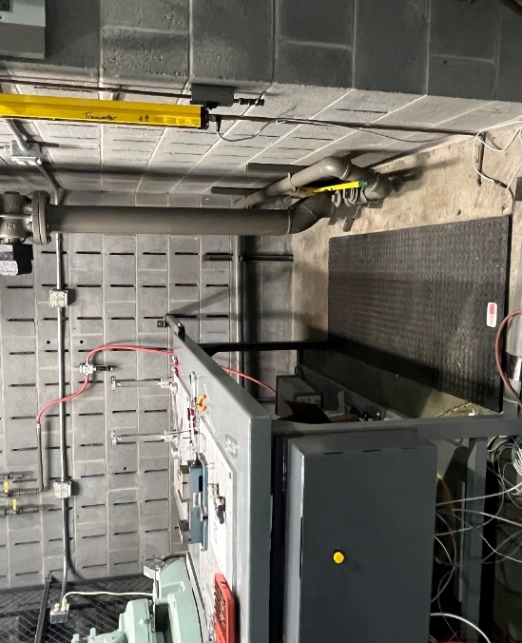
- Make sure the occupancy mat is not being stepped on. See Operations 6c for more information about the occupancy mat.

- Make sure no dead man switches are active. To deactivate a dead man switch turn the switch clockwise. See Instructions 2c for information and location about dead man switches.
Clockwise
Clockwise
- Make sure the joystick direction is not locked. To check the status of the joystick go to the ABB menu then go to Jogging. Next click on Joystick lock and make sure None is selected. See Instructions 4e for information about locking joysticks.
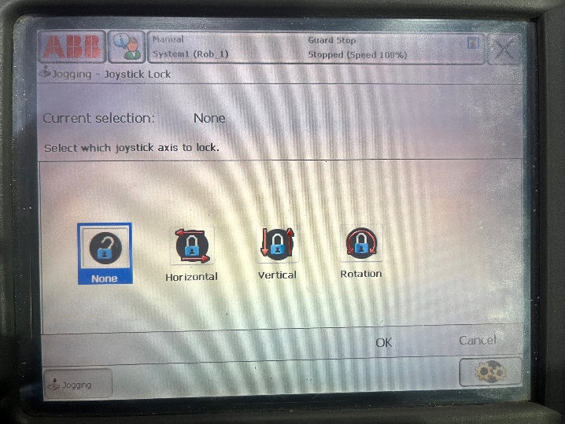

- ABB Menu Too Many Views
If the ABB menu on the pendant runs into the error of too many views, then the user has too many manual views open. To fix first click OK on the event error. Notice at the bottom of the screen there are different tabs corresponding to different ABB views that are currently open. Click on any unneeded tabs then press the large X in the upper right-hand corner to close that view. The pendant can only have 6 views open at a time.
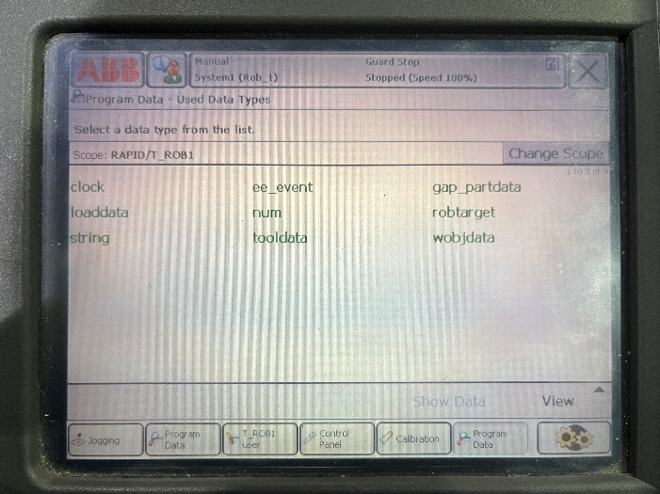
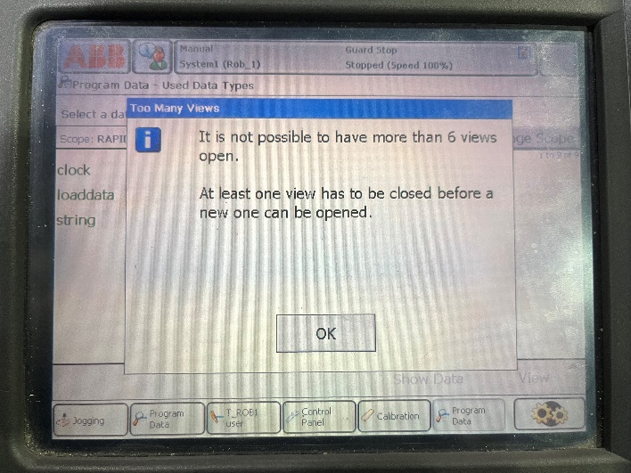

- Emergency Stop State
If an emergency stop has recently been clicked, then the motors will need to be turned on. To turn on the motors push the white button on the computer component light grey box. See Instructions 2dc for more about the dead man switches. See Instructions 2d for more about the white button. If a stop happens and you want to go back to the program see Operation 4f.

- Singularity Error
If you get a singularity error, there might be an error in the RAPID code. In the programming tab try changing any linear motion points, blue arrows, to point to point, orange arrows, in Octopuz pathing. A singularity error could also be caused by other RAPID code issues.
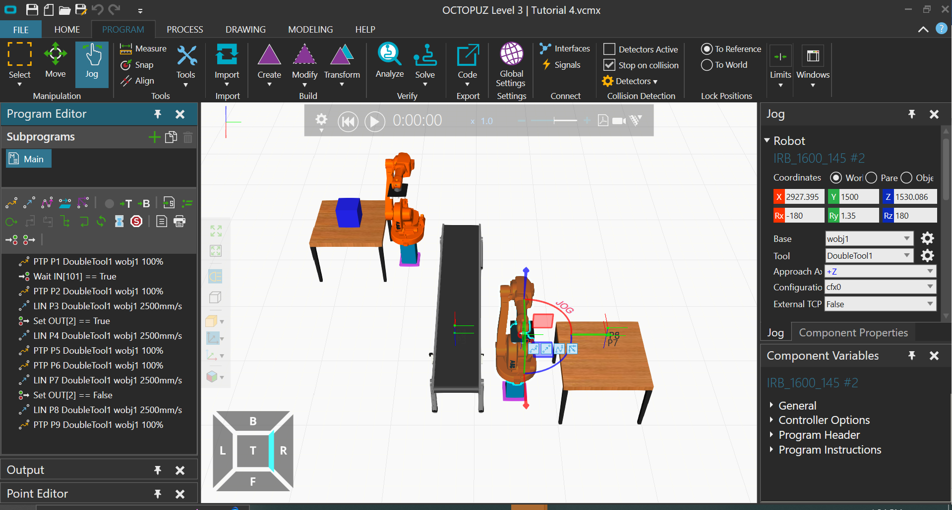

Section 7: Attaching Tools

