ROS2 Setup and Testing Using Raspberry Pi 4

INITIAL BOOT
- Install Raspberry Pi OS using Raspberry Pi Imager.
- Link to Raspberry Pi Imager
- Insert a micro-SD card adapter into the laptop slot.
- Once Raspberry Pi Imager has been opened, fill in the following information for the Raspberry Pi Device, Operating System, and Storage categories:
- Device: Raspberry Pi 4
- Operating System: Other General Purpose OS Ubuntu Ubuntu Server 24.04 LTS (64-bit)
- Storage: Mass Storage Device USB Device Click “Yes” to erasing all existing data
When done, select “Write”.
- Connect the Raspberry Pi device to a monitor and keyboard using a micro-HDMI and a USB-C to power supply cable. The power supply for a Raspberry Pi 4 must be a 5V/3A supply.
- Type in “ubuntu” for the username and “ubuntu” again for the password. When asked to change the password immediately, choose a password and be sure to write it down.
  - For instruction setup, we chose “capstone”.
- Connect Ethernet to the Raspberry Pi through the Capstone shop. It is possible to connect to Wi-Fi directly at this stage, but it is too cumbersome to be reproduced. After finishing this guide, follow the “Networking” section of the “Raspberry Pi Test Plan”, also on the Capstone Support Wiki, in order to connect to RPI Wi-Fi.
- Run the command “sudo rm /etc/ssh/sshd_config.d/50-cloud-init.conf”, then “systemctl restart ssh”. Put in your password when asked.
- On the monitor, type “ip a” + enter for more information on the IP address for ethernet (ETH) and the wireless local-area network (WLAN). In the terminal, use “ssh ubuntu@[IP address of the Pi] to connect to the Pi. The photo below shows the location of the IP address; this will be unique to each router, but for this example, the command would be “ssh ubuntu@192.168.0.102”.
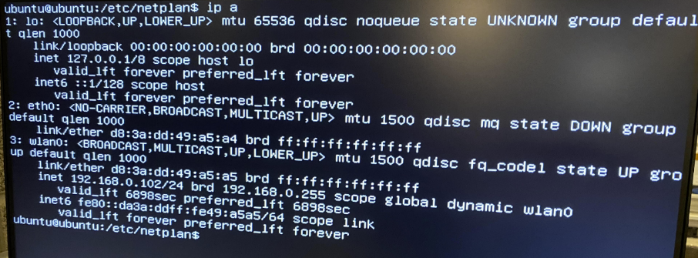
- Run “sudo apt update” followed by “sudo apt upgrade”.
- Run “sudo apt install ubuntu-desktop-minimal”
- Once that’s finished, type “reboot” and hit enter. Once rebooted, you should be greeted by a graphical user interface.
- The Pi is now ready for ROS2 installation.
SETTING UP ROS2 WORKSPACE
- Navigate to https://docs.ros.org/en/jazzy/Installation/Ubuntu-Install-Debians.html to find the instructions for system setup. Follow the steps under the headers labeled Set locale, Enable required repositories, Install development tools, Install ROS 2, and Setup environment.
- To check if the ROS2 install was successful, type the command “source /opt/ros/jazzy/setup.bash” to source the terminal, then type “ros2” as a separate command. This should return information about the ROS2 package with its usage and related commands.
- Using the command “nano .bashrc”, navigate to the end of the bashrc script and add the line “source /opt/ros/jazzy/setup.bash”. Exit the file using Ctrl + X, followed by Y + Enter when asked if you are sure you would like to exit.
- In order to perform ROS2 builds, it is necessary to add the colcon utility. Type “sudo apt install python3-colcon-common-extensions” into the terminal to verify its installation.
- Using the “nano .bashrc” command once more, add the line “source /usr/share/colcon_cd/function/colcon_cd-argcomplete.bash”. This will apply a source to the ROS2 setup bash file each time the session starts.
- Finally, it is time to create a ROS2 workspace named “ROS2-RPi-Design-Lab” where ROS2 nodes can be built. This will rely some key Linux commands: “mkdir” which is used to make a directory, and “cd” which is used to set the current directory. Additionally, the “ls” command lists all the files and directories under a specified directory. The commands used to set up the workspace are shown below.
  - cd
  - mkdir ROS2-RPi-Design-Lab
  - cd ROS2-RPi-Design-Lab/
  - mkdir src
  - ls (src should appear when this command is used)
  - colcon build (this will return that 0 packages have finished)
  - ls (this will return a list with build, install, log, src)
  - cd install/
  - nano ~/.bashrc
- The bashrc script will now open once more. Scroll to the end again and add “source ~/ ROS2-RPi-Design-Lab/install/setup.bash” to a new line. This will make the workspace available whenever a new session is opened. You have successfully set up the ROS2 workspace!
PUBLISHING TO A ROS2 TOPIC
In ROS2, topics are an important communication mechanism that facilitate seamless data exchange between different parts of a robotic system. Topics allow nodes to publish or subscribe to messages, and are designed to enable said nodes to communicate without knowing each other’s identity or location. Messages are data structures that define the information being exchanged between nodes; they are denoted by ‘.msg’ files. ROS2 supports various message types including predefined types for common data such as floats and integers while also tailoring to custom message types specific to application needs. Then ROS2 follows a publish-subscribe paradigm, where nodes can publish data to a topic or subscribe to receive data from a topic. It is important to note that utilizing topics ensures subscribers are provided with continuous updates.
- Open two terminal windows. You will need both!
- In the first terminal, we are going to make a topic called “pirates” that publishes the text string “Ahoy!” The command for this is as follows:
  - ros2 topic pub /pirates std_msgs/String “data: Ahoy!”
where /pirates represents the topic name, std_msgs/String represents the message type, and “data: Ahoy!” represents the contents of the message.
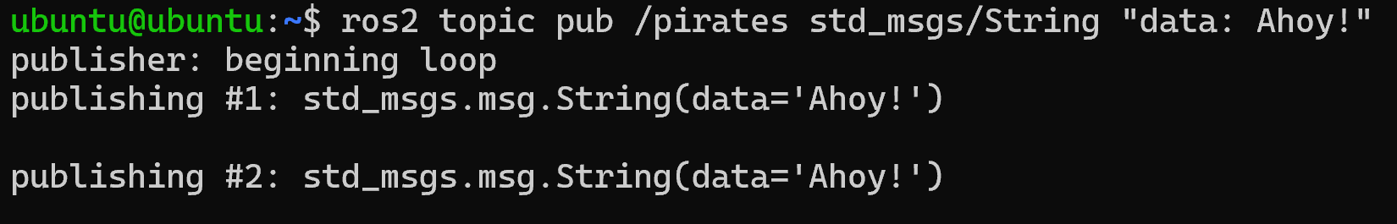
- In the second terminal, type “ros2 topic info /pirates”. This will show the publisher and subscriber information for the topic. There should be one publisher and no subscribers, since we have not subscribed to the topic yet.
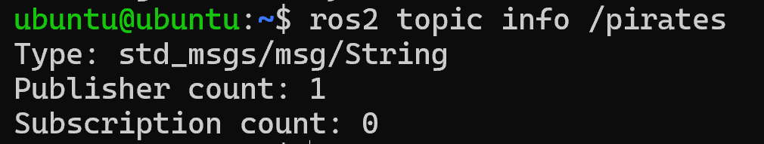
- Now, we will subscribe to the topic and receive continual updates on what is being published.
  - ros2 topic echo /pirates
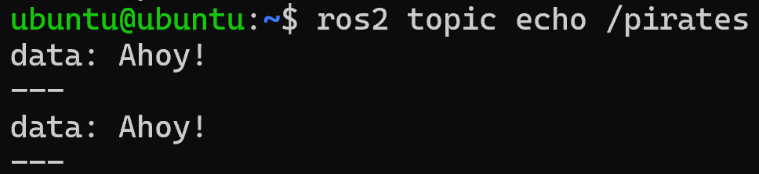
- Use Ctrl+Z to stop the topic echo.
- Check the topic info using the same command as in Step 22. The subscriber count should now be one as well, showing that we have successfully subscribed to the topic.
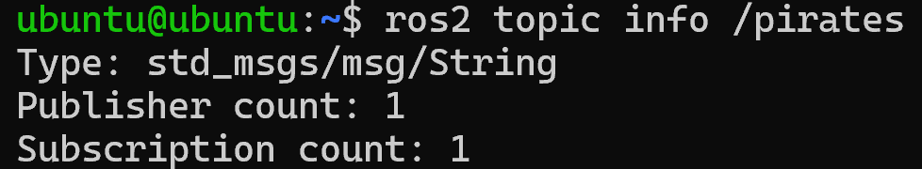
- Similarly, use Ctrl+Z to put publishing to the background.
- As shown in the photos below, if we were to open another terminal window with a second string to be published to the topic, the two messages would publish simultaneously, and the publisher count would become two instead of one.
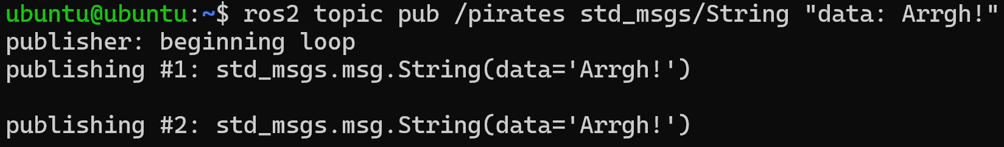
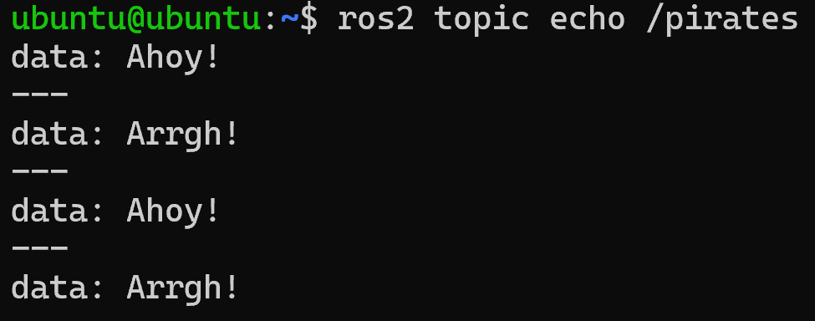
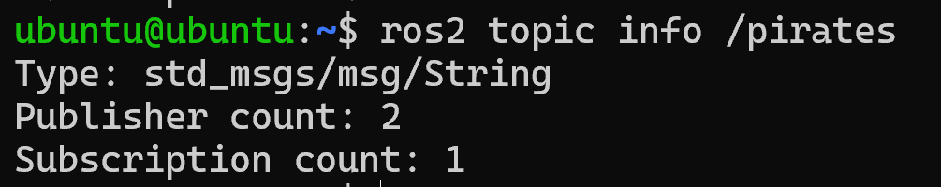

RUNNING THE WEBCAM
In order to make this a reproducible starting environment, the instructions for what we did will be somewhat different than what the students will do. Therefore, we are still in the process of figuring out the “simplified” steps for webcam package setup to be written here.
- In the root folder (ROS2-RPi-Design-Lab) of two different terminals, run the command “colcon build --symlink-install” to build the webcam package.
- Run the “ros2 pkg executables webcam” command to determine which nodes are available to be run from the webcam package. From this, we can see that “webcam_pub” and “webcam_sub” are the names for the publisher and subscriber nodes.
- Run the publisher in one terminal window and the subscriber in the other terminal window using the following commands:
  - ros2 run webcam webcam_pub
  - ros2 run webcam webcam_sub
- The intended output is an image from the camera, and a successful run of the webcam node and image is shown below. Use Ctrl+C to stop the webcam publisher and subscriber nodes when finished.
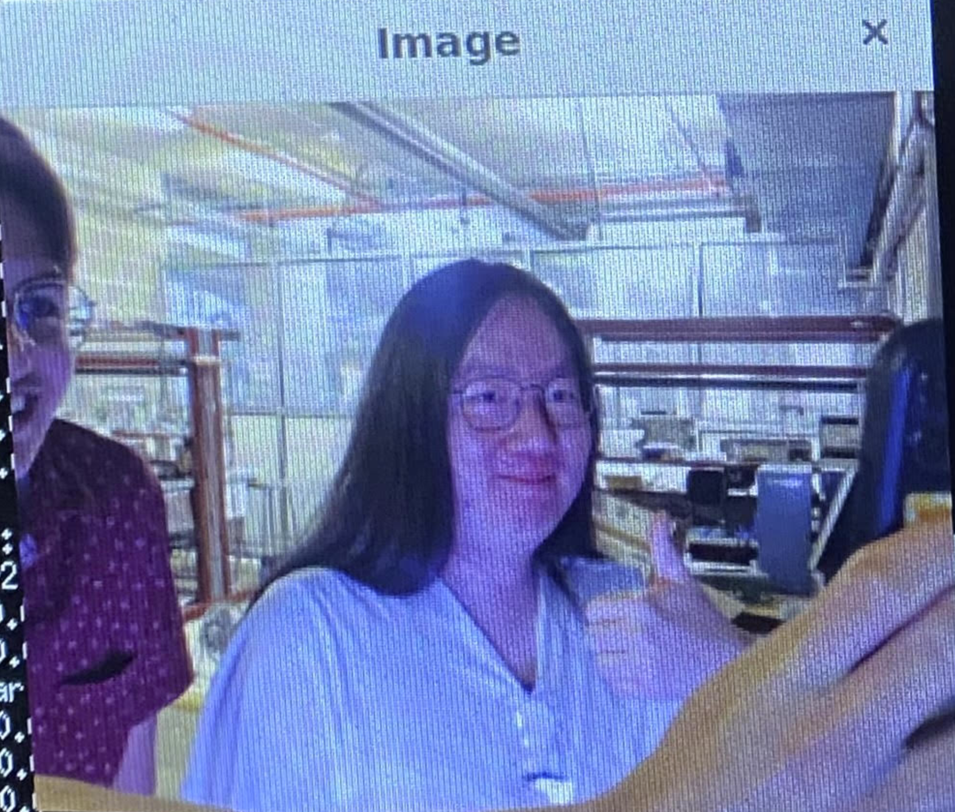

RUNNING TURTLESIM
Turtlesim is a lightweight ROS2 simulator that gives a basic illustration of how a ROS2 system can be implemented for robotic control. It relies on the ros2 tool, which is used for setup of system operations such as nodes, parameters, topics, and services. Therefore, all commands used in the ROS2 programming language will start with “ros2”.
- Check that the Turtlesim package is installed by running the command “ros2 pkg executables turtlesim”. This command should return a list of turtlesim’s executables, including “draw_square”, “mimic”, “turtle_teleop_key”, and “turtlesim_node”.
- In one of the terminal windows, run the command “ros2 run turtlesim turtlesim_node”. This should generate a new window with an image of a turtle imposed on a blue background. As it turns out, we can manipulate this turtle and will do so in subsequent steps.
- In the other terminal window, run the command “ros2 run turtlesim turtle_teleop_key”. This will return instructions for moving and rotating the turtle using the arrow keys and specific letter keys. It is necessary to click back into this window whenever we want to move the turtle.
- Open a third terminal window, and after running a colcon build in the root folder, type “rqt_graph” + Enter. The RQT graph is used to visualize how nodes and topics are connected, as well as any changes made to them. From this node graph, we can see that the turtle (named turtle1) publishes to the “cmd_vel” topic, as shown below.
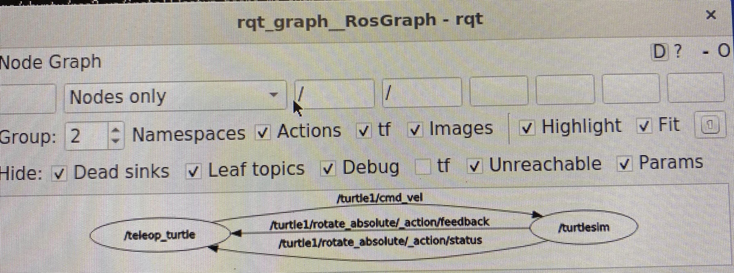
- To see the data being published to the “cmd_vel” topic, run the command “ros2 topic echo /turtle1/cmd_vel”.
- Return to the terminal with “turtle_teleop_key” running and use the arrow or letter keys to move and rotate the turtle. Watching the terminal where the “topic echo” is running simultaneously reveals the position data that is published for every movement of the turtle. The full display for the turtlesim package is shown below.
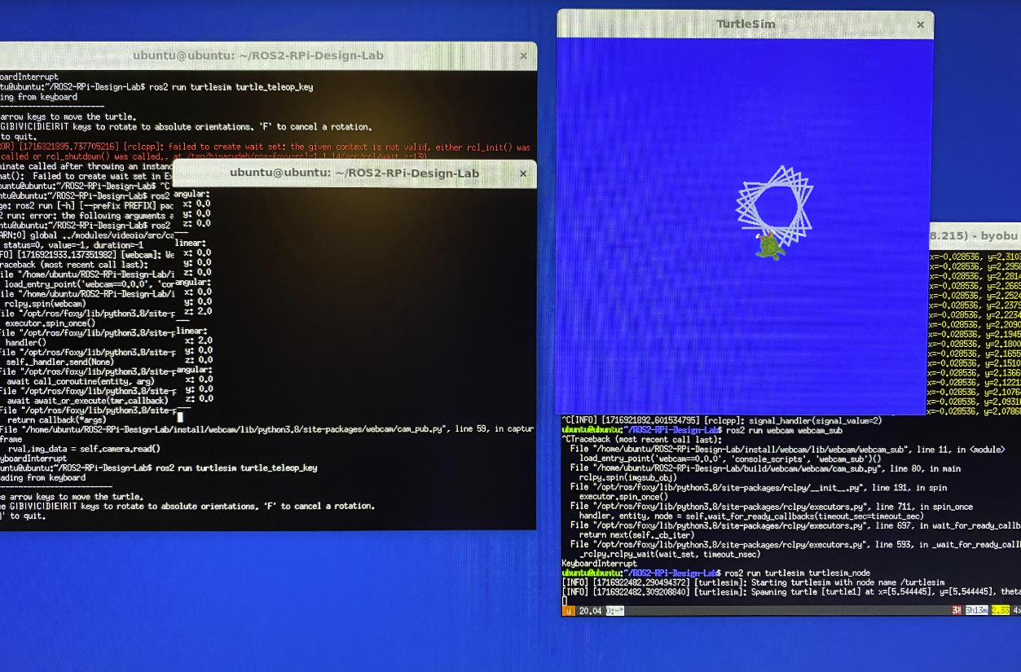
TURTLESIM DISPLAY
TURTLESIM NODE
TURTLE_TELEOP_KEY NODE
TOPIC ECHO DATA
- As shown below, a warning message will be displayed if the turtle makes contact with the borders of the terminal window, along with the coordinates where it made contact.
