Design Lab Raspberry Pi Test Plan
May 28, 2024

Introduction
IF YOU ARE RUNNING INTO SVN ISSUES (HANGING ON CHECKOUT), SEE THE LAST SECTION “EXTRA INFO” IN THIS GUIDE.

Hello! This is a test plan to help you diagnose issues with your Raspberry Pi. When followed along, it can also be used as a quickstart guide of sorts. Please follow all instructions carefully. This test plan covers HDMI, USB, the audio jack, webcams, the Raspberry Pi camera, and all GPIO pins, input and output. Each section covers testing or setup protocols for a type of connectivity on the Raspberry Pi. If you cannot replicate the results of the testing procedures, contact your PE.

Disclaimer
This guide was written on May 28, 2024, and this guide is based on Raspberry Pi OS released on March 15, 2024, which is based on Debian Bookworm. Raspberry Pi OS undergoes many iterations, and further down the line, some programs used by this guide may be changed or removed. If you’re encountering errors that are more in line with a software issue than a hardware issue (say for example the “pintest” command cannot found), reach out to your PE.

Booting (for the First Time)
- Find a microSD card with at least 8GB of storage, and connect it to your computer, either directly through your laptop’s SD card port, or through a USB SD card reader.
- Install the Raspberry Pi Imager by going to https://www.raspberrypi.com/software/ and download it based on your operating system.
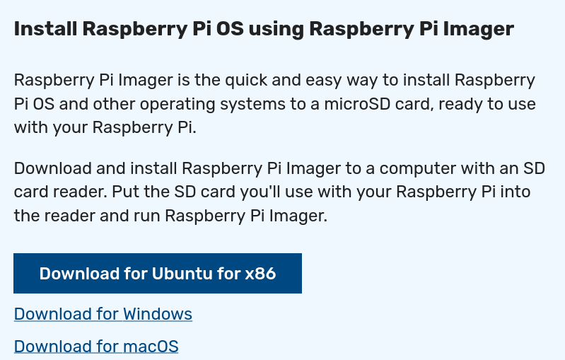

- Once installed, hit “CHOOSE DEVICE”, and pick the correct Raspberry Pi that you are using.
  - To find out what Raspberry Pi you have, look at the top of the Raspberry Pi. For example, this is a Raspberry Pi 3, as noted by the white text near the top right of the image
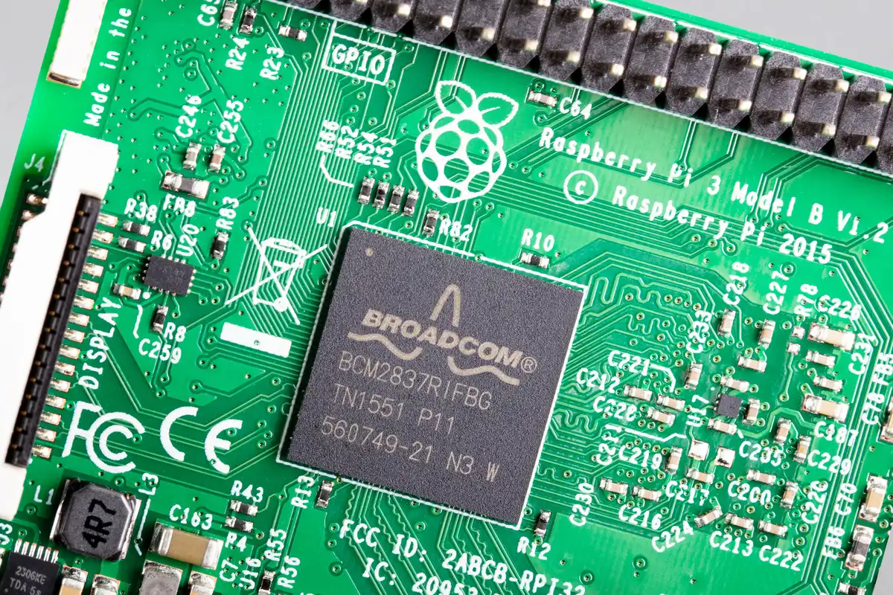

- After selecting the correct device, hit “CHOOSE OS”. and choose the topmost operating system listed. This guide is written with the latest OS in mind as of May 28, 2024.
  - For example, for a Raspberry Pi 4, choose the topmost option as highlighted. Note that this screenshot is taken on May 28, 2024. Your most recent Raspberry Pi OS version may be different.
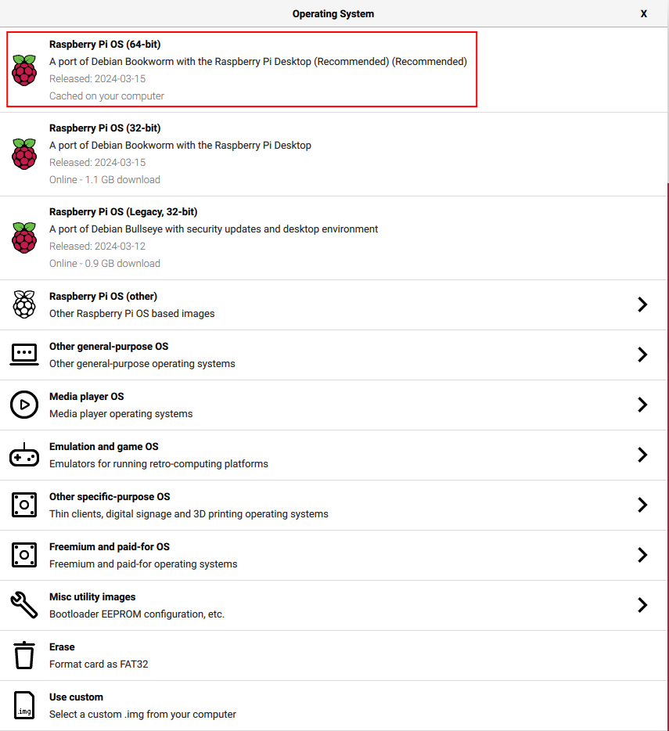
- Next, hit “CHOOSE STORAGE”, and choose the SD card that you have plugged in to your computer.
- Next, hit “NEXT” near the bottom right, and a pop-up window would show, asking if you would like to apply OS customization settings. Choose “Edit Settings.”
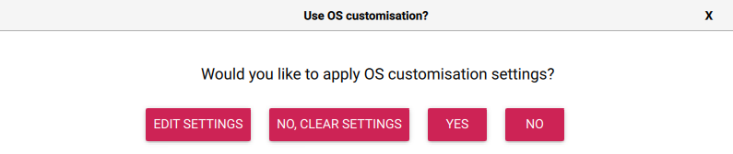
  - Another popup window would show up, as shown below.
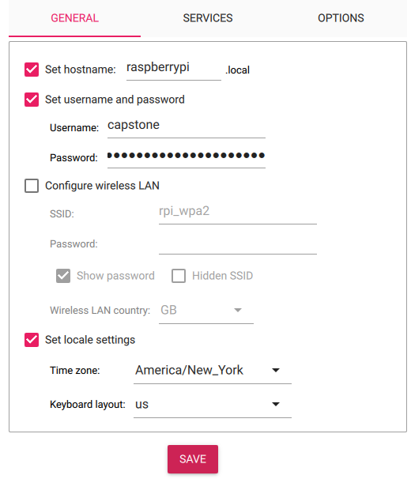
  - Set a hostname by leaving that option checked and giving your Raspberry Pi a name.
  - Set the username and password by leaving that option checked and entering a username and password. Note that this should be communicated with the rest of your team, as well as your PE and CE, so everyone can access this device.
  - Do not check “Configure wireless LAN.”
  - Set the locale by leaving “Set locale settings” checked and entering the correct timezone and keyboard layout.
  - Near the top, click “SERVICES.” The following screen should show up.
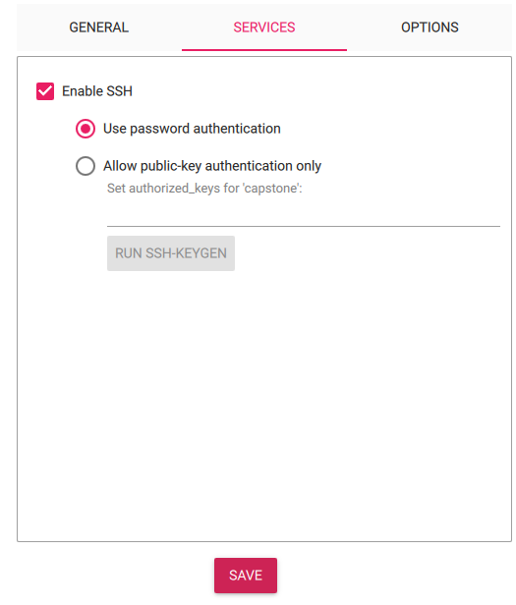
  - Leave the settings exactly as the image above shows by checking “Enable SSH” and picking the radio button that says “Use password authentication.” Only choose “Allow public-key authentication only” if you know what you’re doing.
  - Hit “SAVE” at the bottom.
  - You should be back to the window that says “Use OS customization?” Hit “YES.”
  - On the next window with the title “Warning,” hit “YES.”
  - Wait for the image to be flashed onto the SD card.
  - Once finished, remove it, and plug the SD card into the Raspberry Pi.
- Find a power supply that can support your Raspberry Pi. Don’t plug it in yet.
  - The official recommendation is 5V/2.5A for Raspberry Pi models with micro-USB (Raspberry Pi 1, 2, 3), and 5V/3A for Raspberry Pi 4s, and 27W power supply for Raspberry Pi 5s. The latter two both have USB-C connectors.
- Plug in a mouse, a keyboard, the HDMI cable into the Raspberry Pi.
- Plug in the power supply to the Raspberry Pi. This will automatically power it on.
- If all of these steps are followed and the Raspberry Pi would not boot up, then contact your PE. Symptoms of booting issues may include a rainbow screen repeatedly showing up but nothing is happening.

Networking
This section details connecting to RPI Wi-Fi using the terminal. This can also be done through the desktop GUI by hitting the network icon on the taskbar, and similar fields to ones described in this part of the guide would be present. The terminal steps are detailed as it is more universal (such as when accessing the Raspberry Pi through SSH).
- Open the terminal by hitting the icon at the top left of the screen with the “>_” icon, and run nmtui by typing “nmtui” and hitting enter.
- This opens the NetworkManager terminal user interface. Use the arrow keys to move around, enter to select items, and escape to go back one level.
- Hit enter on “Edit a connection.”
- Navigate to and select "Add".
- Select "Wi-Fi".
- (Optional) Enter a profile name like "RPI Wi-Fi".
- Enter rpi_wpa2 into the SSID field.
- Navigate to “Security” and select "WPA & WPA2 Enterprise".
- Navigate to “Authentication” and select "PEAP".
- Enter anything into "Anonymous identity".
- Enter your RCS ID into “Username” and your password into "Password".
  - Note that anyone with access to this Raspberry Pi can probably get your password from this point on. To avoid this issue, have a dedicated router set up for your Capstone project.
- Navigate to and hit OK at the bottom of the page. Your end result should look something like my example here.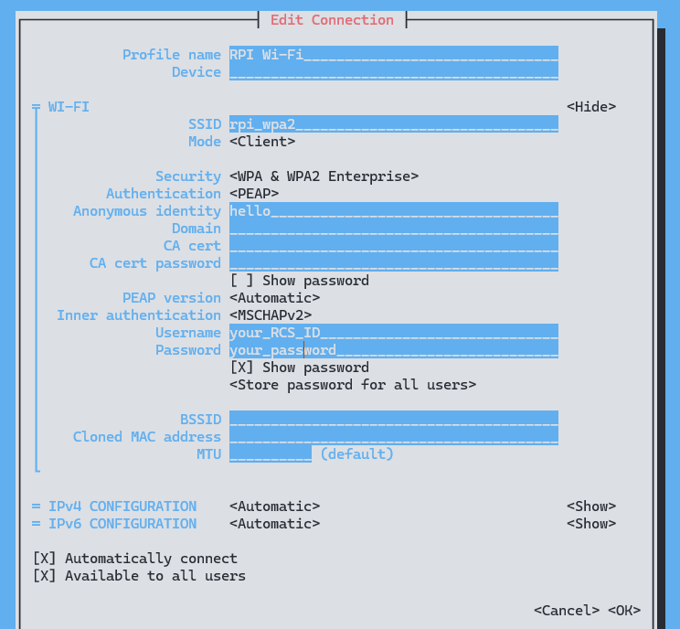

Audio
- Plug in 3.5mm headphones into the audio jack.
- On the Raspberry Pi desktop, right click the audio icon on the top right of the screen
- Select “AV jack” if it isn’t already selected.
- Scroll the volume bar up and down in order to check if there is sound coming from the headphones.

GPIO
- First, get a pinout of the Raspberry Pi GPIO pins. Open the terminal and run pinout. You should see something like the following image. Under the section “J8,” note that the orientation of that graph has the USB ports at the bottom.
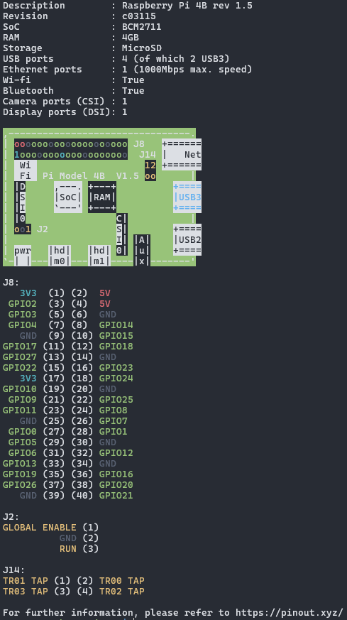
- From this point on, we will refer to pins by the number that follows the characters “GPIO”. For example, to access GPIO17, denoted as “(11)” in the middle two columns of the pinout, use pin number 17, not 11! Another example, GPIO21 corresponds to “(40).” Use 21, not 40!
- Open another terminal. To test the status of all GPIO pins, run pintest, then enter “y” when prompted. Make sure that the GPIO pins aren’t connected to anything. If all pins are working, then you should see output that looks like the following image.
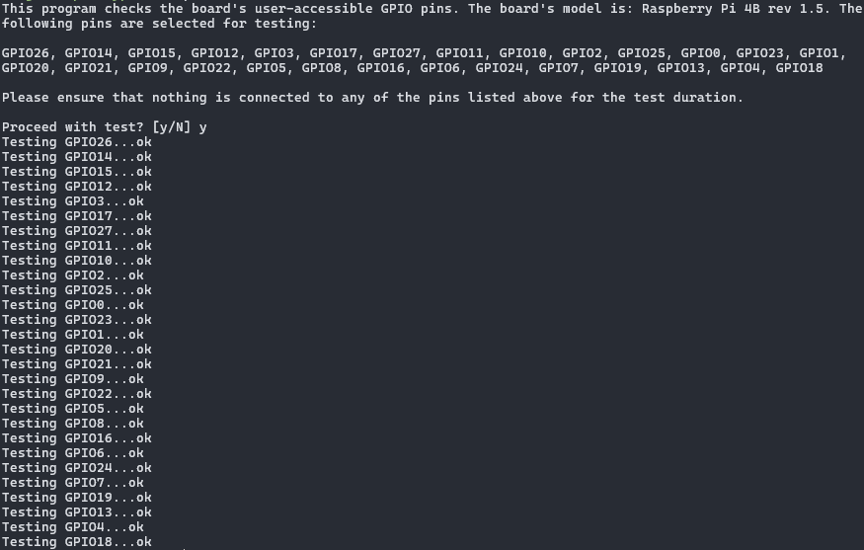
- If you are still having issues with specific GPIO pins, go to the Capstone Support Wiki, then find and download the test program “simple_gpio_test.py”.
- Prepare the hardware needed for this test. You will need a breadboard, a button switch, an LED, a resistor (1K would work), and two wires to connect components together. Alternatively, the Design Lab may have circuit boards prepared for testing Raspberry Pis.
- Ensure that you are in the terminal, and in the same directory with the test Python program, then run python3 simple_gpio_test.py
  - The program comes with instructions to build test circuits and test either input with the button or output with the LED. Please follow them carefully.
  - When asked for which pin you want to test, simply type the number that follows “GPIO.” Do not type the words GPIO themselves.

USB Webcam
- Ensure that no other video input is connected to the Raspberry Pi (such as a Raspberry Pi camera).
- Plug a USB webcam into a USB port of the Raspberry Pi.
- Ensure ffmpeg is installed by opening the terminal and running sudo apt install ffmpeg. It should be already installed if instructions are followed. If it’s not installed, install it with the command above.
- In the terminal, run ffplay /dev/video0.
- The webcam feed should show up on the desktop.

Raspberry Pi Camera
- Turn off the Raspberry Pi.
- Connect the Raspberry Pi Camera.
  - This link’s FIRST 4 STEPS can help: https://projects.raspberrypi.org/en/projects/getting-started-with-picamera/2
  - Instructions categorized with bullet points are outdated.
- Turn on the Raspberry Pi, open the terminal, and run rpicam-hello.
- A video preview of the camera should show up for 5 seconds on the desktop.

Bluetooth
- Click the Bluetooth button on the top right of the desktop.
- Click “Make Discoverable.”
- Try pairing the Raspberry Pi with your phone. Open your Bluetooth settings on your phone, and pair with the Raspberry Pi.
- After you are done testing, feel free to turn off discoverable, or Bluetooth altogether.

Ethernet
- Plug the Ethernet cable into the Ethernet port.
- Check that the network icon on the top right of the desktop becomes an up and down arrow.
- Double check by opening the terminal and running curl example.com. The output should look something like the following image.
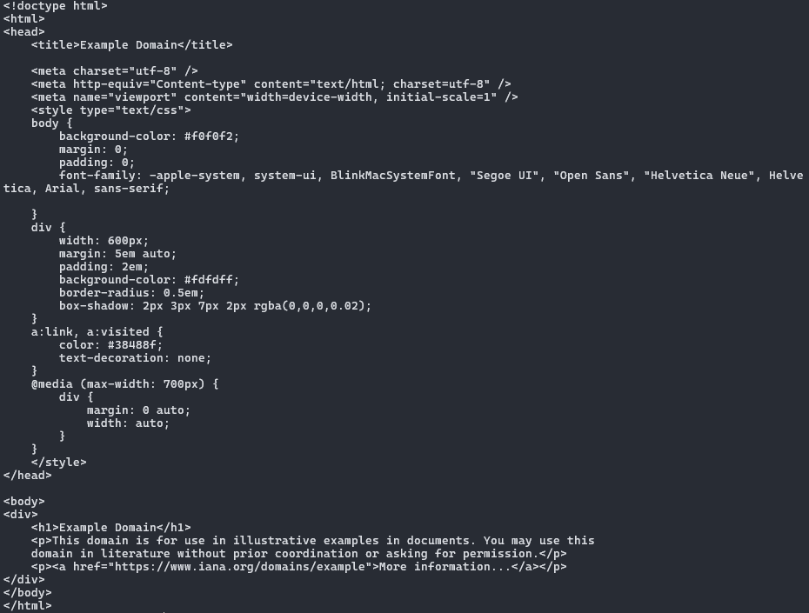

Extra Info
- When using svn on a Raspberry Pi, it is possible for the svn checkout command to hang after inputting the password. To solve this, edit ~/.subversion/config, and make the line that starts with password-stores (there might be pound signs before it) look like this: password-stores =. This should bypass an issue where svn hangs indefinitely looking for a keyring response that never comes.
- Using a Raspberry Pi camera is a little dependent on the OS version of the Raspberry Pi. With frequent changes to the OS, as well as different camera versions, it might be hard to get the Raspberry Pi camera to work with non-libcamera sources through /dev/video0, such as using it with ffmpeg or gstreamer. Online resources may be outdated, depending on the OS version. Consider using webcams, which have robust drivers in the Linux kernel that make them easy to work with.

- Connecting to RPI Wi-Fi, which is an enterprise variant that requires both an identity and a password, is much more complicated on non-latest Raspberry Pi OS versions. The Raspberry Pi OS version based on Debian Bookworm uses NetworkManager, which provides nmtui to interactively help you connect to RPI Wi-Fi. Using wpa_supplicant provided on older versions of Raspberry Pi OS requires a lot more work and research to get set up.

