Individua Risk Management Plan for [enter your name]

Project : [enter project name]

Mentors: [enter CE and PE names]

Sponsor: [enter company name]

Date: [enter date]

1. **My Plan**

To Do: You must work toward your team’s goals/objectives. First, write a paragraph to describe how you plan to make your technical contributions. For example, describe subsystems or technical problems you plan to work on. Make sure to show its relevance in terms of the team’s semester goals.

Next, write a paragraph or two about a technical approach(es) that will be used in designing the subsystems or solving the problems. Provide specific information on the technical aspects and how you will solve them.

If you did not identify a technical approach clearly, explain how you plan to resolve the issue. Moreover, open the related tasks (issues) in EDN. Examples of such tasks are: 1) research existing solutions; 2) benchmark competing products, and 3) experimentally determine the technical feasibility of possible solutions.

On the EDN, you can use Assignee to filter to show only your tasks and save a Gantt chart as an image (PNG). Update the % complete before generating a Gantt chart screenshot. Replace a sample Gantt chart, Figure 1, with your own, and reference the Gantt chart in the text.

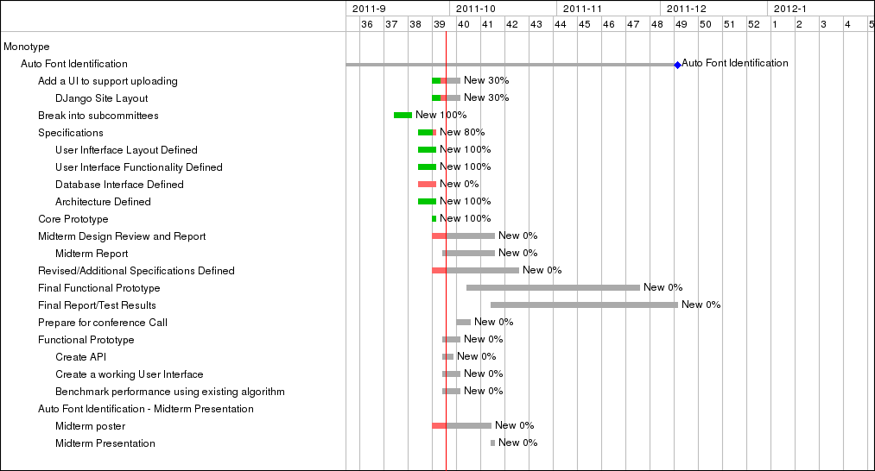

Figure Sample Gantt Chart

1. **Technical Risk Analyses**

Risk is anything that prevents you from completing your tasks and your team’s goals if it occurs. Review your technical approach and plan, and identify technical risks.

If you think that there is no risk, explain how you came up with the conclusion.

* **Lack of Knowledge and Skills**  
  Identify the knowledge and skills needed to complete your tasks based on your technical approach. Study if you have the necessary knowledge and skills or not.
* **Testing Your System (Solution)**  
  You must objectively demonstrate how well your system (solution) met the customer’s needs and requirements. Identify things you need to measure. Identify the corresponding acceptable values (successful results). If you do not have a plan, you must define a task to develop a test plan.
* **Lack of Appropriate Hardware, Software, and Samples**  
  List everything you need to build and test your system (solution). Examples include hardware, circuitry, sensors, and software. You may have to create a test fixture, generate test data, write test program, or purchase sample materials.

Table 1 shows sample problems and the corresponding risk management plans.

Table 1 Sample Technical Risks and Risk Management Plans

|  |  |
| --- | --- |
| **Problem (Risk)** | **Risk Management Plan** |
| I am not familiar with Technology-X | Allocate time to study and learn Technology-x. |
| I cannot operate a CNC machine to fabricate parts. | Ask the Design Lab technician to fabricate parts using CNC machines. |
| I know how to implement subsystems, except Subsystem-Y. | Schedule to work on Subsystem-Y first.  (Note: Students tend to work on straightforward problems first and run out of time to work on difficult issues.) |
| I do not know if Approach-Z will work or not. | Build a prototype and study its feasibility. |
| I do not have a tool necessary to perform a task. | Ask PE/CE about tool availability. |