Instructions to update the KitProg (programmer) firmware on the BLE Pioneer Kit Baseboard
- Plug in the BLE Pioneer Kit Baseboard to your PC using the provided USB cable.
- Wait for driver enumeration to complete (you can “skip” the windows update as the drivers are locally installed on your PC).
- Open PSoC Programmer and click to select “KitProg/xxxxx…..” Important step, especially if you have multiple Cypress kits plugged into your PC.
- You may see the following warning about programmer being out of date.
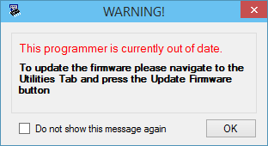
- Switch to the “Utilities” tab and click on the “Upgrade Firmware” button
- Verify KitProg has been updated to version 2.10 (or newer)
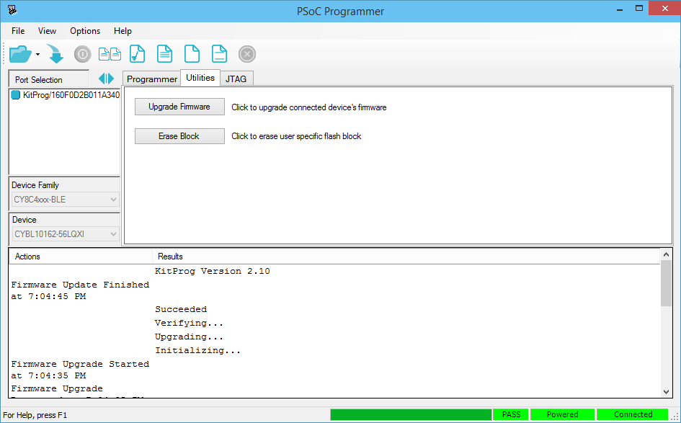
- You have successfully completed the KitProg firmware upgrade on the BLE Pioneer Kit

Instructions to update KitProg (programmer) and BLE (CYBL10162-56LQXI) firmware on the BLE-USB Bridge
- Plug the BLE-USB Bridge into your PC’s USB port.
- Wait for driver enumeration to complete (you can “skip” the windows update as the drivers are locally installed on your PC).
- Open PSoC Programmer and click to select “KitProg/BLExx…” Important step, especially if you have multiple Cypress kits plugged into your PC.
- You may see the following warning about programmer being out of date.
- Switch to the “Utilities” tab and click on the “Upgrade Firmware” button
- Verify KitProg has been updated to version 2.10 (or newer)
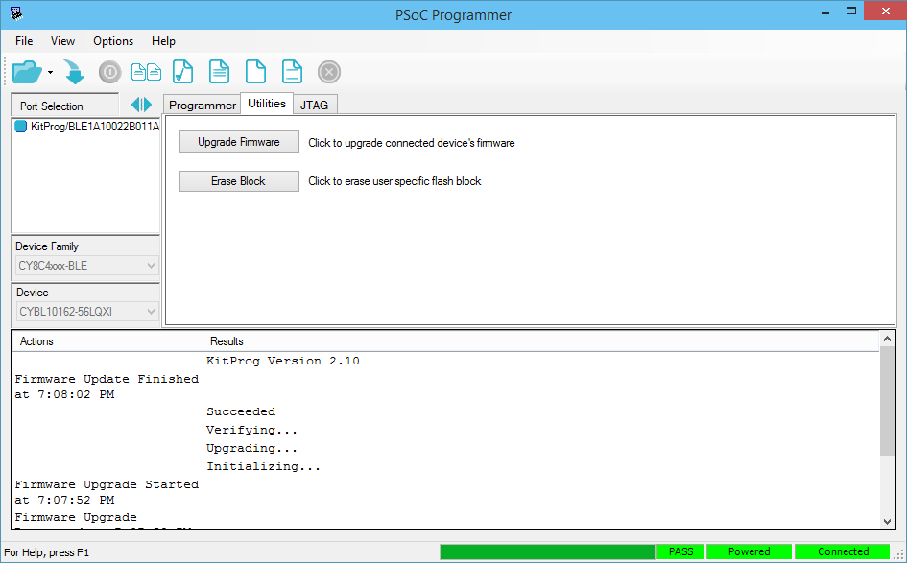
- You have successfully completed the KitProg firmware upgrade on the BLE-USB Bridge.
- Ensure you are still connected to the BLE-USB Bridge “KitProg/BLE1A….”
- Click on the “File > File Load…” menu item (or press F4)
- Select the following file:
C:\Program Files (x86)\Cypress\CY8CKIT-042-BLE Kit\1.0\Firmware\BLE Dongle\Hex Files\BLE_Dongle_CySmart.hex (or download latest from www.cypress.com/cy8ckit-042-ble)
- Click on “File > Program” menu item (or press F5)
- Verify programming of the CYBL10162-56LQXI device has completed successfully
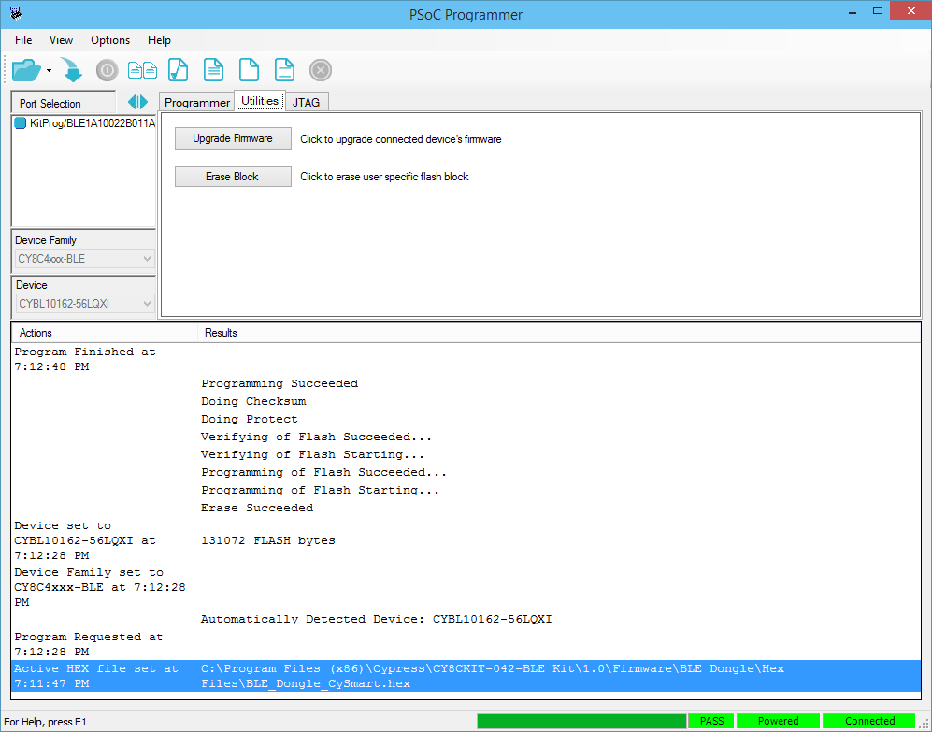
- You have now successfully upgraded the BLE firmware on your BLE-USB Bridge.

