Revision Fall 2021

*This single document will be submitted in 3 Phases over the course of the semester. As the semester progresses and the team’s accomplishments and understanding of the project grow, more content will be added. At the end of the semester, this finished document will help your project sponsor and/or the next Capstone team understand and carry the work forwards.*

*In industry, Phase 1 roughly corresponds to a ‘Statement of Work’ document to set the project’s scope. Phase 2 is a ‘Preliminary Design Document’ to justify feasibility and secure additional funding. And Phase 3 is the ‘Final Report’ of all work completed.*

*The table below illustrates which sections should be created and updated for each phase.*

*The ENTIRE document will be reviewed/graded at each step.*



***IMPORTANT NOTE!***

* ***At all stages, the file name and location in the repository remains the same:***

***“working/Reports/Design Report and Poster/Design Report.docx”***

* ***Replace the document elements, <xxx>, with your project and team information on the title page.***
* ***Subsystem requirements, concepts, analysis, and selection are typically made for each subsystem at a time. Therefore, an alternate document structure consists of a system overview section followed by subsystem sections. Consult with your Project Engineer and choose the most appropriate section(s) according to the nature of your project.***
* ***Update Contents, List of Figures and Tables, and References before submitting your design document.***
* ***Hide unused sections.***
  + ***Select (highlight) unsed sections.***
  + ***Press Cntr+Shift+h***
* ***Follow the above steps and hide the instructions in completed sections. Instructions are italicized and made blue.***
* ***You can unhide all hidden text by the following steps.***
  + ***Highlight the entire document by clicking Ctrl+A.***
  + ***Right-click and select Font from the context menu.***
  + ***Unmark Hidden in the effects.***

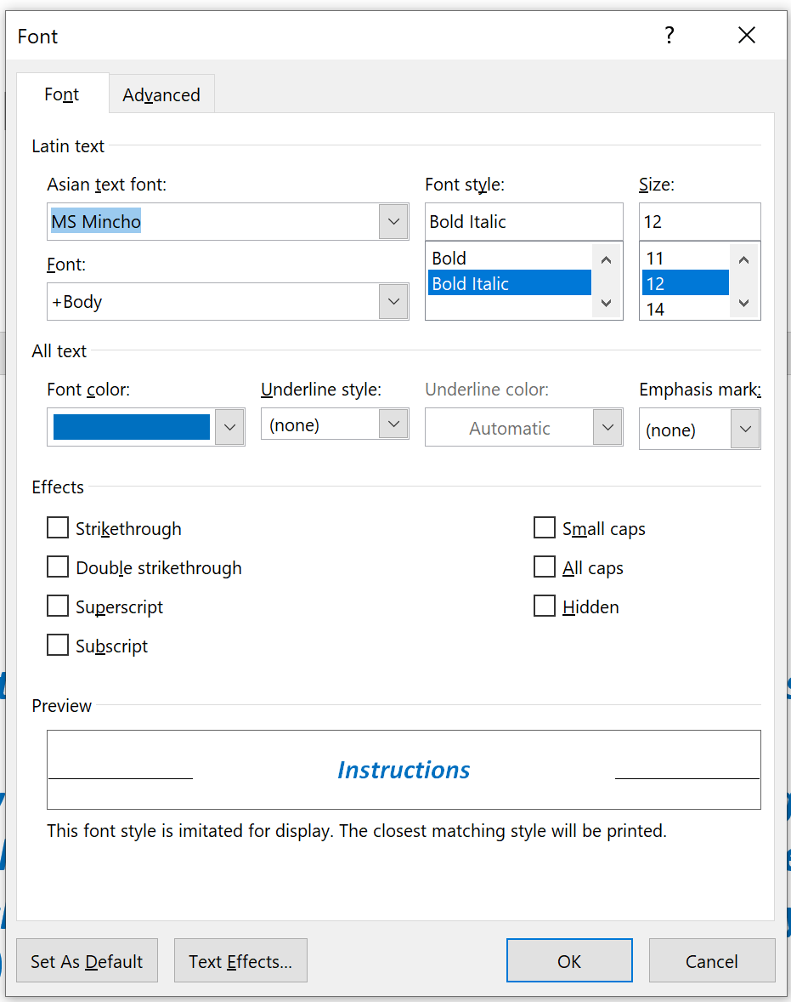

* ***This page and all instructions within each section should be deleted when you submit the Final Design Report (Phase 3) at the end of the semester.***

**Final Report for**

<Descriptive Project Title>

Sponsored By

<Sponsor Name>

Version <F21>

<Month, Date Year>

Prepared by

<Name (Discipline)>

<Name (Discipline)>

Project Engineer <Name>

Chief Engineer <Name>

# Executive Summary

*(Final Report)*

*To Do: The Executive summary is a condensation of an entire report and must be short; try to keep it no more than one page. Focus on the objective(s) and the project’s benefits, the major points of your design and validation, and recommendations. It is neither an introduction nor an outline (table of contents) of the report. Hence, it should not contain phrases such as “This report presents …” and “Our main results are described in chapter 1”.*

*Although this is usually read first, it is better written last!*

# Contents

Executive Summary 4

Contents 5

List of Figures and Tables 6

Revision History 7

Glossary 8

1. Introduction 9

2. Project Objectives & Semester Objectives 10

3. Engineering Tools and Methods 11

4. Technical Background, Assessment of Relevant Existing Technologies and Engineering Standards 12

5. Customer Needs and Engineering Design Requirements 13

6. System Concept Development 14

7. Design Analysis 15

8. Final Design and Engineering Specifications 16

9. System Evaluation 17

10. Significant Accomplishments and Open Issues 18

11. Conclusions and Recommendations 19

References 20

Appendix A: Initial Deliverables and Dates 21

Appendix B: Project Plan 22

Appendix C: System Evaluation Plan 23

Appendix D: Ethical and Professional Responsibilities 24

Appendix E: User Manual 26

Appendix F: Cost Analysis and Manufacturability Analysis 27

Appendix G: Expense Report 28

Appendix H: List of Manuals and Other Documents 29

# List of Figures and Tables

*(All)*

**Figure 1 Sample Gantt chart** 23

# Revision History

*(All)*

|  |  |  |  |
| --- | --- | --- | --- |
| Version | Date | Name | Reason for Changes |
| 1.0 |  |  | Initial document. |
|  |  |  |  |
|  |  |  |  |

# Glossary

*(All)*

*To Do: Your final report will be reviewed by people both in the field and outside of the field. Define all the abbreviations, acronyms, and terms required to interpret your final report properly. Examples of abbreviations that have two or more commonly used meaning are as follows:*

* *ATM – Asynchronous Transfer Mode or Automated Teller Machine*
* *UPS – Uninterrupted Power Supply or United Parcel Services*

*For any unfamiliar abbreviation, write the full name followed by the abbreviation in parentheses the first time it is mentioned in the report.*

# Introduction

*(Statement of Work)*

*To Do: Introduces your project. You must cover just enough in this section to fully understand the identified customer needs and semester objectives presented next. Write 2-4 paragraphs to state the following issues:*

* *Who is the project sponsor?*
* *Who is the customer?*
* *Major customer needs*
* *What is the problem that the team is going to solve?*
* *The history behind the project for an on-going project*
* *Why is it important for the sponsor to solve the problems? (What is the sponsor’s motivation to solve the project?)*

*Add appropriate subsections if necessary.*

# Project Objectives & Semester Objectives

*(Statement of Work)*

*To Do: This section contains both long term objectives and the planned semester objectives and the corresponding deliverables. Provide bulleted lists of the objectives for the overall project and for this semester. Introduce each list with a paragraph stating the purpose of the list. In both cases, focus on final outcomes, not intermediate steps. Do not include task assignments in this section. The objectives should be understandable by themselves. However, you can follow the objectives with a statement of scope to clarify what you planned to do (in scope) and that you planned not to do (out of scope).*

***Project Objectives and Customer Payoff***

*Write a clear statement of the overall project objective and what the benefit to the sponsor (customer) will be once the overall project is completed.*

***Current Semester Objectives***

*Write a clear statement of the project scope for this semester. What are the valuable results that the team will produce and deliver to the sponsor (customer) in the semester? These should include commitments by your team and should be project-specific, not generic. Focus on your specific project rather than the engineering design process you are following or the project management methods you may employ. Occasionally, to avoid misunderstanding, you may also state out of scope items, i.e., things you will not do, as needed.*

*Example:*

* *In Scope: Developing an Android smart phone application.*
* *Out of Scope: Developing an iOS version.*

# Engineering Tools and Methods

*(Statement of Work)*

*To Do: Translate the semester objectives into engineering problems and provide specific information on the technical aspects of how the team will solve them. Do not present the generic design process because teams are expected to follow that. Make this specific to your particular project. Do not present your team’s project management approach as all teams should use good project management techniques.*

# Technical Background, Assessment of Relevant Existing Technologies and Engineering Standards

(Preliminary Design Document)

To Do: Present adequate additional background information and benchmarking to identify the engineering problems (requirements) you will solve to satisfy the customer needs. (What technology exists or is needed to solve the problem?)

Present industry and de facto standards that are relevant to your project. Some of these standards become design constraints. Examples of things that might be applied to your project are found in:

https://designlab.eng.rpi.edu/edn/projects/capstone-support-dev/wiki/Standards

If competitors’ products were reviewed, state design targets identified the assessment process also.

Where appropriate, refer to the previous final report(s). Make sure to provide correct in-text citations that refer readers to References. (See References also.) This section is also the place to summarize your patent search if applicable.

# Customer Needs and Engineering Design Requirements

*(Preliminary Design Document AND Final Report)*

*To Do: Provide a high-level summary of key Customer Needs and related Engineering Requirements for the overall project and each of the subsystems (what engineering problem are you solving?). Reference specific Needs/Requirements by their numbers from the workbook when discussing. Be sure to cite standards and regulations where used for Requirements.  
  
This section should be updated as appropriate for the Final Report.  
  
Include a reference to the Needs and Requirements Workbook in the Engineering Analysis folder in your team’s repository. You MUST indicate the repository revision number for the Needs and Requirements workbook at each submission (Preliminary Design Document and Final Report) so that this report properly synchronizes with the specific versions.*

# System Concept Development

*(Preliminary Design Document AND Final Report)*

*To Do: Present the system concept that the team ultimately developed. Help the reader visualize the system concept using appropriate drawings/diagrams, such as sketches, system schematics, circuit diagrams, and UML diagrams. Describe the significant criteria that lead to concept selection, alternate concepts that were considered, and design trade-offs. Where appropriate, refer to the previous final report(s). For the remaining concepts considered, provide appropriate pointers.*

# Design Analysis

*(Final Report)*

*To Do: Present the methodology and analyses used in coming up with a well-defined structure for the selected concept and major results. If the methodology is based on prior published work, cite the reference instead, with additional appropriate comments.*

*Examples of analysis techniques include:*

* *Technical/mathematical modeling*
* *Simulation*
* *Quick prototype and experimentation*

# Final Design and Engineering Specifications

*(Final Report)*

*To Do: Present the final design, including the detailed design, with appropriate diagrams/drawings with design values. Describe the critical design parameters. Where applicable, address manufacturability and cost issues and include details in an Appendices. Similarly, organize and place large data tables and/or a set of detailed diagrams/drawings in Appendices.*

# System Evaluation

*(Final Report)*

*To Do: In this section, present data and experiment results that objectively show how well your final design met the requirements (may also be presented in subsystems). Discuss the results, make clear conclusions and recommendations for future steps.*

*Note that the reader should be able to reproduce the test results. Provide detailed procedures, equipment, and settings used for the tests in an Appendix.*

# Significant Accomplishments and Open Issues

*(Final Report)*

*To Do: Discuss the evaluation results in terms of the final design. Describe significant accomplishments compared to your objectives. If you did not meet all objectives, or if you accomplished something that was not in your plan, explain why. Report planned tests that were not performed as open issues. If uncertainties remain, they should be pointed out also. If your results were not completely successful, state why the chosen approach (concept) is not viable or limited. (Unsuccessful results are useful in eliminating unproductive effort by allowing future design teams to learn from your mistakes.)*

*Make recommendation for design changes or modifying requirements/specifications as needed. This section is also the place to suggest future enhancements based on lessons learned from this project.*

# Conclusions and Recommendations

*(Final Report)*

*To Do: Bring together, concisely, the conclusions to be drawn. Your conclusions must be supported by the material presented in the previous sections. Recommend next steps.*

*References*

*(All)*

*To Do: The references must list all published information sources, including electronic documents that are directly quoted or used to support your discussion or equation.* ***All references must be cited at the appropriate points within the report text.***

*For MS Word, use Citations & Bibliography that is available under the References tab and generate this section automatically.*

*If you plan to prepare this section by hand, the following formats are recommended because you will not have to renumber citations when a new item is added to your paper.*

* *Single author: [Author’s Last Name, Year]*
* *Two authors: [Author’s Last Name 1 & Author’s Last Name 2, Year]*
* *Three or more authors [First Author’s Last Name, et al., Year]*

*This list of references uses the alphabetical order. For more information, see Citing Sources in:*[*https://info.rpi.edu/comm-d/resources*](https://info.rpi.edu/comm-d/resources)

# References

**There are no sources in the current document.**

# Appendix A: Initial Deliverables and Dates

*(Statement of Work)*

*To Do: (Mandatory) Deliverables are used to determine whether or not the semester goals are met and to set the overall project schedule. List specific high-level project deliverables that will be provided to your sponsor, not tasks, with the delivery dates. Include intermediate deliverables as needed. For example, preliminary versions of software can be released. Typically six to eight deliverables (milestones) are adequate for summarizing your project results. Do not include course items, such as the mid-term report. Dates reflect a good first approximation of the project schedule.*

|  |  |
| --- | --- |
| **Deliverable** | **Date** |
|  |  |
|  |  |
|  |  |
|  |  |

# Appendix B: Project Plan

*(Preliminary Design Document)*

*To Do: Present your plan to provide a high probability path to meeting your objectives. Include delivery (completion) of deliverables as milestones.* ***Provide sufficient details for your Chief Engineer to assist you in refining the plan as needed.***

*Organize the work structure into sub-plans based on either subsystems or milestones. For each sub-plan, create the corresponding Gantt chart and describe why the tasks are relevant and complete so that the team can achieve the goal. Show how tasks are divided among the team members.*

*EDN (Electronic Design Notebook) allows you to save a Gantt chart as an image (PNG) using the “Also available in” option at the bottom of the Gantt page. Make sure to update the issues before generating a Gantt chart.*

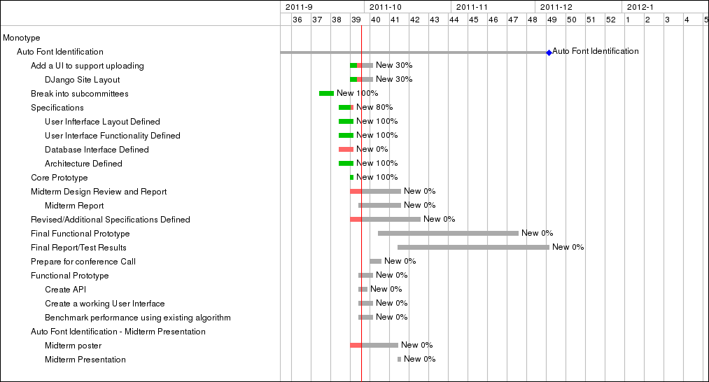**Figure 1 Sample Gantt chart**

# Appendix C: System Evaluation Plan

*(Preliminary Design Document)*

*To Do: (Mandatory) Provide a detailed test plan, including procedures, equipment, and settings used in the tests.*

# Appendix D: Ethical and Professional Responsibilities

*(Final Report)*

*To Do: (Mandatory) You developed a new system (technology) and solved a given engineering problem. Your solution could affect the world beyond the technology (immediate scope of your project). Complete the following table by briefly indicating your team’s perceived impact and describing your thoughts on how your work affects these issues. Then as an additional paragraph(s), briefly describe how you made engineering decisions to deal with these issues. Examples of impacts are shown in the table although yours are likely to be a bit longer and more complete.* ***Delete these examples*** *and add your thoughts and actions to the table. If the team feels that a particular issue does not apply to your project, explain how the team came up with the conclusion. Remember –* ***delete the examples****!*

| **Issues** | **Impact, 1(low) – 5(high)** | **Description of Impact and Related Project Decisions** |
| --- | --- | --- |
| Public Health, Safety, and Welfare | 2 | Our system design results in nominally higher emissions rates than other alternatives, however the faster processing times results in lower total emissions.  We modified concept XX to include YYY to address emissions. |
| Global | 4 | EU-based users can use our web tool. Our design met some of the European Union GDPR (General Data Protection Regulation). For more information, see Chapter 4 System Requirements.  We chose concept 1 because it included multilanguage support and conformed to the GDPR. |
| Cultural | 1 | This design facilitates in-depth, non-contact examination of fragile artifacts, enhancing our understanding of previous civilizations.  Because we feel that the impact for this is very low, we chose not to address this at this time. |
| Social | 2 | Our product provides opportunities for families to communicate in nonvel ways when they can’t otherwise be together, enhancing family bonds.  As the team feels that the impact of this for our protoype is low, we chose to document the needs and requirements that we discovered but not to use those to down select from our coucepts. Future teams may want to revisit this. |
| Environmental | 5 | Although the cost of the product was slightly increased, sustainable materials were used in the design to protect the environment. See Chapter 6. Design Analyses.  Due to the importance of this, we selected the more expensive materials. |
| Economic | 5 | Providing a cost-effective means to to convert otherwise low-value wood to valuable fuel supports forest economies by providing additional income to landowners and the forestry industry in general  We developed concepts 5 & 6 in an effort to support the forest economies. |

# Appendix E: User Manual

*(Final Report)*

*To Do: (Optional) Present the procedure to operate your prototype. Make sure to include all safety-related instructions.*

# Appendix F: Cost Analysis and Manufacturability Analysis

*(Final Report)*

*To Do: (Optional) Provide cost estimate to manufacture the product (system) you designed. Do not confuse it with the cost of building a prototype. Perform make-buy analysis on critical system elements. For projects working on mass-produced products, present manufacturability issues.*

# Appendix G: Expense Report

*(Final Report)*

*To Do: (Optional) Summarize your expenses as a Table as needed.*

|  |  |  |  |  |
| --- | --- | --- | --- | --- |
| **Item** | **Quantity** | **Unit Price** | **Subtotal** | **Vendor** |
|  |  |  |  |  |
|  |  |  |  |  |
| **Total** |  |  |  |  |

# Appendix H: List of Manuals and Other Documents

*(Final Report)*

*To Do: (Optional) To assist future teams in reusing the components used in the prototype, list all manuals came with the components and any other useful documents available. Make sure to submit the listed documents with your final report.*