Individual Technical Contribution Memo
<Name (Discipline)>

<Project Title>
<Sponsor Name>

Project Engineer <Name>
Chief Engineer <Name>

Contents
Contents 2
List of Figures 3
List of Tables 4
Glossary 5
1. Assessment of Relevant Existing Technologies and Engineering Standards 6
2. Sub-System Specifications and Design Constraints 7
3. Summary of Preliminary Engineering Analysis 8
4. Project Plan and Risk Management 9
References 10
https://www.commd.rpi.edu/resources/ 10
Appendix : 11

List of Figures
Figure 1Sample Gantt Chart 14

List of Tables
No table of figures entries found.

Glossary
To Do: Define all the abbreviations, acronyms, and terms required to properly interpret your memo. Examples of abbreviations that have two or more commonly used meaning are as follows:

- ATM – Asynchronous Transfer Mode or Automated Teller Machine
- UPS – Uninterrupted Power Supply or United Parcel Services

For any unfamiliar abbreviation, write the full name followed by the abbreviation in parentheses at the first time it is mentioned in the report.

Introduction
To Do: This introduction should frame your individual contributions within the overall scope of the team project. Provide enough information about the sub-system and why it's an important area, so that the reader can understand the customer needs presented later in this document.

Assessment of Relevant Existing Technologies and Engineering Standards
To Do: Provide appropriate background information related to your portion of the project. For a multi-semester on-going project, present the status of the sub-system at the end of the previous semester. For a new project, focus on relevant technologies and/or competitors’ products/solutions.

Present industry and de facto standards that are relevant to your project. Examples of things that might be applied to your project are found in:

https://designlab.eng.rpi.edu/edn/projects/capstone-support-dev/wiki/Standards

If competitors’ products were reviewed, state design targets identified in the assessment process also.

It is not enough to only document your findings. Discuss anticipated implications of what you have found on project decisions.

Sub-System Specifications and Design Constraints
To Do: Present the key functions and/or features of the sub-system (product, or process/services) you are designing.
Full list of project specifications are included in the team PDR Written Summary document. Here you should address specifications and constraints relevant to your section of the project.

Design constraints are explained in:
https://designlab.eng.rpi.edu/edn/projects/capstone-support-dev/wiki/Constraints
Feel free to change this section title, such as Feature Requirements or Validation of Sub-System Requirements, according to the nature of your project.

Summary of Preliminary Engineering Analysis
To Do: Identify areas where engineering analysis and/or experiments can be used to quantitatively justify your choices for critical elements. If you have completed the task, present your analysis and result. If not, present a list of problems to be analyzed and the planned approach.

Project Plan and Risk Management
Precondition: The team has opened and organized issues (tasks) using EDN. Milestones are defined using Versions. For each subsystem, the corresponding category was defined.
To Do: Filter the team Gantt chart by assignee to display ONLY your individual tasks and present your personal plan to provide a high probability path to meeting your objectives. Include delivery (completion) of deliverables as milestones. Provide sufficient details for your Chief Engineer to assist you in refining the plan as needed.
In addition to a written explanation of your plan, include a Gantt chart(s) that shows details. EDN allows you to save a Gantt chart as an image (PNG). Make sure to update the tasks before generating a Gantt chart. Make sure to reference each Gantt chart (figure) at an appropriate location in text.
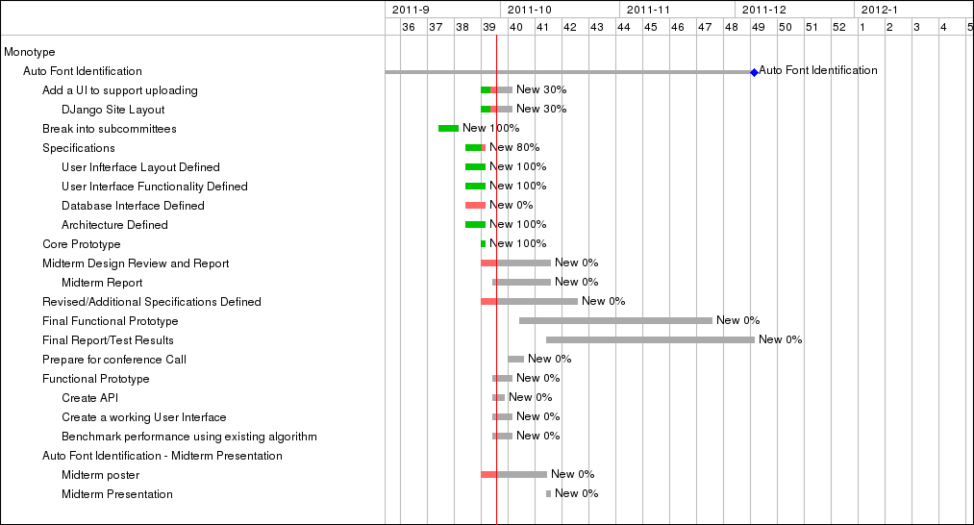
Figure 1Sample Gantt Chart
Conduct a risk analysis of your individual project plan. Also include team-level project risks, and the corresponding risk management plan.

References
To Do: The references must list all published information sources, including electronic documents that are directly quoted or used to support your discussion or equation. All references must be cited at the appropriate points within the report text.

For a full version of MS Word, use Citations & Bibliography that is available under the References tab and generate this section automatically. Note that currently MS Word On-Line does not provide this feature.

If you plan to prepare this section by hand, the following formats are recommended because you will not have to renumber citations when a new item is added to your paper.

- Single author: [Author’sLastName, Year]
- Two authors: [Author’sLastName1 & Author’sLastName2, Year]
- Three or more authors [FirstAuthor’sLastName, et al., Year]

This list of references uses the alphabetical order. For more information, see:

https://www.commd.rpi.edu/resources/

Appendix :
To Do: Include any necessary appendixes as needed.

