A meaningful needs and requirements document can be assessed using this checklist. The list is not necessarily in any order. The middle column can be completed with a three level Likert scale of high (good) / medium / low (H/M/L) assessment or simply a yes/no (Y/N) or a checkmark. The assessment is intended to apply to the entire needs and requirements document but can also be used when focusing on evaluating a single item. The right-hand column can be used to record feedback to explain the assessment in the middle column.

| **Evaluation criteria** | **H/M/L** | **Feedback** |
| --- | --- | --- |
| 1. The needs do not include specific solutions. |  |  |
| 1. The needs do not include values. |  |  |
| 1. The requirements do not include specific solutions, i.e., 'how' a need may be accomplished. |  |  |
| 1. Requirements are solution independent to allow multiple concepts to be generated. |  |  |
| 1. The requirements are measurable, and include measurement units. |  |  |
| 1. The numerical values for requirements make proper use of less than, greater than, equal to or between. |  |  |
| 1. Each requirement is associated with at least one need. |  |  |
| 1. The requirements are not “binary” as in, “the device must work”, “the device must be “safe”. Instead, look to specific measurable requirements. |  |  |
| 1. The needs focus on functionally defining what the project must do, i.e., what functions need to be performed / what features are important. |  |  |
| 1. The requirements focus on quantifying measurable things to achieve that help meet the goal(s). |  |  |
| 1. Each need has 2 or more associated requirements. |  |  |
| 1. Needs are expressed as the student team’s interpretations of customer statements and are not simply a copy of what the customer stated. |  |  |
| 1. The list of needs is sufficiently detailed as to fully define a “minimum viable product”. |  |  |
| 1. Each requirement refers to one, and only one, specific “thing”. Complex items must be broken into multiple requirements. |  |  |
| 1. Constraints are included based on Industry standards, legal or technical requirements. |  |  |
| 1. The requirements does not simply restate the need. |  |  |
| 1. The requirement should not simply state the units. For example, if the need is “low cost” and the target values are 150-200 then the units are dollars. The requirement cannot be “dollars”. It might instead be “retail sale price” or wholesale price”. |  |  |
| 1. Requirements do not simply refer to third party standards. Instead, they restate the specific items that apply. |  |  |
| 1. Needs and requirements avoid using opinion terms, e.g. “inexpensive”, “cheap”, “safe”, “small”. |  |  |
| 1. Needs include clarity as to why it is a need / the purpose of the need. For example, “system needs to keep temperature high” is weak while “system needs to be able to boil water” is strong. |  |  |
| 1. Needs are defined appropriately / separately corresponding to the user type(s). If there are multiple types of users, typically they may have different needs. |  |  |
| 1. Needs characterize the operating environment, e.g. location, environment, user skill levels, portability, etc. |  |  |
| 1. Needs associated with external interfaces, such as hardware and software, are clearly and separately called out. |  |  |
| 1. Non-functional requirements should be included as appropriate, e.g., response time, speed, etc. These must be grouped with their appropriate need. |  |  |
| 1. Focus is on engineering items rather than artistic / esthetic aspects. |  |  |
| 1. Needs and associated measurable requirements related to quality are included. |  |  |
| 1. If appropriate to the project, needs and measurable requirements involving any user interfaces are defined. |  |  |
| 1. Needs and associated measurable requirements related to security are defined. |  |  |
| 1. Needs and requirements are unambiguous. |  |  |
| 1. Requirements are verifiable / testable. |  |  |
| 1. Needs and requirements are realistic |  |  |
| 1. Needs and requirements are within the approved School of Engineering safety parameters. |  |  |
| 1. The needs and requirements are complete and consistent. |  |  |
|  |  |  |
|  |  |  |
|  |  |  |
|  |  |  |
|  |  |  |
|  |  |  |
|  |  |  |
|  |  |  |
|  |  |  |
|  |  |  |
|  |  |  |
|  |  |  |

Comments:

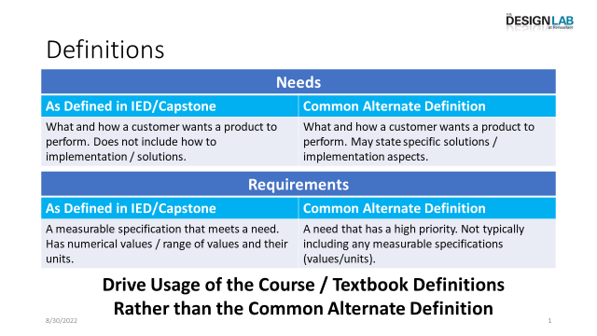

Figure 1 - Definitions