**Preliminary Design Document for**

<Descriptive Project Title>

Sponsored By

<Sponsor Name>

Version <S19>

<Month, Date Year>

Prepared by

<Name (Discipline)>

<Name (Discipline)>

Project Engineer <Name>

Chief Engineer <Name>

# Contents

Contents 2

List of Figures 3

List of Tables 4

Revision History 5

Glossary 6

1. Introduction 7

2. Customer Needs and Project Requirements 8

3. Project Objectives and Scope 9

4. Assessment of Relevant Existing Technologies and Engineering Standards 10

5. System Specifications and Design Constraints 11

6. System Concept Development 12

7. Summary of Preliminary Engineering Analysis 13

8. Project Plan and Risk Management 14

References 15

Appendix A: Additional Considerations (mandatory) 16

Appendix B: System Evaluation Plan (mandatory) 17

Appendix C: System Requirements (optional) 18

Appendix : 19

# List of Figures

Figure 1Sample Gantt Chart 14

# List of Tables

**No table of figures entries found.**

# Revision History

|  |  |  |  |
| --- | --- | --- | --- |
| Version | Date | Name | Reason for Changes |
| 1.0 |  |  | Initial document. |
|  |  |  |  |
|  |  |  |  |

# Glossary

To Do: Define all the abbreviations, acronyms, and terms required to properly interpret your final report. Examples of abbreviations that have two or more commonly used meaning are as follows:

* ATM – Asynchronous Transfer Mode or Automated Teller Machine
* UPS – Uninterrupted Power Supply or United Parcel Services

For any unfamiliar abbreviation, write the full name followed by the abbreviation in parentheses at the first time it is mentioned in the report.

# Introduction

To Do: Review and update material from the Statement of Work (SoW). This introduction should provide enough information about the project area, why it's an important area, so that the reader can understand the customer needs that we present in the next section.

# Customer Needs and Project Requirements

To Do: The term “customer” is used in a general sense. In this section, identify the different customer types whose needs are addressed, even indirectly, by this project.

Examples of different types of customers:

* Client who sponsors this project
* Customers who make purchasing decisions
* End users who actually use the product

Next, gather customer needs and then convert those into project requirements. After that, study applicable engineering standards (regulations) for any additional requirements (or constraints). Add these new items to your project requirements document.

Document the customer needs and project requirements using appropriate forms, such as a table, a set of use cases (user stories), and UML diagrams.

If you have many needs and specifications, present a summary here. Provide details in an Appendix A or reference an external document, such as your existing Excel file that is used to maintain customer needs and system requirements.

# Project Objectives and Scope

To Do: This section contains both long term objectives and the planned semester objectives. Review and update materials from the SoW. Provide a bullet list of the objectives for this semester. Focus on final outcomes, not intermediate steps. Do not include academic assignments that will be included in the Project Plan section. The objectives should be understandable by themselves. Clarify what you planned to do (in scope), and that you planned to not do (out of scope) as needed.

# Assessment of Relevant Existing Technologies and Engineering Standards

To Do: Provide appropriate background information. For a multi-semester on-going project, present the status of the project at the end of the previous semester. For a new project, focus on relevant technologies and/or competitors’ products.

Present industry and de facto standards that are relevant to your project. Examples of things that might be applied to your project are found in:

<https://designlab.eng.rpi.edu/edn/projects/capstone-support-dev/wiki/Standards>

If competitors’ products were reviewed, state design targets identified the assessment process also.

It is enough to only document your findings. Implications for project decisions must be documented.

Feel free to modify this section title and/or create multiple subsections according to your needs.

# System Specifications and Design Constraints

To Do: Present the key functions and/or features of the system (product, or process/services) you are designing. Reference industry and de facto standards that are relevant to your project. Examples of things that might be applied to your project are found in:

<https://designlab.eng.rpi.edu/edn/projects/capstone-support-dev/wiki/Standards>

Design constraints are explained in:

<https://designlab.eng.rpi.edu/edn/projects/capstone-support-dev/wiki/Constraints>

Feel free to change this section title, such as Product Requirements or Validation of System Requirements, according to the nature of your project.

If you have detailed requirements, present a summary here and the details in an Appendix.

# System Concept Development

To Do: You are expected to develop several concepts and evaluate the best way to proceed. Introduce your major system concepts and evaluation results. (If you have developed many concepts, present the remaining concepts in an Appendix.) We recommend including visual presentations of your concepts, such as engineering drawings, block diagrams, and data flow diagrams.

# Summary of Preliminary Engineering Analysis

To Do: Identify areas where engineering analysis and/or experiments can be used to quantitatively justify your choices for critical elements. If you have completed the task, present your analysis and result. If not, present a list of problems to be analyzed and the planned approach.

# Project Plan and Risk Management

Precondition: The team has opened and organized issues (tasks) using EDN. Milestones are defined using Versions. For each subsystem, the corresponding category was defined.

To Do: Integrate individual project plans and present your team’s plan to provide a high probability path to meeting your objectives. Include delivery (completion) of deliverables as milestones. Do not cut and paste individual project plans. **Provide sufficient details for your Chief Engineer to assist you in refining the plan as needed.**

**In addition to a written explanation of your plan**, include a Gantt chart(s) that shows details. EDN allows you to save a Gantt chart as an image (PNG). Make sure to update the tasks and before generating a Gantt chart. Make sure to reference each Gantt chart (figure) at an appropriate location in text.

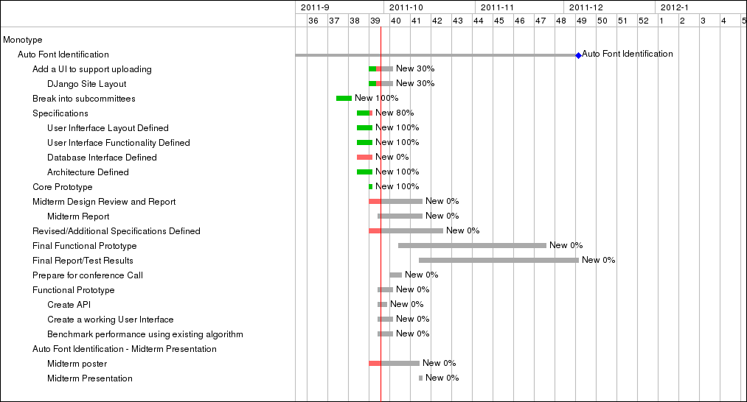

Figure 1Sample Gantt Chart

Review risk analyses included in individual project plans and present team-level project risks, and the corresponding risk management plan.

# References

To Do: The references must list all published information sources, including electronic documents that are directly quoted or used to support your discussion or equation. **All references must be cited at the appropriate points within the report text.**

For a full version of MS Word, use Citations & Bibliography that is available under the References tab and generate this section automatically. Note that currently MS Word On-Line does not provide this feature.

If you plan to prepare this section by hand, the following formats are recommended because you will not have to renumber citations when a new item is added to your paper.

* Single author: [*Author’sLastName*, *Year*]
* Two authors: [*Author’sLastName1* & *Author’sLastName2*, *Year*]
* Three or more authors [*FirstAuthor’sLastName*, et al., *Year*]

This list of references uses the alphabetical order. For more information, see:

# https://www.commd.rpi.edu/resources/

# Appendix A: Additional Considerations (mandatory)

To Do: You must consider the following issues to design your solution and/or make engineering decisions in addition to your customer’s specified needs.

* Public health, safety, and welfare
* Global
* Cultural
* Social
* Environmental
* Economic

If you already addressed the issue in a previous section, you only need to reference the section. If you do not think that a particular issue does not apply to your project, explain how you came up with the conclusion.

# Appendix B: System Evaluation Plan (mandatory)

To Do: You will have to objectively measure your accomplishments at the end of the semester. Provide a detailed test plan, including procedures, equipment, and settings used in the tests.

# Appendix C: System Requirements (optional)

To Do: Present the system requirements. Organize the requirements according to appropriate types or priority. Assign a unique ID to each requirement. Any requirements that are design constraints must be marked as Constraints.

If your project focuses on a subset of the customer requirements, present them as either “in scope” or “out of scope”.

Feel free to change this section title, such as Product Specifications or Validation of System Requirements, according to the nature of your project.

# Appendix :

To Do: Include any necessary appendixes as needed.