Mid Term Information Package for

Descriptive Project Title

Sponsored By

Sponsor Name

Version 1.0

Month, Date Year

Prepared by

Name (Discipline)

Name (Discipline)

Project Engineer – Name

Chief Engineer - Name

Table of Contents

Table of Contents 2

List of Figures 3

List of Tables 4

1. Customer Needs and Project Requirements 5

2. System Concepts, Engineering Analysis, and Design 6

3. Project Plan and Risk Management 7

References 9

Appendix A: (Optional) 10

List of Figures

**Figure 1 Sample Gantt chart** 7

List of Tables

Table 1 Sample Project Risks and Risk Management Plans 8

# Customer Needs and Project Requirements

To Do: The term “customer” is used in a general sense. In this section, identify the different customer types whose needs are addressed, even indirectly, by this project.

Examples of different types of customers:

* Client who sponsors this project
* Customers who make purchasing decisions
* End users who actually use the product

Next, gather customer needs and then convert those into project requirements. After that, study applicable engineering standards (regulations) for any additional requirements (or constraints). Add these new items to your project requirements document.

Document the customer needs and project requirements using appropriate forms, such as a table, a set of use cases (user stories), and UML diagrams.

If you have many needs and specifications, present a summary here. Provide details in an Appendix or reference an external document, such as your existing Excel file that is used to maintain customer needs and system requirements.

# System Concepts, Engineering Analysis, and Design

To Do: You are expected to develop several concepts and evaluate the best way to proceed. Introduce your major system concepts and evaluation results. (If you have developed many concepts, present the remaining concepts in an Appendix.) We recommend including visual presentations of your concepts, such as engineering drawings, block diagrams, and data flow diagrams. These figures and tables must be referenced and described in the text.

Identify areas where engineering analyses and/or experiments can be used to make good choices for critical elements. Present either completed analyses and/or experiments or plans for ones that not yet completed.

# Project Plan and Risk Management

To Do: Present your plan to provide a high probability path to meeting your objectives. Include delivery (completion) of deliverables as milestones. **Provide sufficient details for your Chief Engineer to assist you in refining the plan as needed.**

Include a complete Gantt chart and explain major units, such as subsystems and milestones, used to organize the work structure. Electronic Design Notebook allows you to save a Gantt chart as an image (PNG). Make sure to update the issues before generating a Gantt chart.

Choose a unit, create the corresponding Gantt chart, and describe why the tasks are relevant and complete so that the team can achieve the goal.

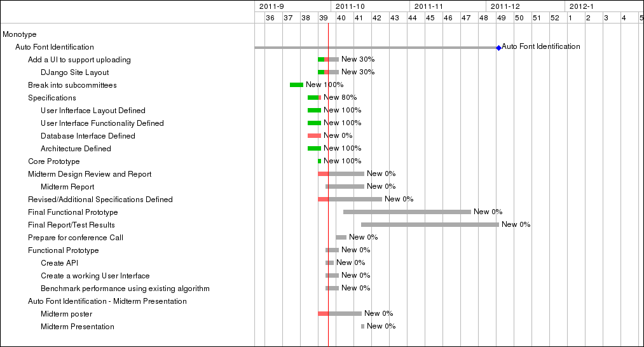**Figure 1 Sample Gantt chart**

After that study the following common problem areas (project risks) and revise your project plan as needed.

1. **Lack of Knowledge and Skills**  
   Identify knowledge and skills needed to complete the project based on your technical approach. Study if the team have necessary knowledge and skills or not. Sample problems and the corresponding risk management plans are shown in Table 1.

Table 1 Sample Project Risks and Risk Management Plans

|  |  |
| --- | --- |
| **Problem (Risk)** | **Risk Management Plan** |
| We are not familiar with Technology-X | Allocate time to study and learn Technology-x. |
| We cannot operate a CNC machine to fabricate parts. | Ask the Design Lab technician to fabricate parts. |
| We know how to implement subsystems, except Subsystem-Y. | Schedule to work on Subsystem-Y first.  (Note: Students tend to work on easy problems first and run out time to work on difficult problems.) |
| We do not know if Approach-Z will work or not. | Build a prototype and study its feasibility. |

1. **Testing Your System (Solution)**  
   You must objectively demonstrate how well your system (solution) met the customer needs and requirements.
   1. Identify things you need to measure? Identify the corresponding acceptable values (results)? If you already developed a test plan, present it in an Appendix. If not, you must plan to develop a test plan.
   2. List everything, such as hardware, circuitry, sensors, software, etc., you need to test your system. You may have to plan and create a test fixture, test data, and/or sample materials.
2. **Lead Time and Resource Availability**  
   Things do not happen instantaneously. You must anticipate delays and schedule tasks. Examples are as follows.
   1. Your design must be reviewed and approved by your Project Engineer before you can order parts and/or start fabricating it. It typically takes two more reviews before a design is approved. Plan at least two reviews.
   2. The Design Lab uses RPI’s purchasing system. It takes **two to five days** for your parts to arrive after submitting a purchase request to Valerie. When you plan to acquire parts, include a delay.
   3. In general, many teams ask the Design Lab technician to fabricate their parts near the end of the semester. Hence, you may have to wait for a long time to receive your parts. You design must be completed, reviewed, and approved by your PE by the end of the 9th week.
   4. If you need to borrow (or access) any special apparatus to perform a task, check its availability and schedule the task.
3. **Dealing with Delays and Unexpected Problems**  
   Things could go wrong. How did you plan for delays and unexpected problems? We recommend that you plan to complete all tasks in 14 weeks and keep the 15th week as a buffer.

Explain how you modified the project plan based on these risk analyses.

# References

To Do: The references must list all published information sources, including images, photos, electronic documents that are directly quoted or used to support your discussion or equation. **All references must be cited at the appropriate points within the report text.** MS Word’s Citation & Bibliography features that are available under the References Tab are extremely useful.

Appendix A: (Optional)

To Do: Create Appendixes to make the mid-term information package easy to read, provide detailed and/or any other information useful in defining the project and/or clarifying proposed tasks. Examples include use case diagram for requirements analyses, minor system concepts that were not presented in the main body of the report, detailed engineering analyses, and a test plan. For each Appendix, provide a descriptive title. All Appendixes must be referenced in the main body of the document.